

**II.2314 / II.2414**

**Advanced Databases and Big Data**

**Lab 1 & 2 & 3**

**GUO Xiaofan**

CONTENT

Lab 1 4

**Exercice 1: DDL queries** 4

1. Copy 4

2. E/R diagram: 5

3. First integrity Constraint: 5

4. Second integrity Constraint 6

5. Third integrity Constraint on Delete 6

6. Explain Errors for Integrity Constraint 8

7. Define a sequence 10

8. Use Sequence: 11

**Exercise 2: DML queries Answer the following queries using SQL.** 11

1. List the content of all tables to see the attributes names. 11

2. Select employees whose commission is higher than their salary. 12

3. Select employees earning between 1200 and 2400 (earning is sal + commision) 12

4. Select employees who are CLERK or ANALYST 13

5. Select employees whose name begins by M. 13

6. Select employees whose name includes a L in second position. 14

7. Select employees who are MANAGER or CLERK in the department 10 and whose salary is greater than 1500. 14

8. Select employees whose commission is NULL 15

9. Select employees by ascending order (by hiredate) 15

10. Select employees ordered by job, and for each job, by decreasing salary 16

11. Select departments without employees 16

12. List employees indicating for each the name of his/her manager 17

13. List employees earning more than JONES 18

14. List employees displaying in the same column salary and commission 18

15. List department numbers which are both in table EMP and in table DEPT 19

16. List employees working in CHICAGO and having the same job than JONES 19

17. List employees who don't work in the same department than their manager 20

18. List employees working in a department having at least one CLERK 20

19. List employees of department 10 having the same job than someone from the depart SALES 21

20. List employees having the same job than JONES or a salary greater than FORD's salary 21

21. List employees having a salary greater than all employees of department 20 22

**Exercice 3: Join Table** 23

1. Create a Table for employee’s Projects: 23

2. Create the Join Table: 23

3. List all employees (by empno) who work on all projects? 25

4. Options on View creation: 25

5. View Creation: 26

6. Division Query: 27

7. Analyze: 28

Lab 2-Advanced SQL 29

**Exercice 1: Analytics Queries . Window Queries** 29

1. Gets the 2 persons per department, who have arrived the latest in the company. 29

2. Show your analytical Skill and Invents an interesting query using Windows Functions. 30

**Exercice 2: Index & Explain Plan** 31

1. Execute this script. 31

2. The goal of all exercice will be to tune the following query: 31

3. 1 Use EXPLAIN plan to analyze the query 32

3. 2 Activate stats. 32

**Exercice 3: Data Dictionary** 38

**Exercice 4: Use postgres via CLI** 39

**Exercice 5: Transaction Part 1 – Beginner** 39

Lab 2-Part 2 PL/SQL 41

**Exercice 1: Functions** 41

**Exercice 2: Procedure & Display & Cursors** 42

**Exercice 3. Procedure & Update** 43

**Exercice 4. Procedure** 44

**Exercice 5. SELECT for UPDATE** 45

**Exercice 6. Condition on EXIT loop** 48

**Exercice 7. Triggers** 49

**1. Create the triggers & 2. Function to analyze results** 49

Lab 3 50

**Part I: A Graphic of Table: communication with database** 50

**1.** Load Driver - 2. Connect to bdd - 3. Make a request. 50

Exercise 1: Modify the query above to add the location of the department. 55

Exercice 2: Move Department. 55

**Exercice 3: Generic display of Tables: 57**

Exercice 4: Security: 58

Exercice 5:Modify moveDepartement() to use PrepareStatemen 58

Exercice 6: Try with displayTable 59

Exercice 7: With J2EE 60

**Part II : DAO.** 60

Exercice 8: What are cons of JDBC as used above? 60

Exercice 9 : Write the Bean for Department 61

Exercice 10 : Write Implementation for method find for departement DAO 62

Exercice 11: Write Implementation for method find for employee DAO. 65

Exercice 12 : Create DAOFactory and use it in previous example 67

**Part III : Spring Boot & JPA.** 68

**Exercice III.2 : Activate JPA and connect to your Database** 69

**Exercise III.3 : Read Data in your Database** 70

**Exercise III.4 : Create an Object via JPA and expose it on a REST endpoint** 71

**Exercise III.5 : GET by ID / Update by id / Delete by ID / Get All, via JPA / REST** 72

# **Lab 1**

## **Exercice 1: DDL queries**

### **1. Copy**

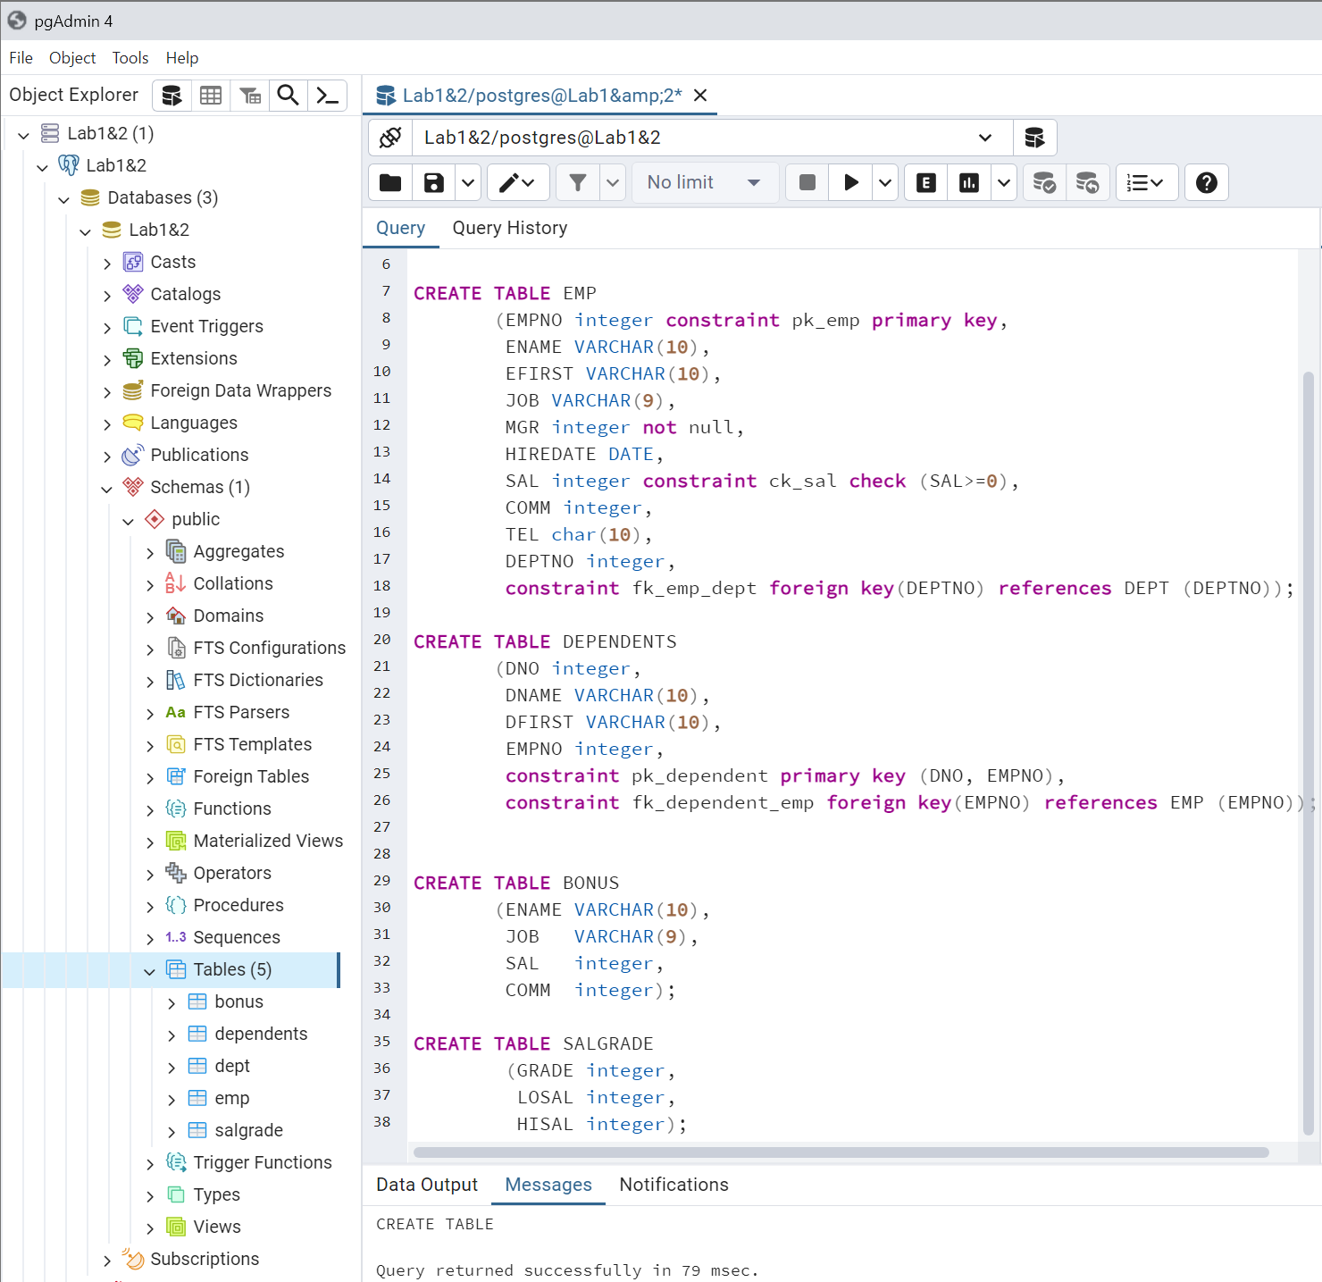

### **2. E/R diagram:**

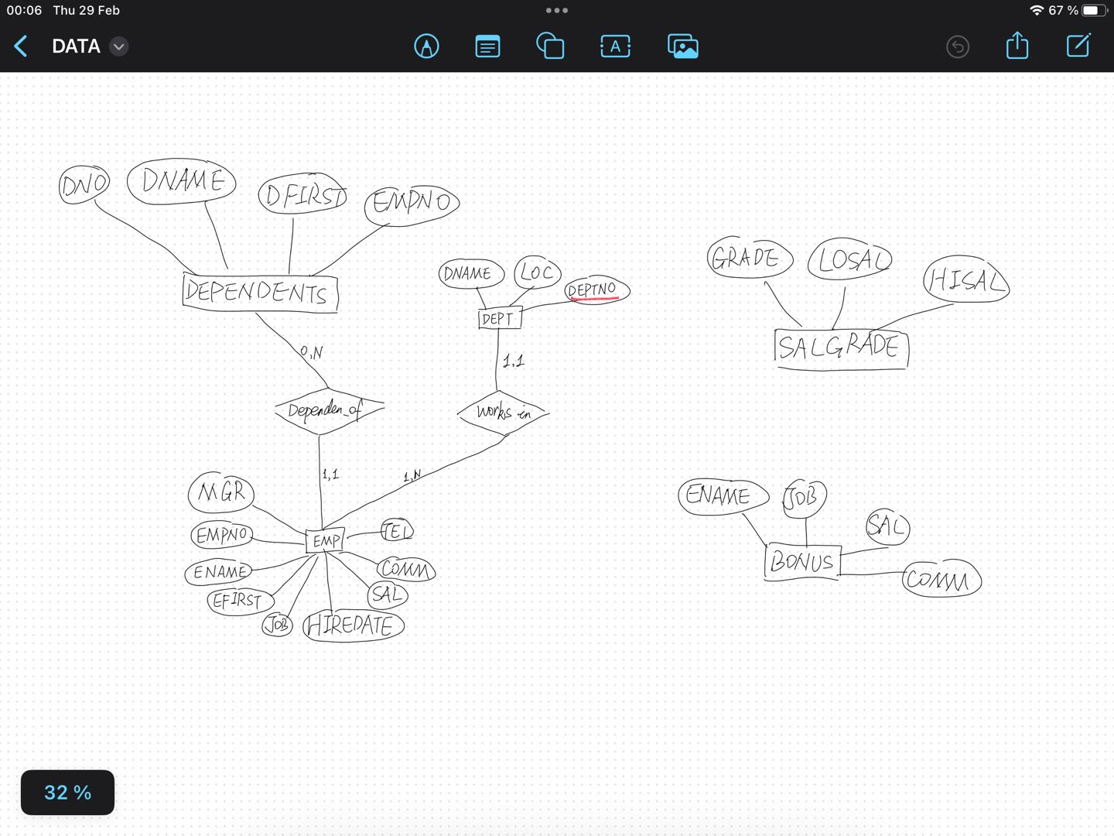

### **3. First integrity Constraint:**

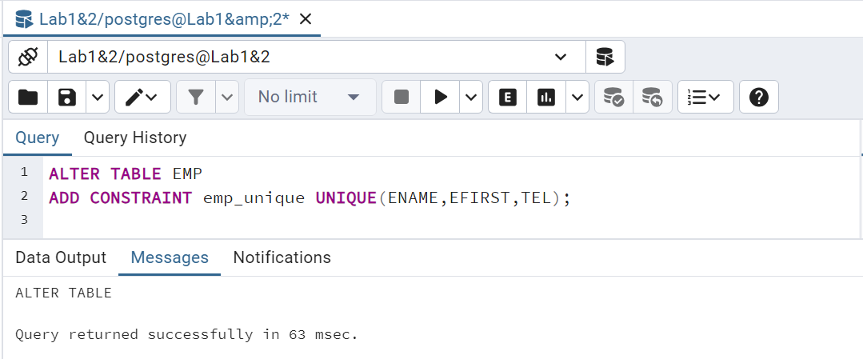

### **4. Second integrity Constraint**

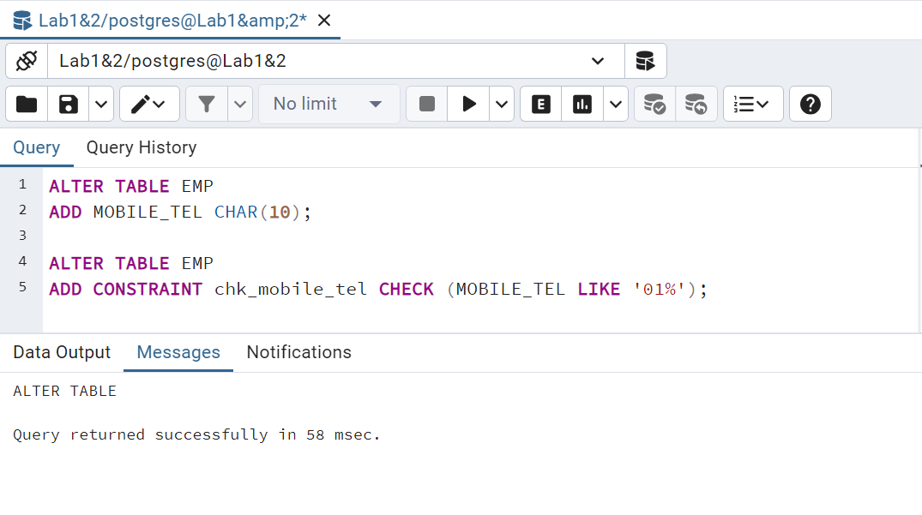

### **5. Third integrity Constraint on Delete**

**1) remove the referential constraint fk_ depenent_emp**

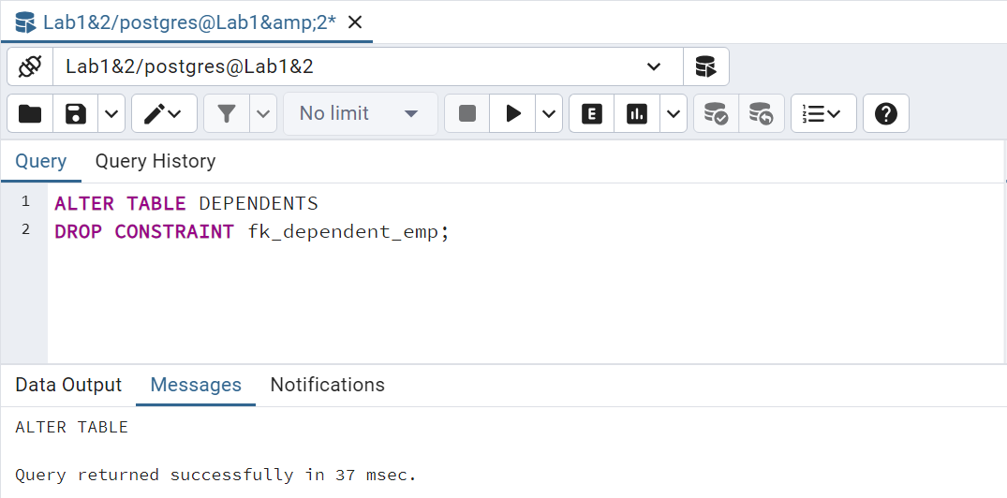

**2) delete an employee and remove all his dependents on the same time.**

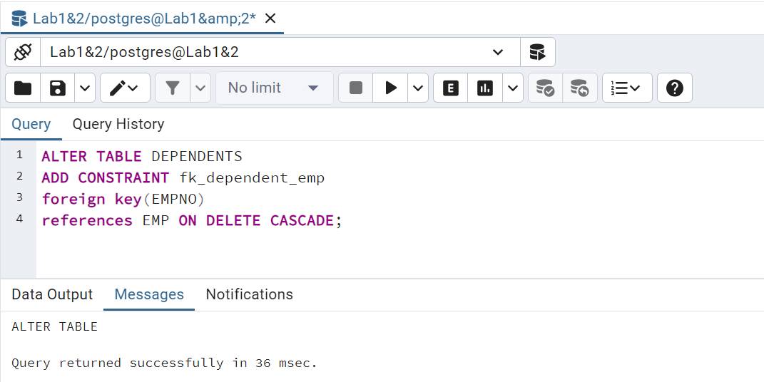

**ON DELETE CASCADE is an option used when setting foreign key constraints in the database. It defines that when a record in the referenced table (parent table) is deleted, for the table (child table) containing the referenced key (foreign key) The behavior of how associated records should be processed.**

### **6. Explain Errors for Integrity Constraint**

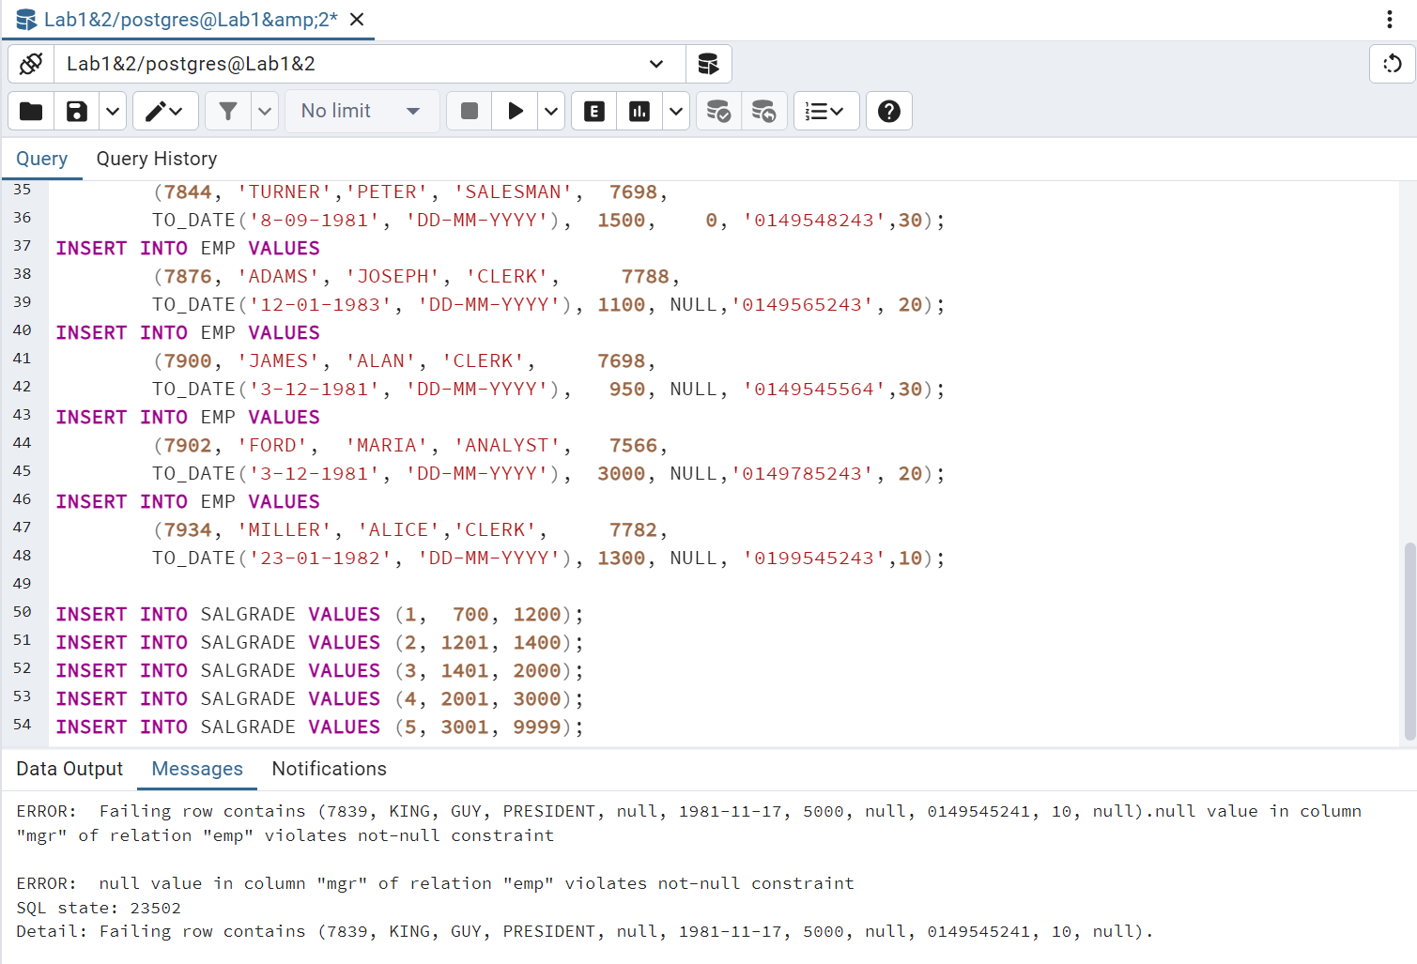

**If run the code directly, we will find that due to the existence of null information, then need to do the following:**

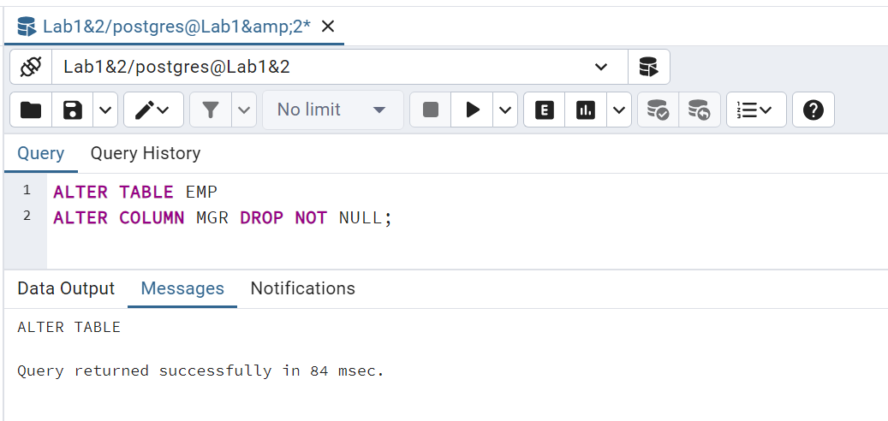

**ALTER COLUMN MGR DROP NOT NULL is used to modify column attributes in database tables. This statement is used to remove the NOT NULL constraint on the MGR column in the EMP table. In SQL, the NOT NULL constraint is used to ensure that a column cannot contain null values (NULL), that is, the column must have a value in each row.**

**Then run the before code again:**

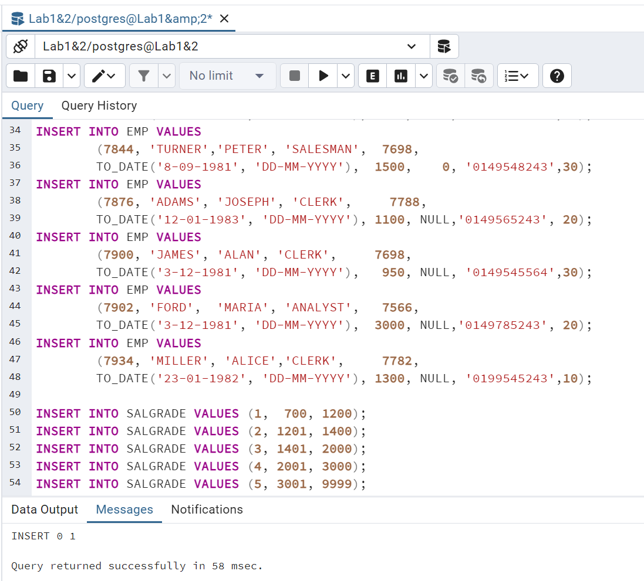

**salgrade->view data check results:**

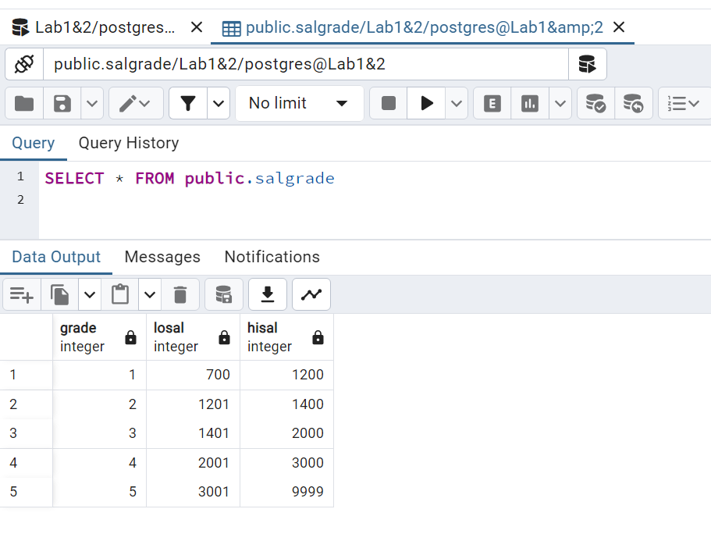

### **7. Define a sequence**

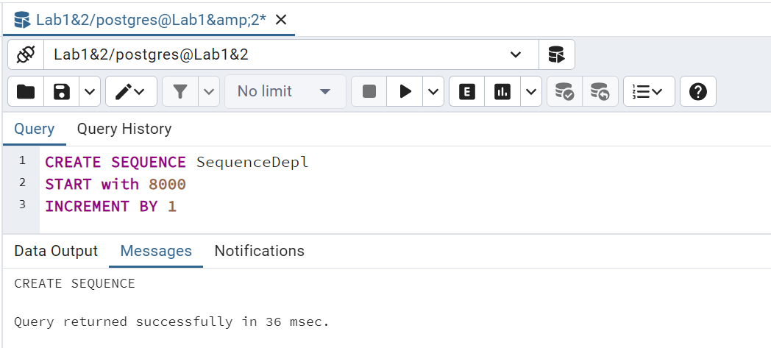

### **8. Use Sequence:**

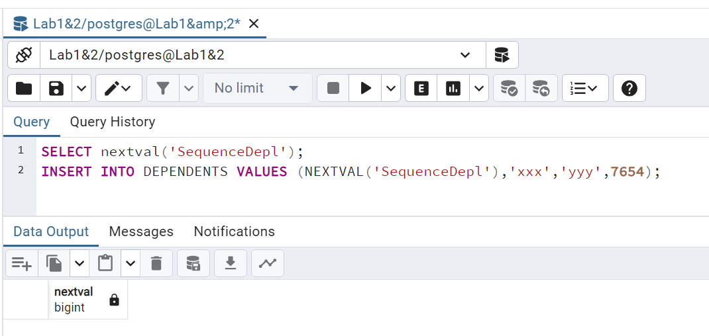

## **Exercise 2: DML queries Answer the following queries using SQL.**

### **List the content of all tables to see the attributes names.**

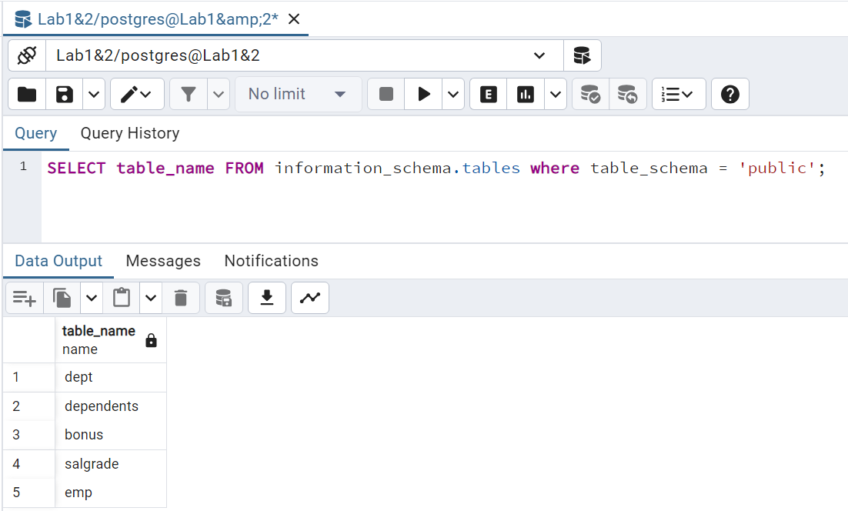

### **Select employees whose commission is higher than their salary.**

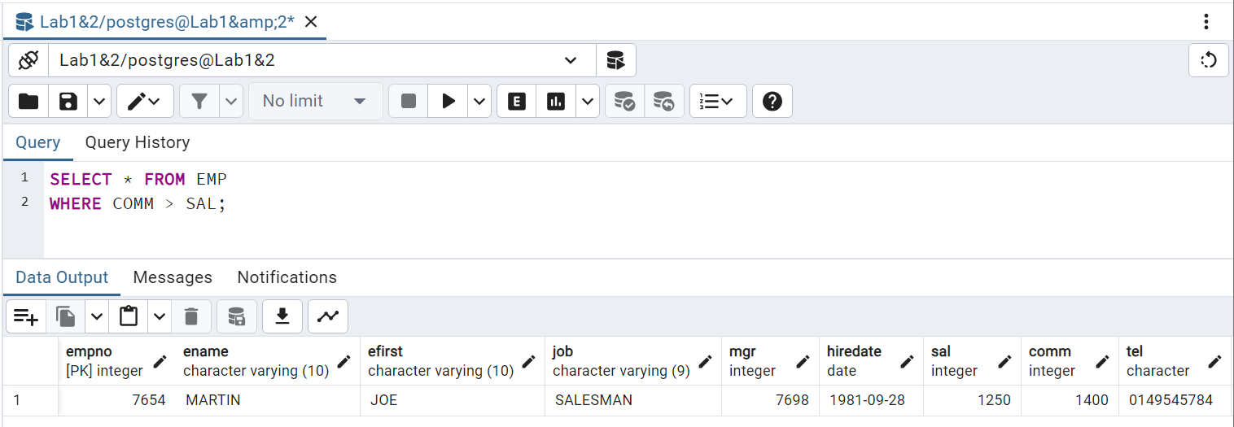

### **Select employees earning between 1200 and 2400 (earning is sal + commision)**

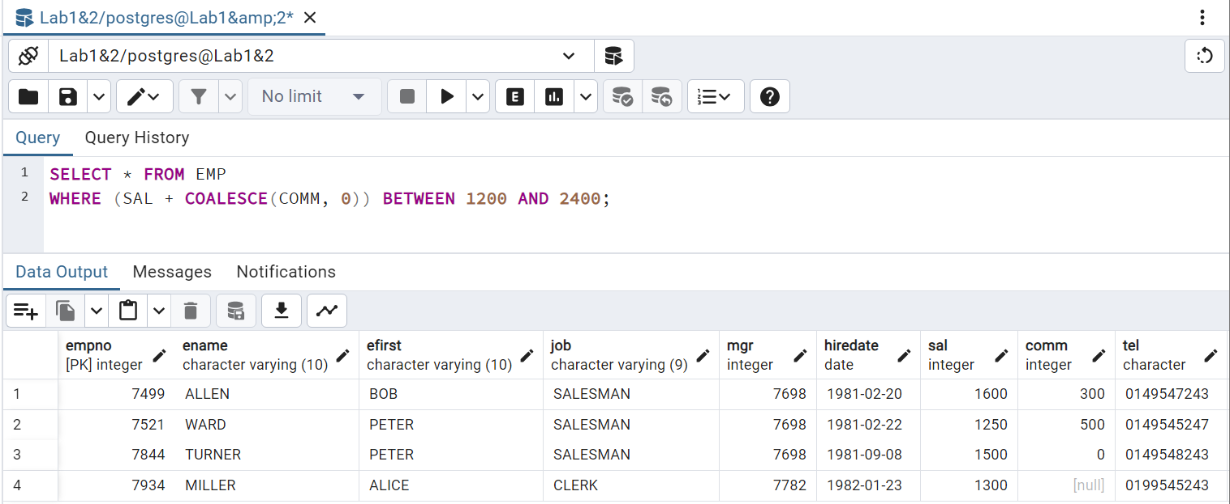

### **Select employees who are CLERK or ANALYST**

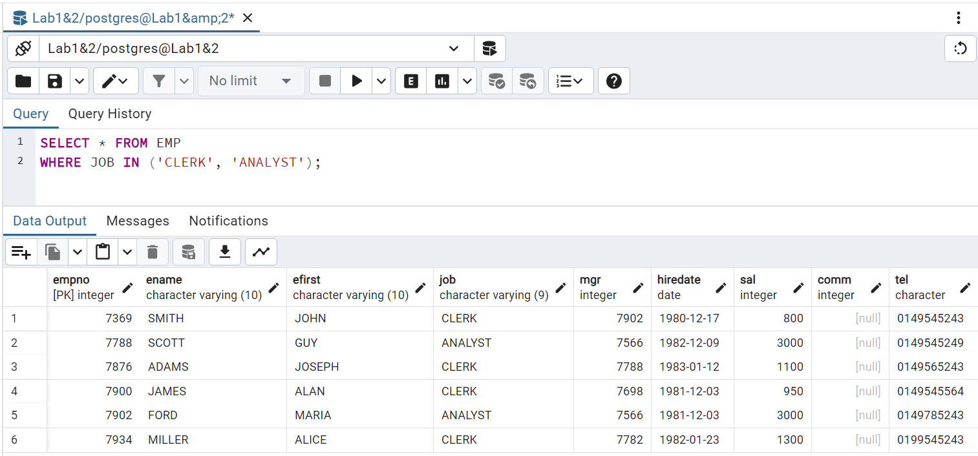

### **Select employees whose name begins by M.**

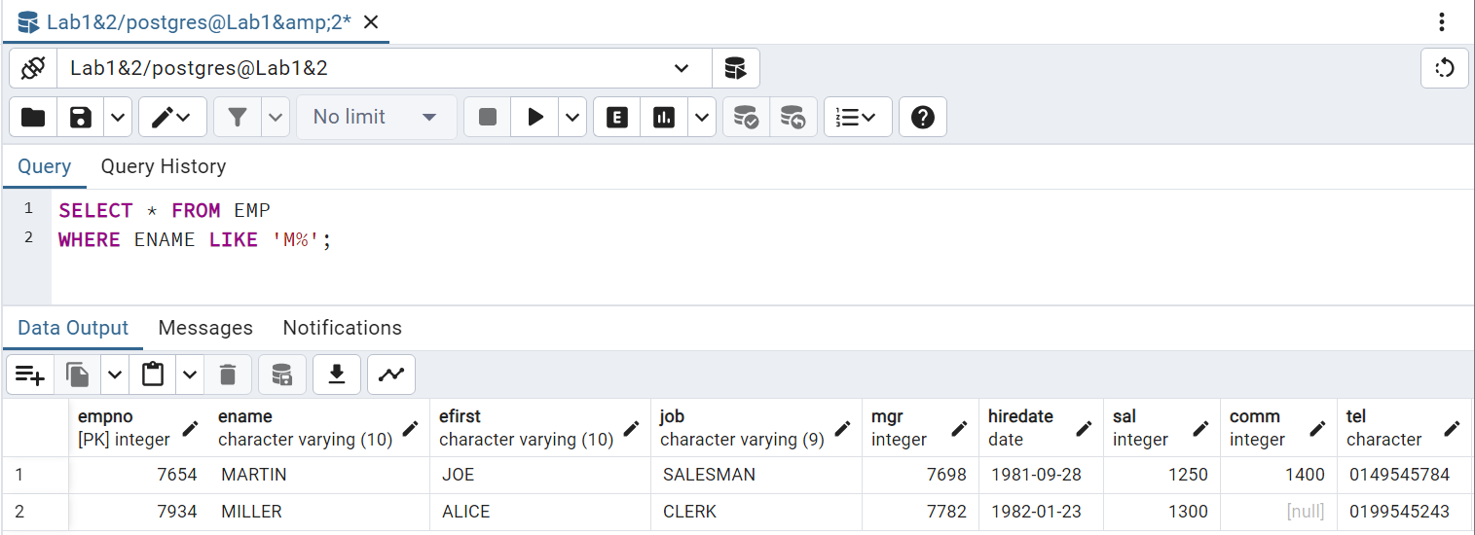

### **Select employees whose name includes a L in second position.**

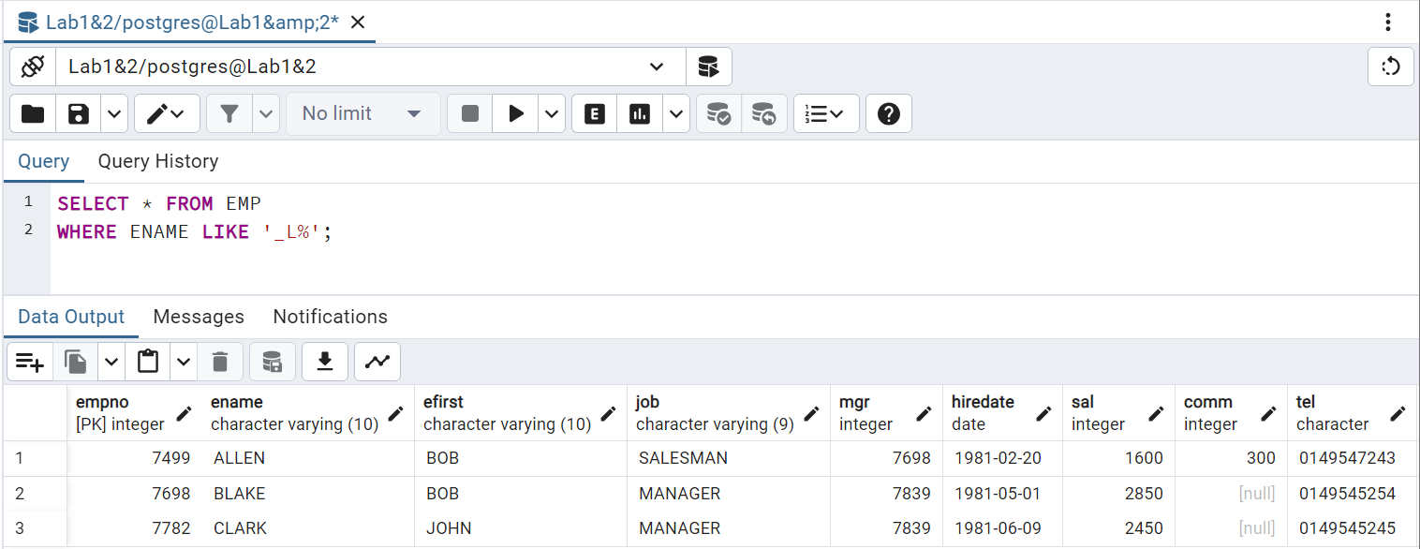

### **Select employees who are MANAGER or CLERK in the department 10 and whose salary is greater than 1500.**

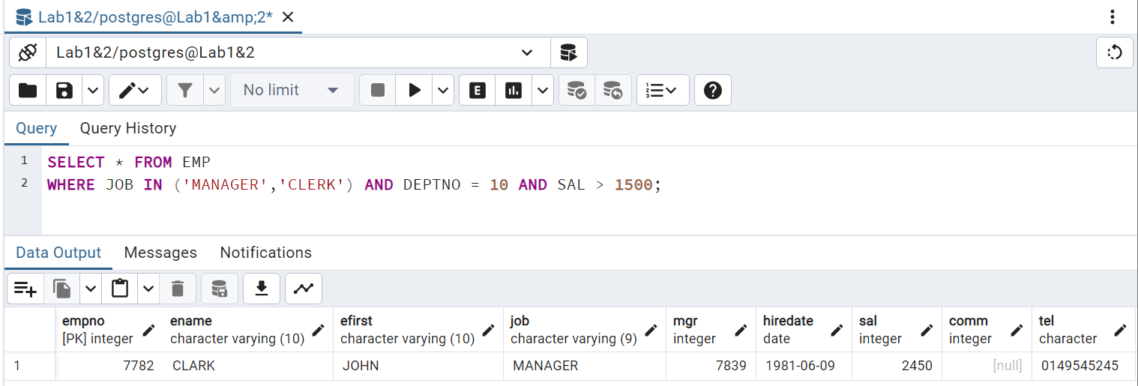

### **Select employees whose commission is NULL**

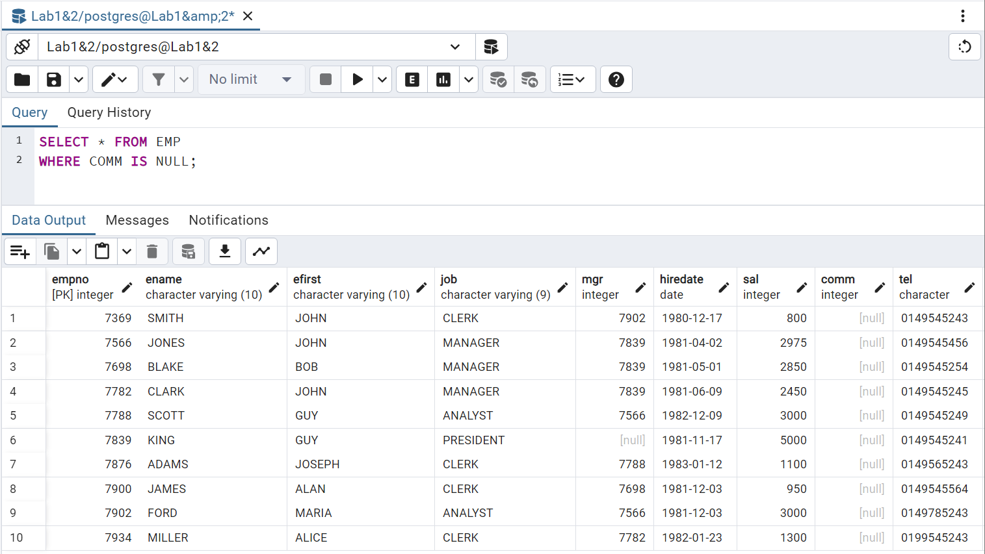

### **Select employees by ascending order (by hiredate)**

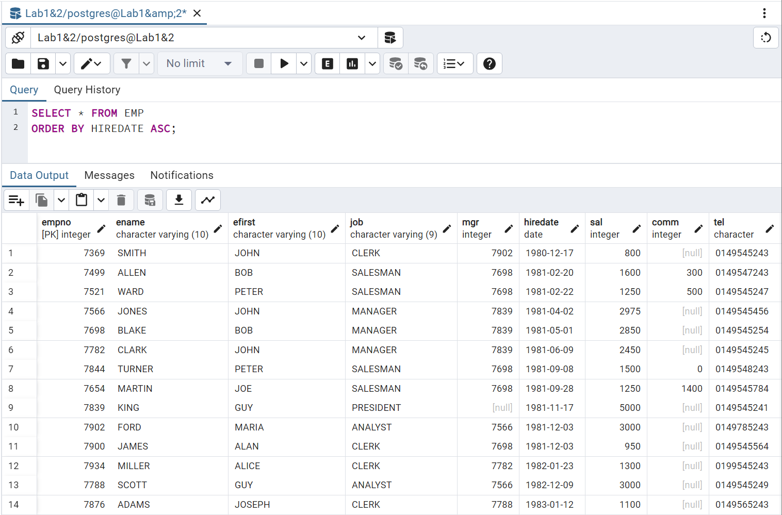

### **Select employees ordered by job, and for each job, by decreasing salary**

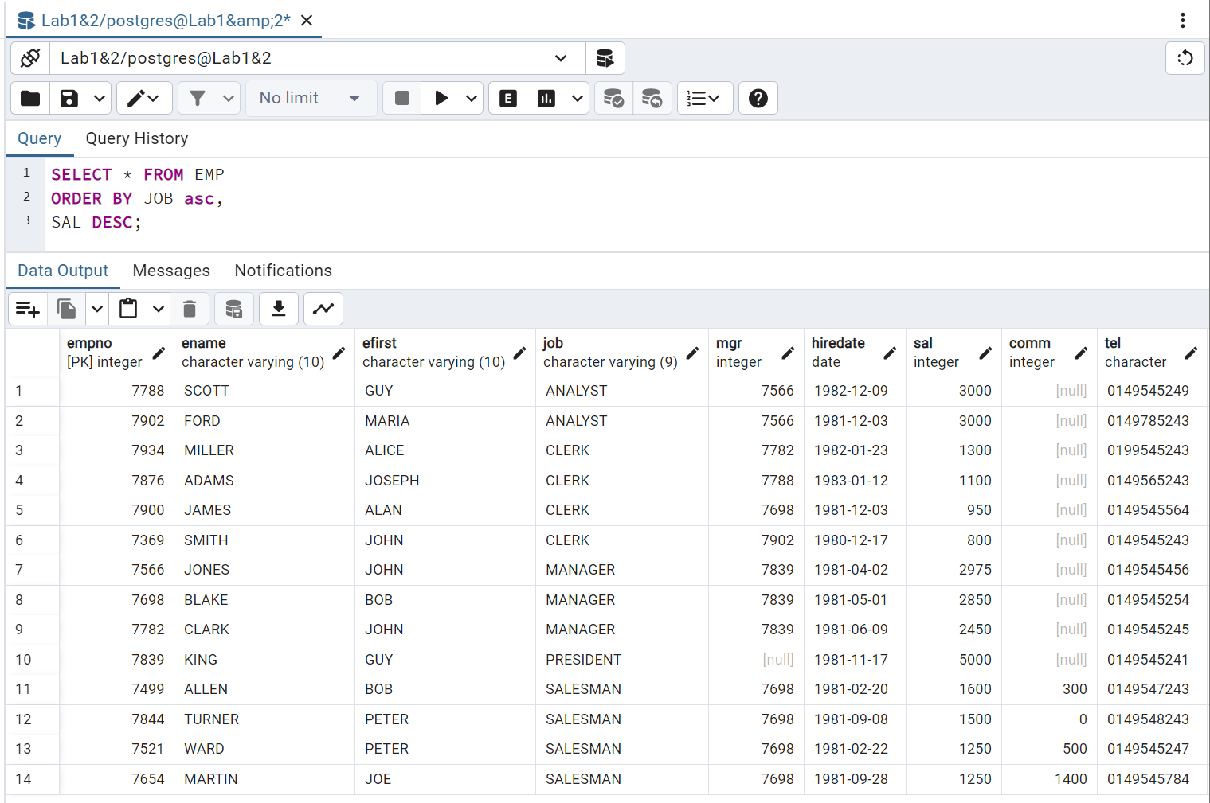

### **Select departments without employees**

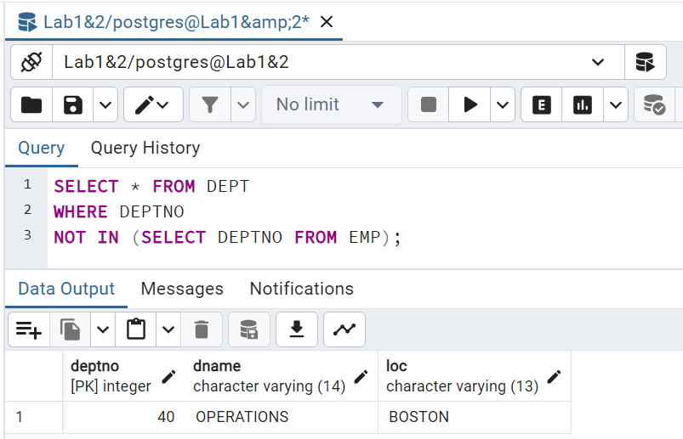

### **List employees indicating for each the name of his/her manager**

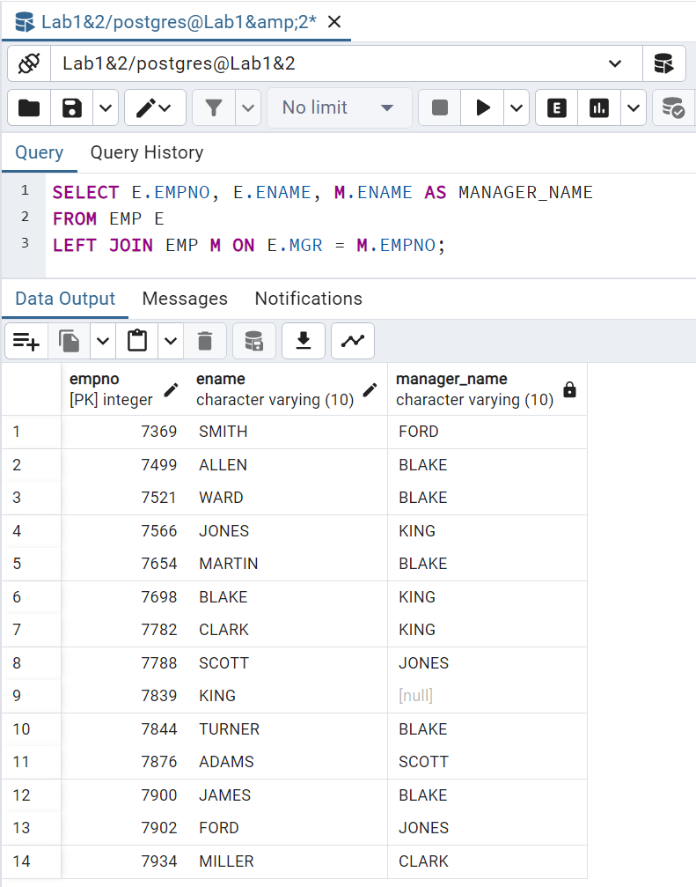

### **List employees earning more than JONES**

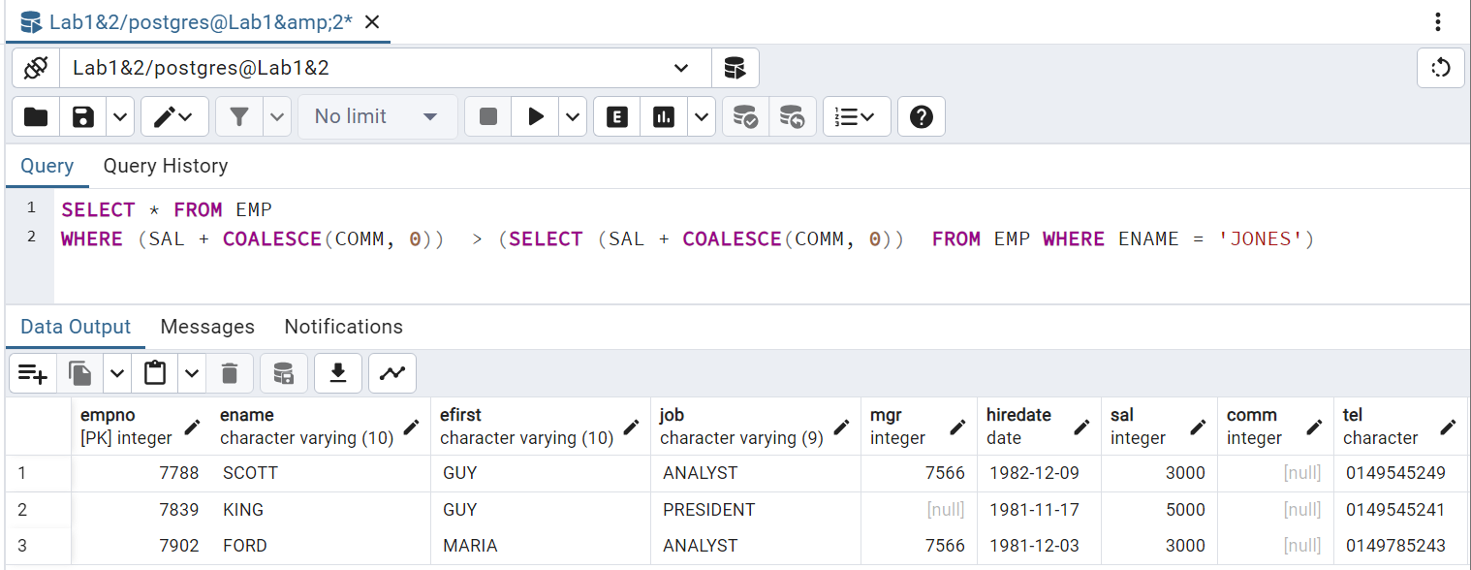

### **List employees displaying in the same column salary and commission**

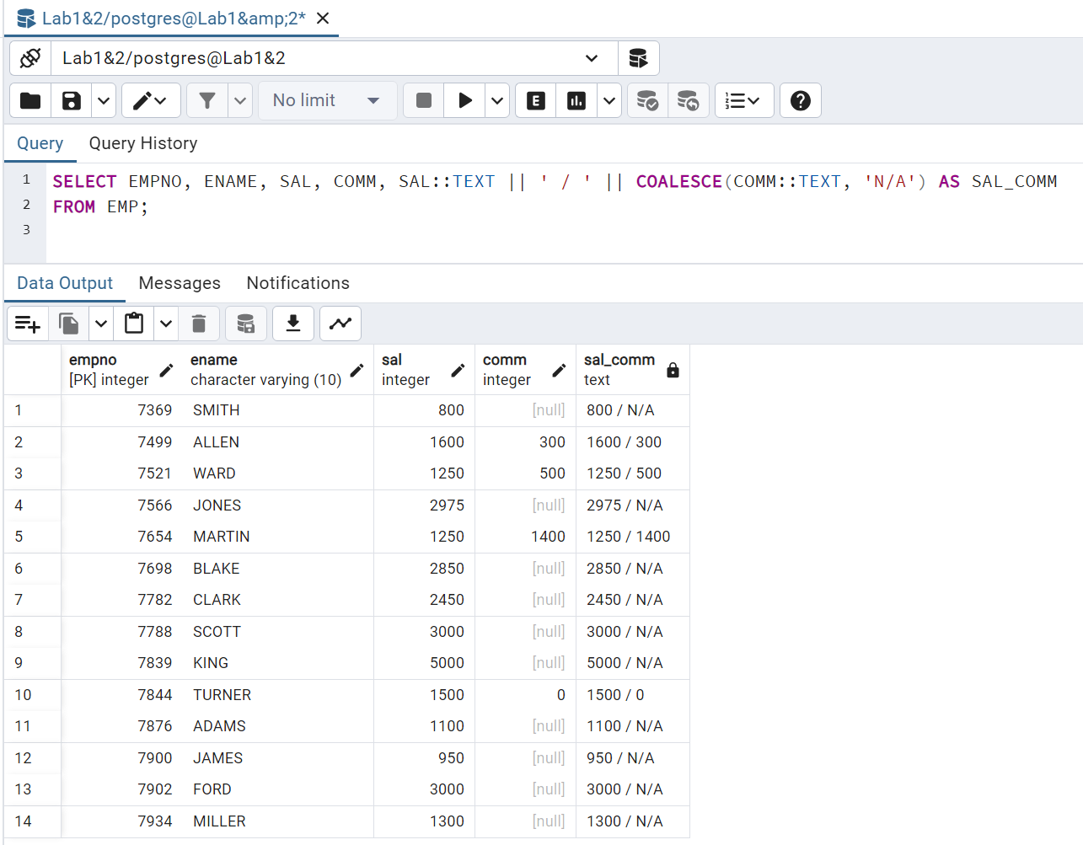

**Note: The COALESCE function requires all parameters to be of the same type**

### **List department numbers which are both in table EMP and in table DEPT**

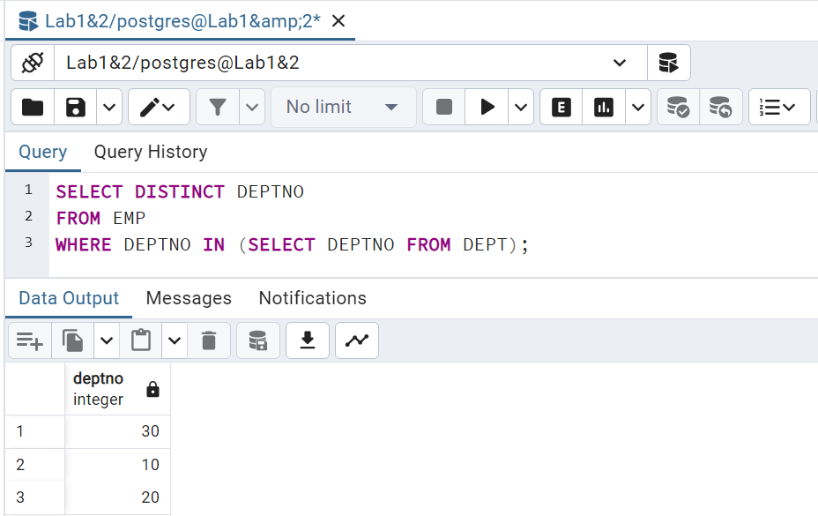

### **List employees working in CHICAGO and having the same job than JONES**

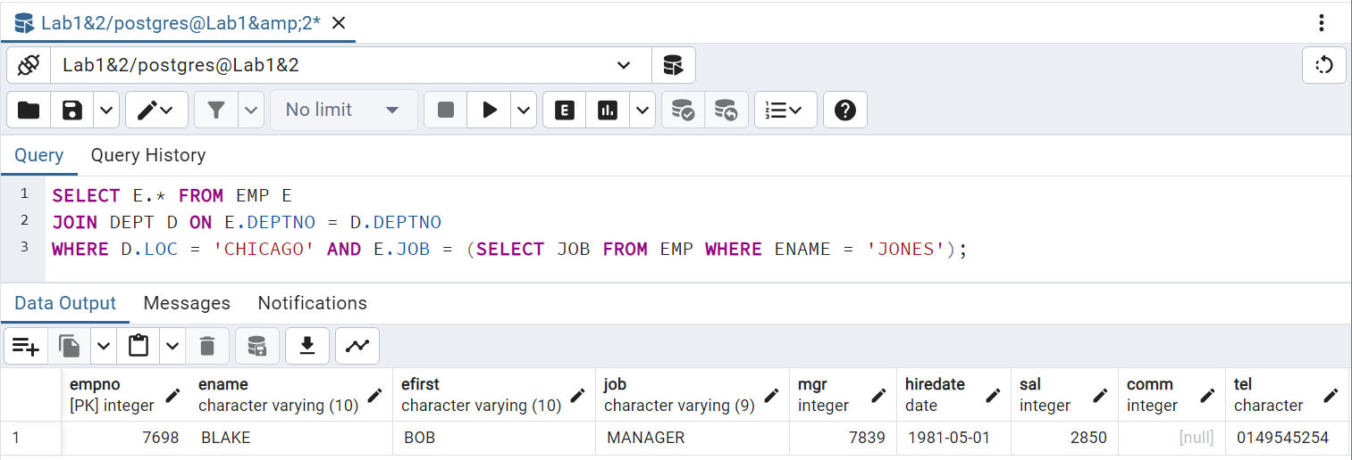

### **List employees who don't work in the same department than their manager**

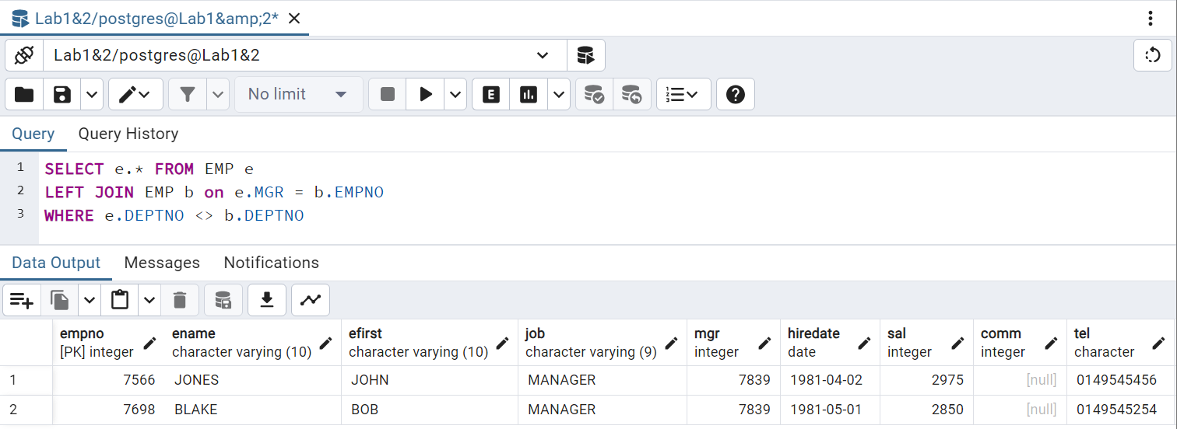

### **List employees working in a department having at least one CLERK**

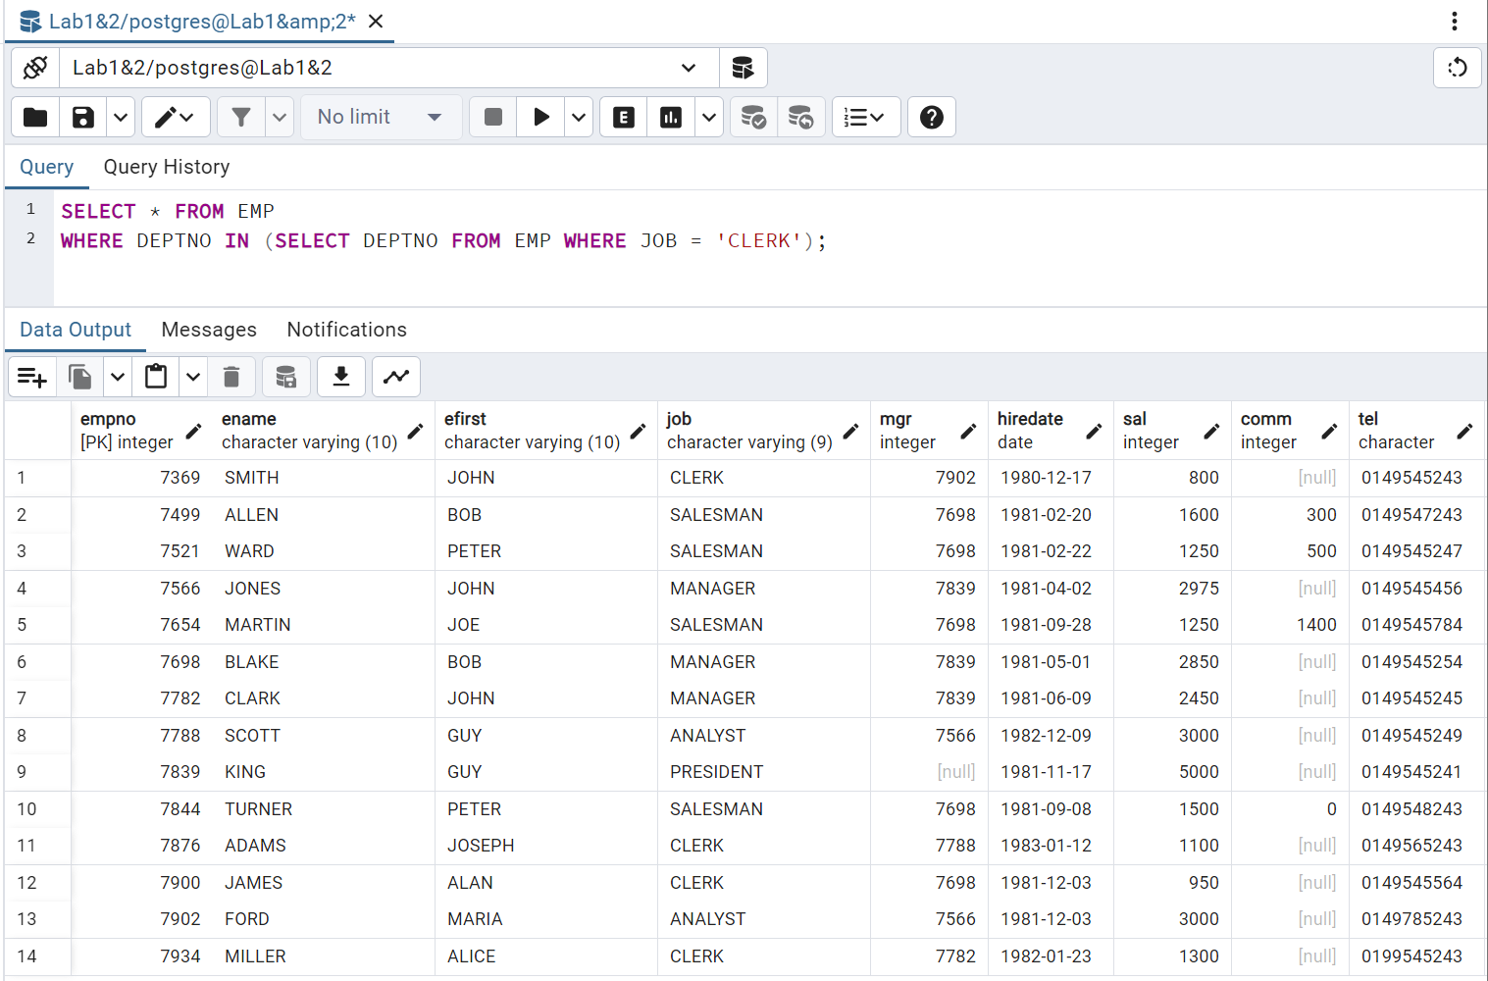

### **List employees of department 10 having the same job than someone from the depart SALES**

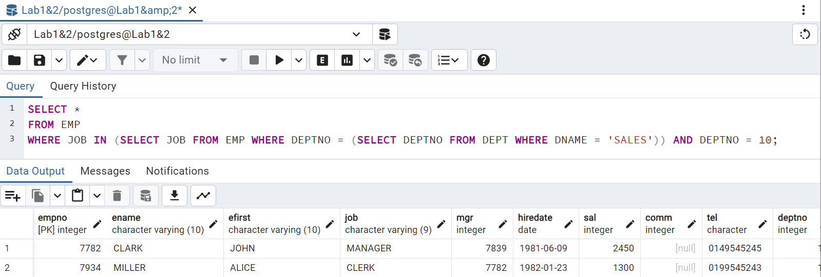

### **List employees having the same job than JONES or a salary greater than FORD's salary**

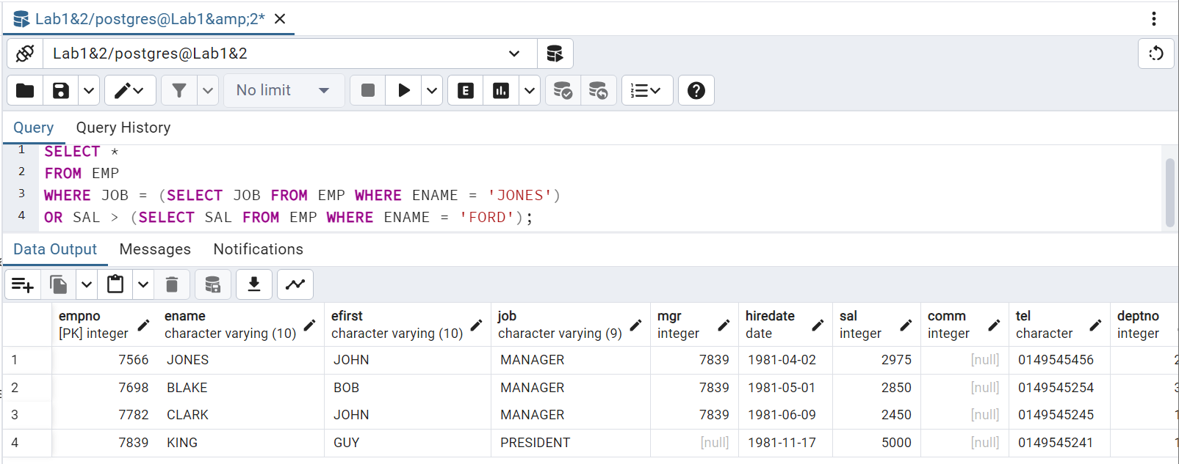

### **List employees having a salary greater than all employees of department 20**

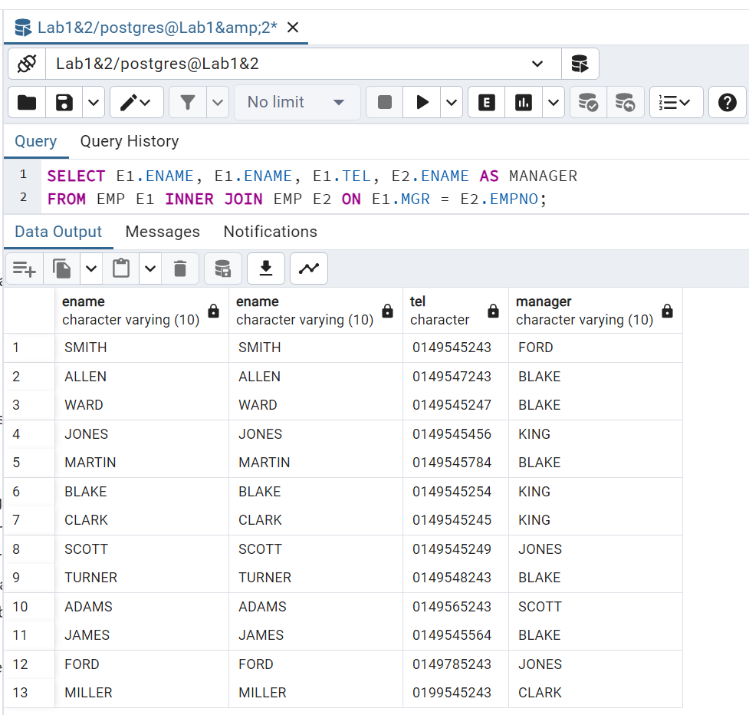

## **Exercice 3: Join Table**

### **Create a Table for employee’s Projects:**

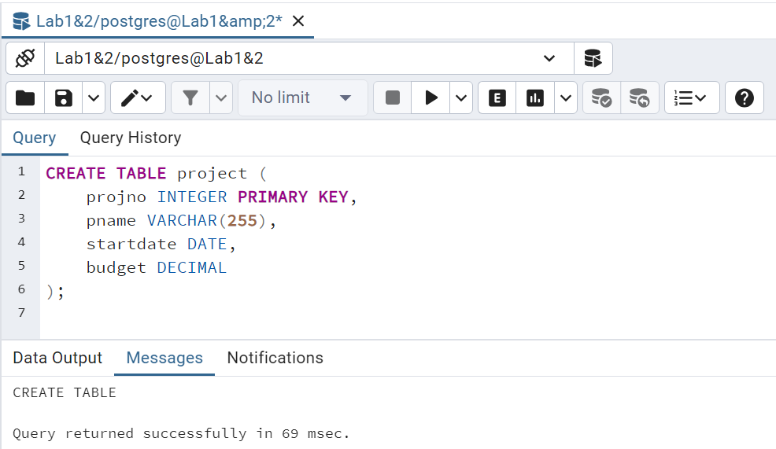

### **Create the Join Table:**

**Create table project_emp:**

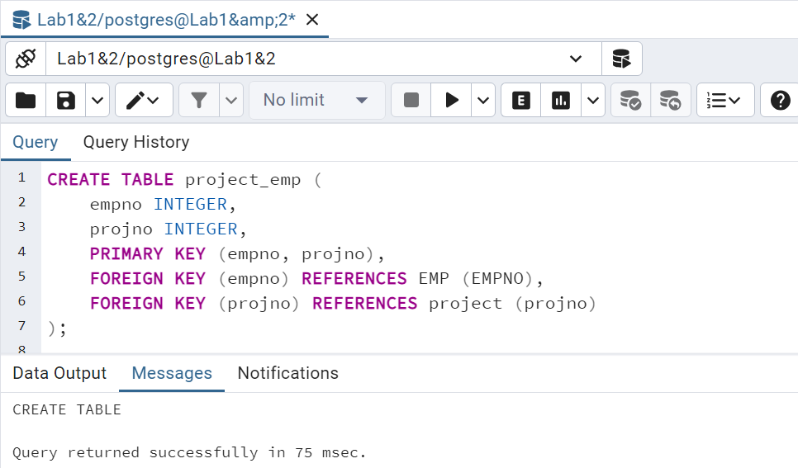

**Insert project data into the project table:**

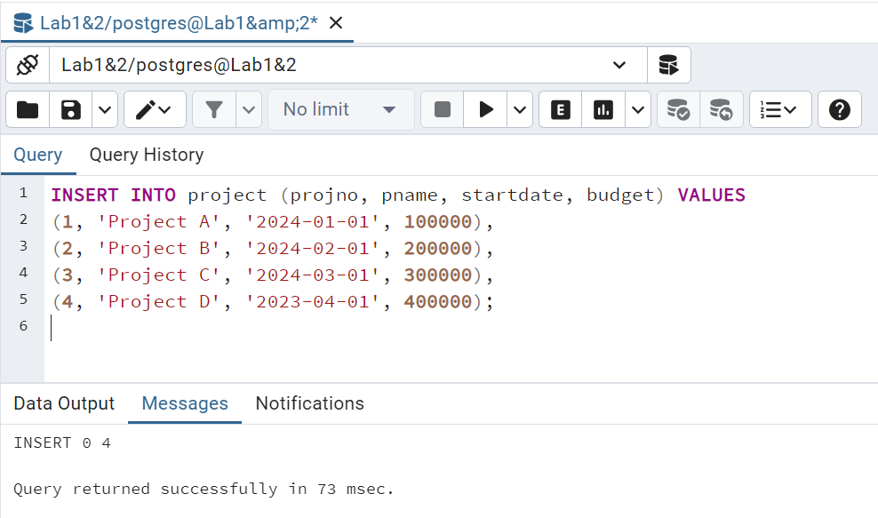

**Insert project data into the project_emp table:**

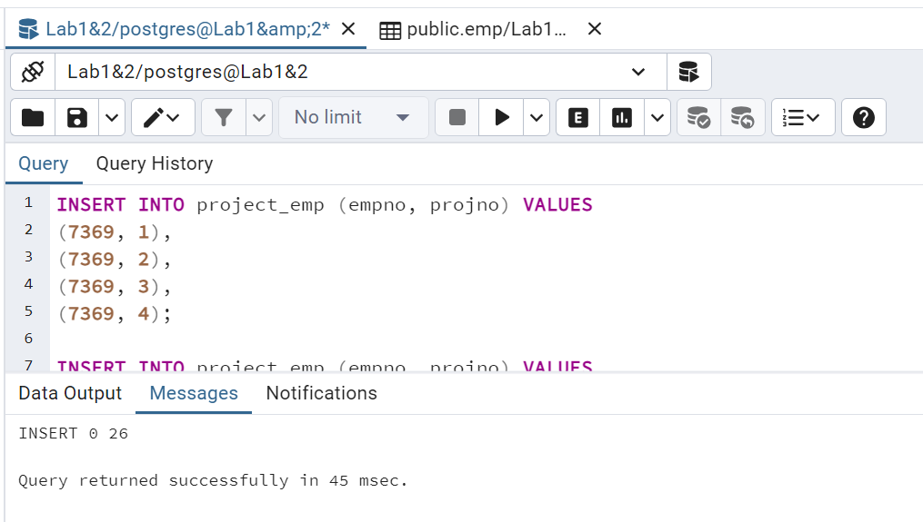

### **List all employees (by empno) who work on all projects?**

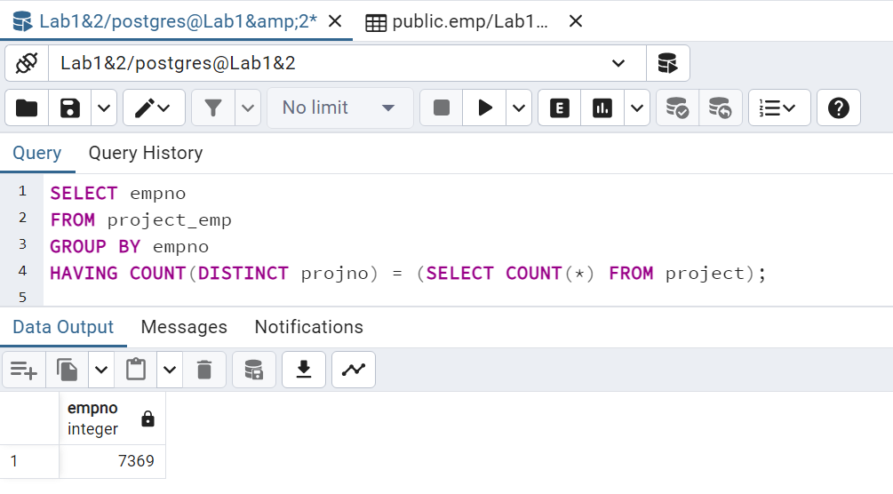

### **Options on View creation:**

**“CREATE VIEW” statement creates a view named sales_staff, Select the data from the three fields empno, ename and deptno from the emp table, which only contains information about employees with department number 10.**

**“WITH CHECK OPTION” ensures that all data modifications through the view (including insert and update operations) will comply with the “WHERE “condition in the view definition: all insert or update operations through the sales_staff view must ensure that deptno remains 10.**

### **View Creation:**

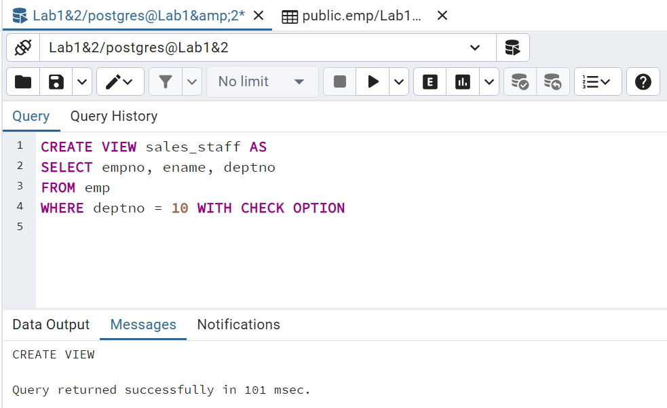

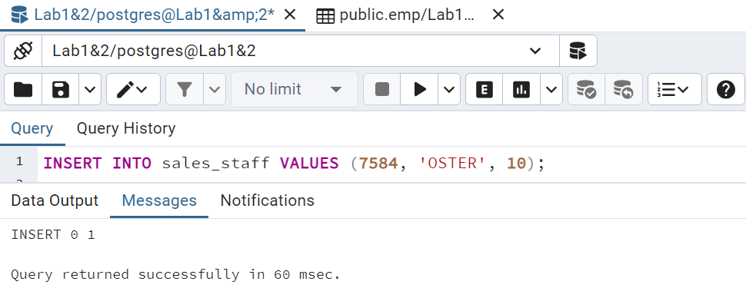

**Insert a new record with deptno 10 into the sales_staff view. Insert operations are allowed.**

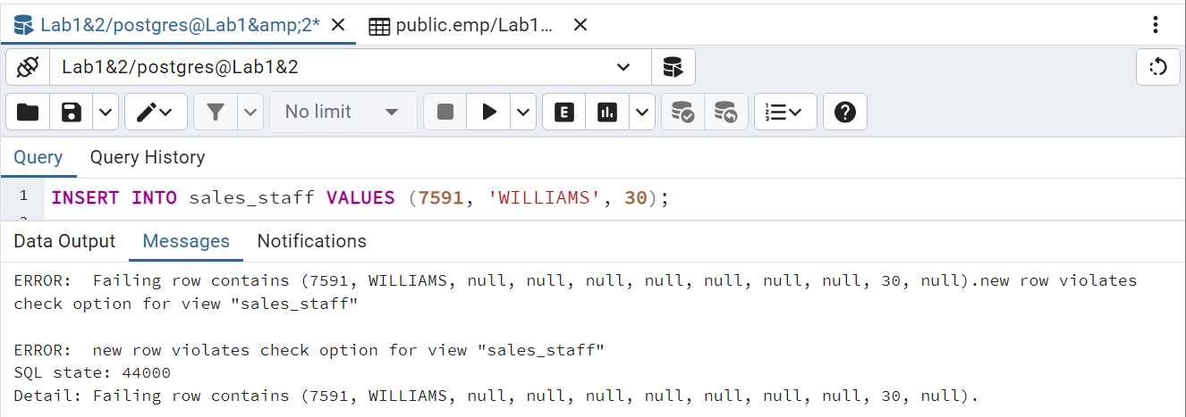

**Insert a record with deptno 30 into the sales_staff view. This violates “deptno=10” as well as “WITH CHECK OPTION” . Therefore, this insert operation is rejected.**

### **Division Query:**

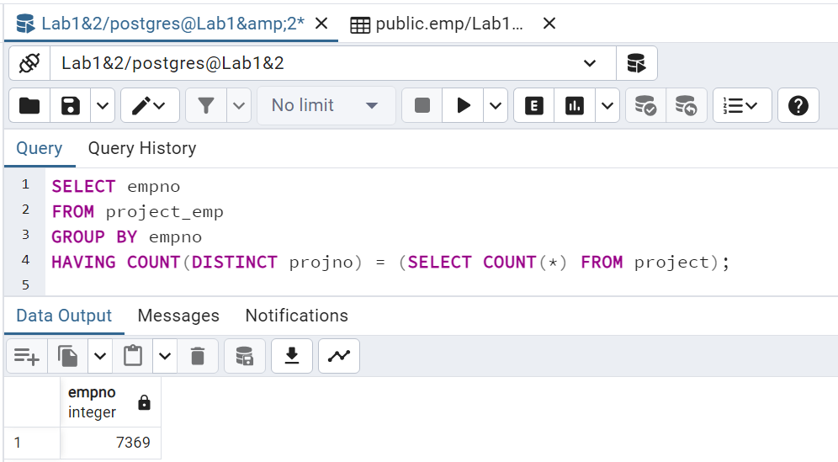

### **Analyze:**

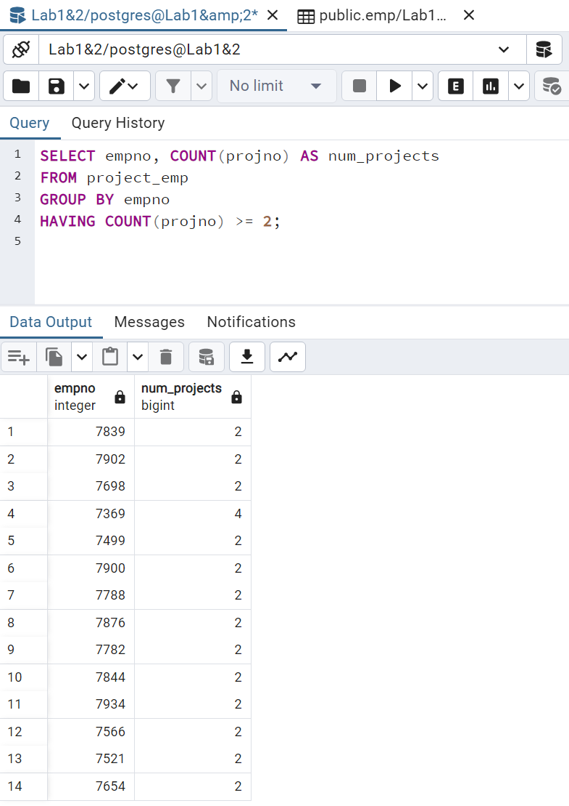

# **Lab 2-Advanced SQL**

## **Exercice 1: Analytics Queries . Window Queries**

### **Gets the 2 persons per department, who have arrived the latest in the company.**

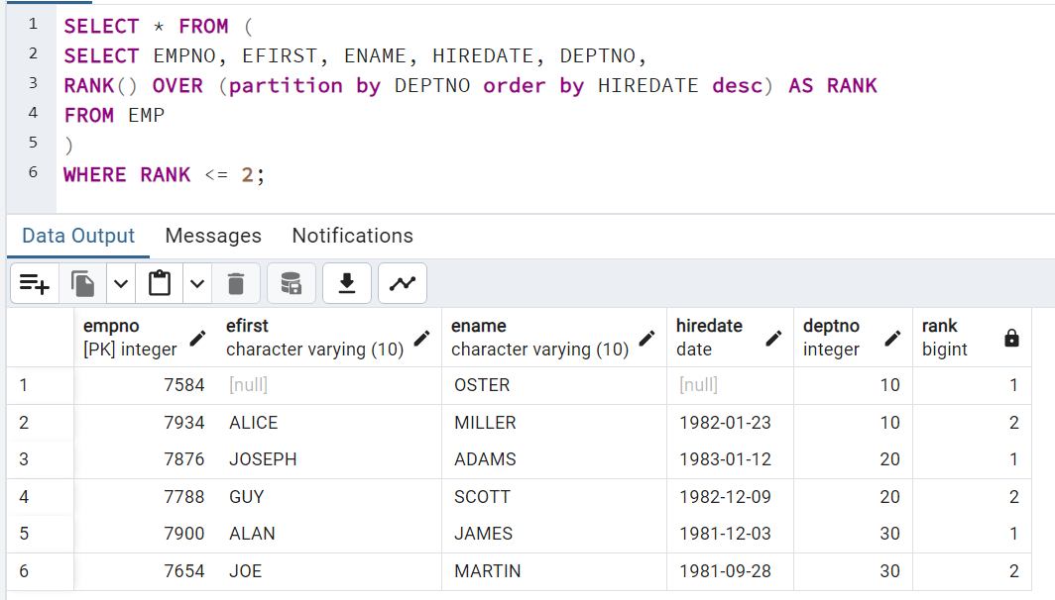

### **Show your analytical Skill and Invents an interesting query using Windows Functions.**

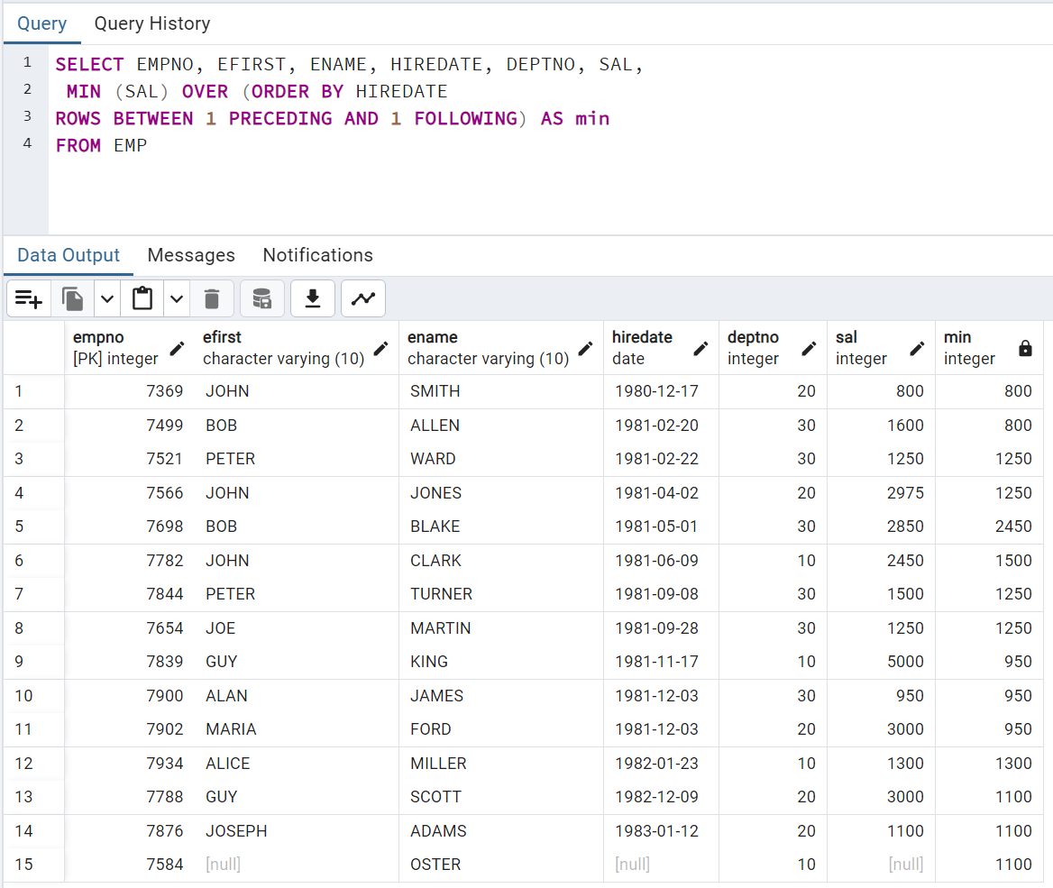

## **Exercice 2: Index & Explain Plan**

### **Execute this script.**

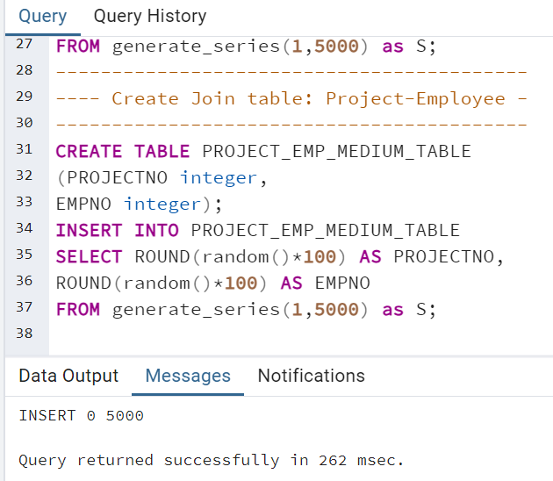

### **The goal of all exercice will be to tune the following query:**

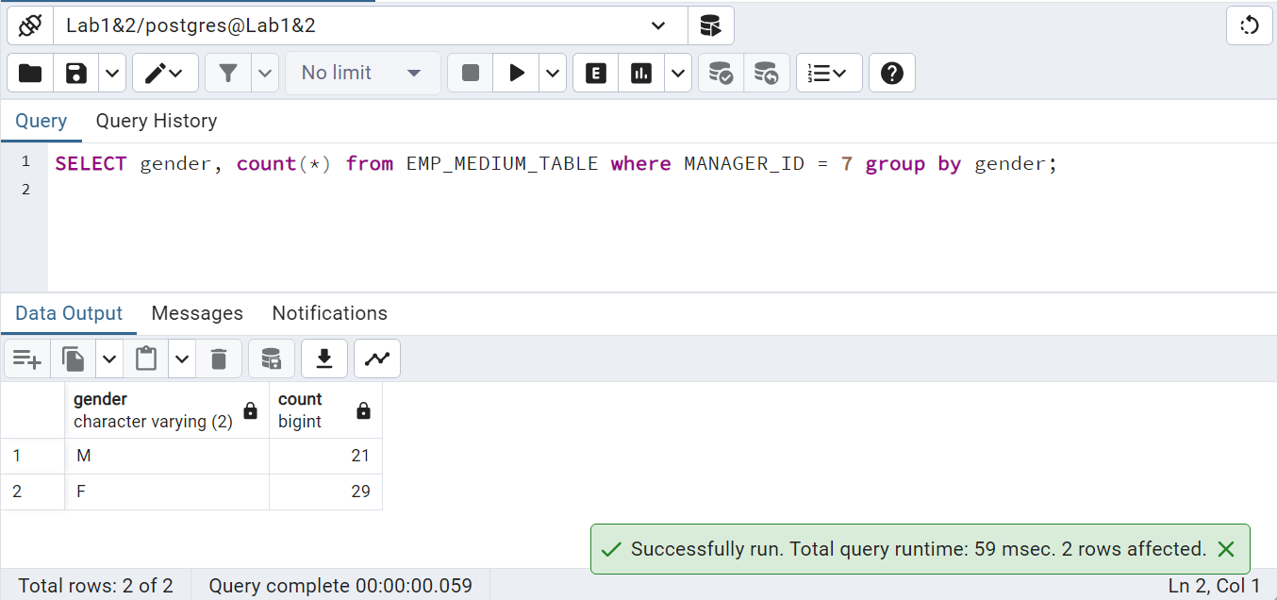

### **1 Use EXPLAIN plan to analyze the query**

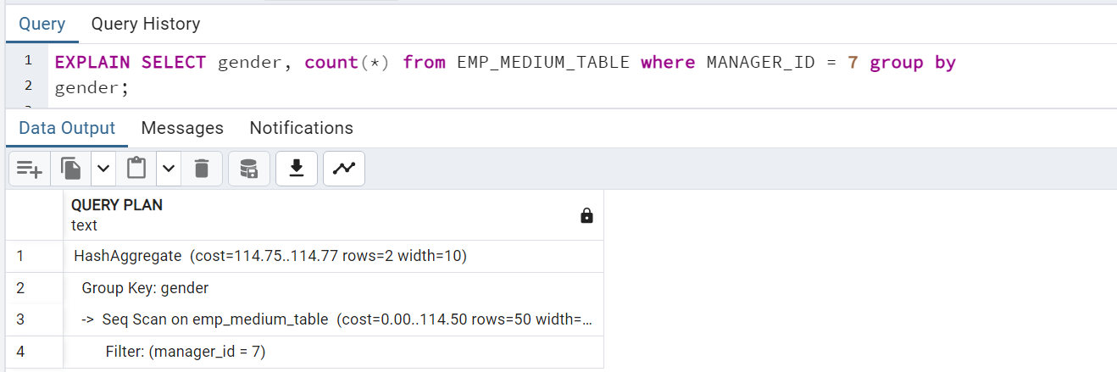

### **2 Activate stats.**

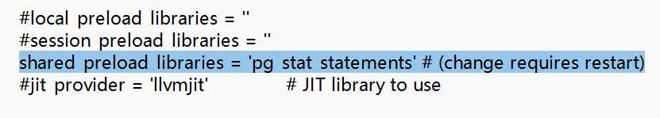

**Run:**

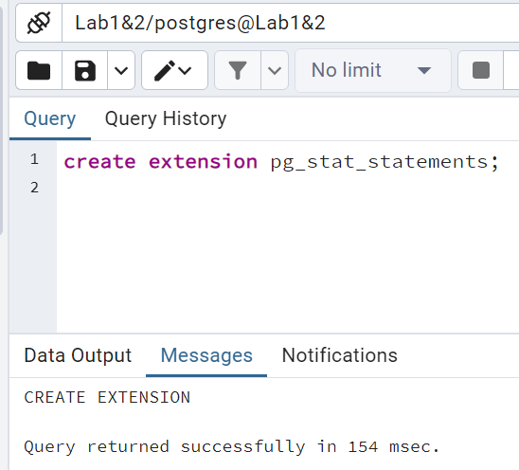

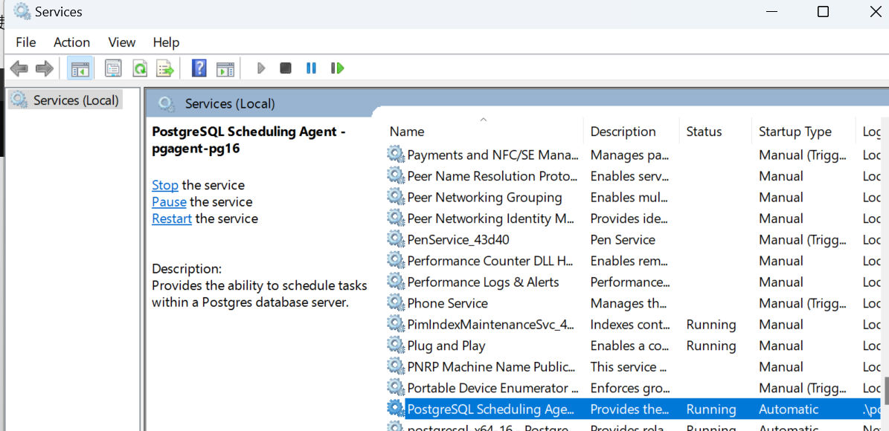

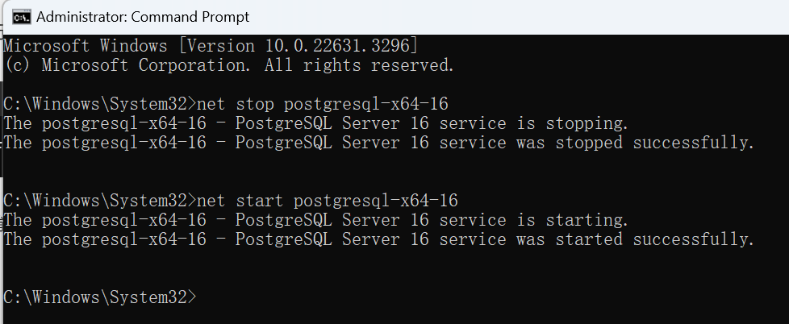

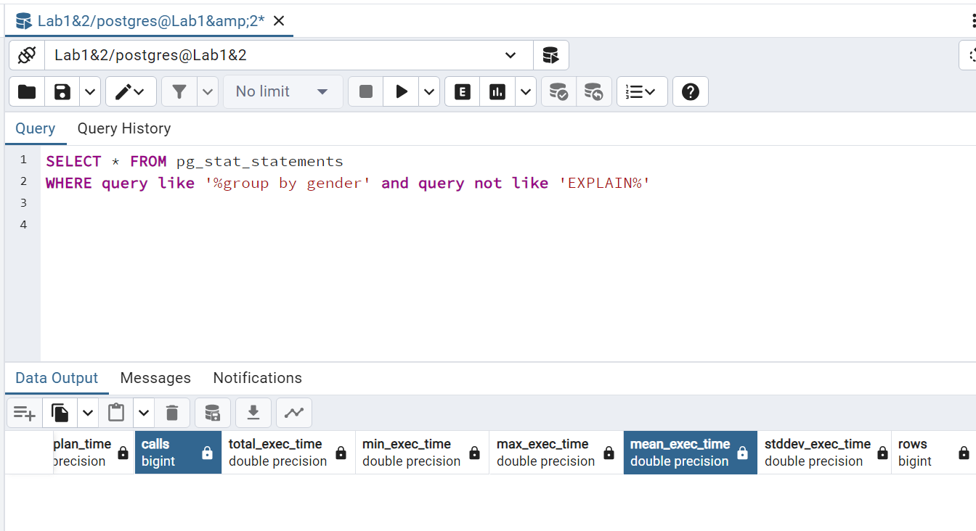

**Re-run 10 times:**

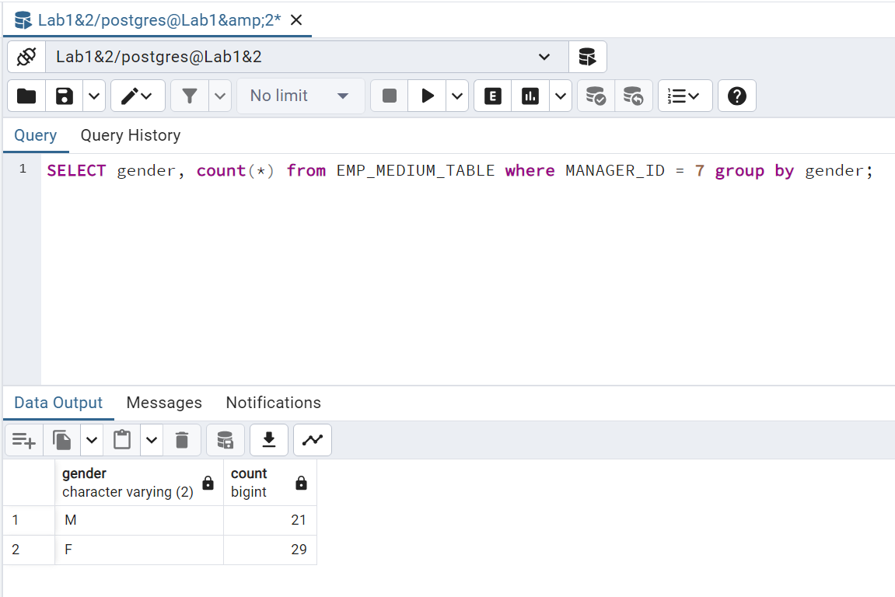

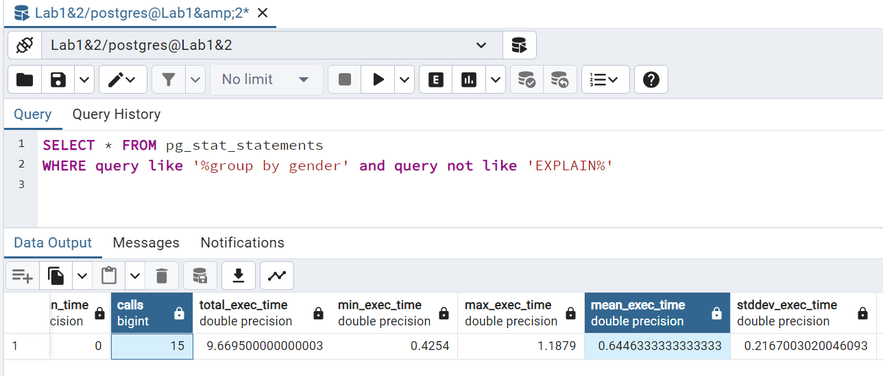

1. **Add a covering index on both columns fetched:**

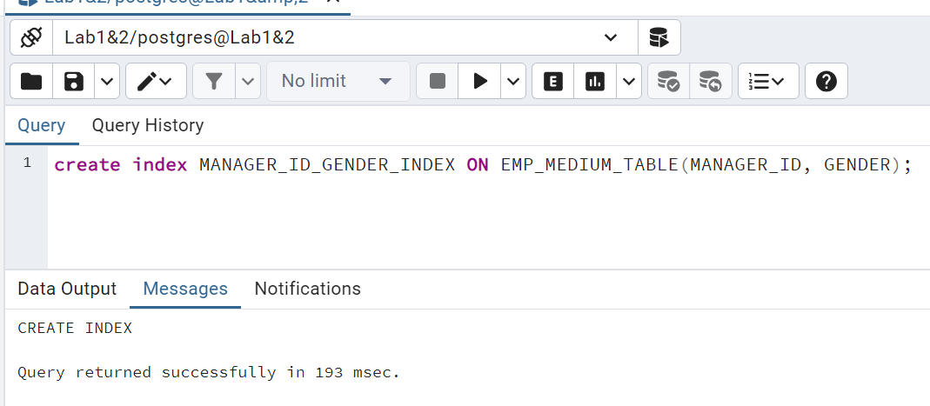

1. **Reset the stats:**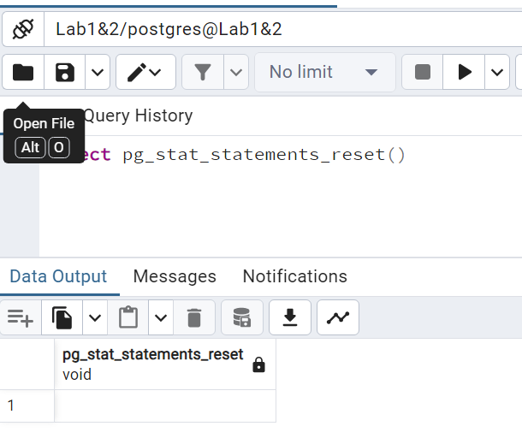

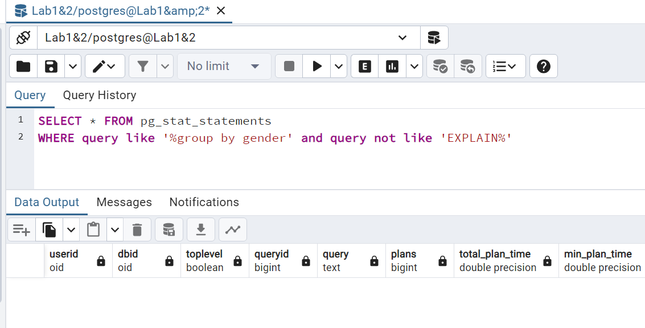

1. **Re-run query the same query 15 times:**



1. **Use the EXPLAIN plan again and compare the plan before the INDEX**

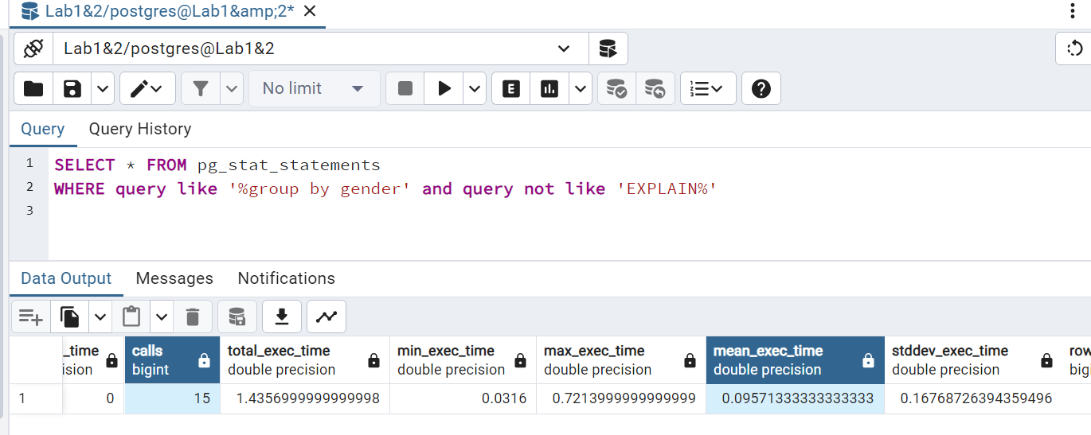

**For the query performance recorded in the “pg_stat_statements” view before and after the creation of the index “MANAGER_ID_GENDER_INDEX”:**

1. **the “Calls” remained at 15 times.**
2. **the “Mean Exec Time” dropped significantly.**
3. **the value shows that after the creation of the index, the average execution of the query time is reduced, which is direct evidence that indexes optimize query performance.**
4. **By creating indexes on the MANAGER_ID and GENDER columns, PostgreSQL can locate these specific rows with MANAGER_ID 7 more quickly and group and count more efficiently because the indexes provide This reduces the number of data pages that must be read and the amount of work that queries must perform.**

## **Exercice 3: Data Dictionary**

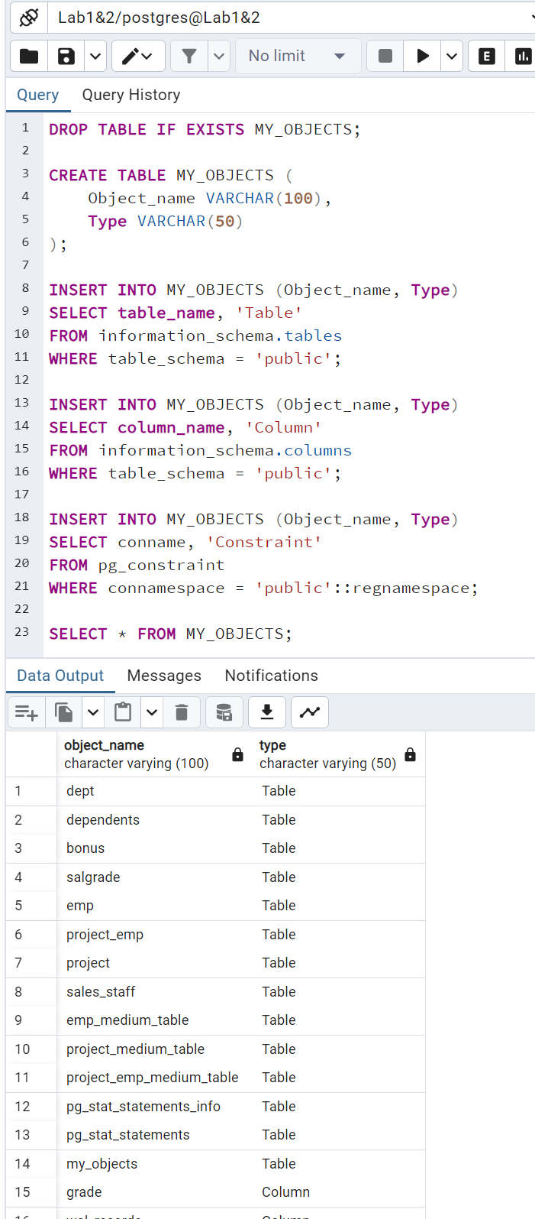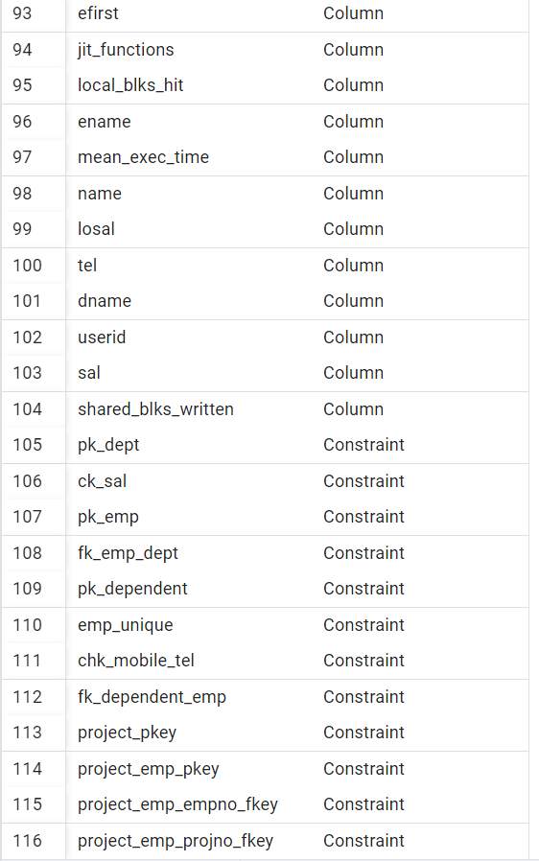

## **Exercice 4: Use postgres via CLI**

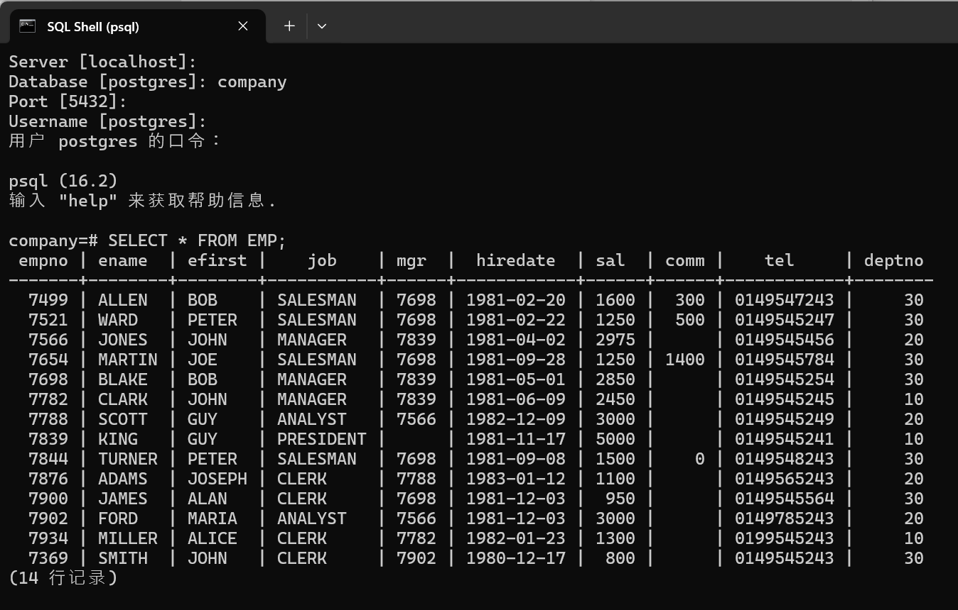

## **Exercice 5: Transaction Part 1 – Beginner**

**1.& 2. & 3.**

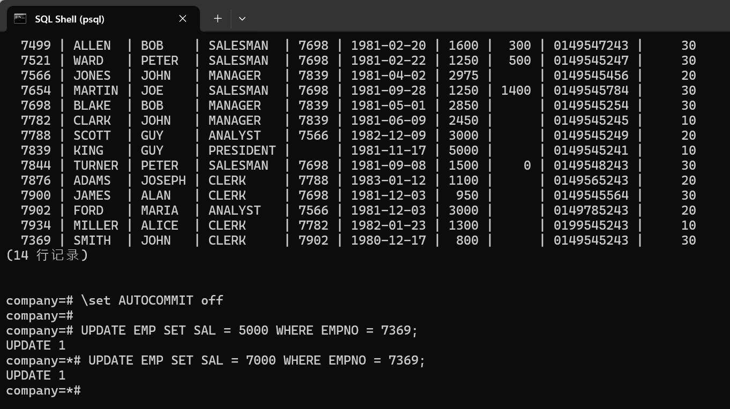

**This update will not take effect immediately to the database because the transaction has not yet been committed.**

**4.-5.**

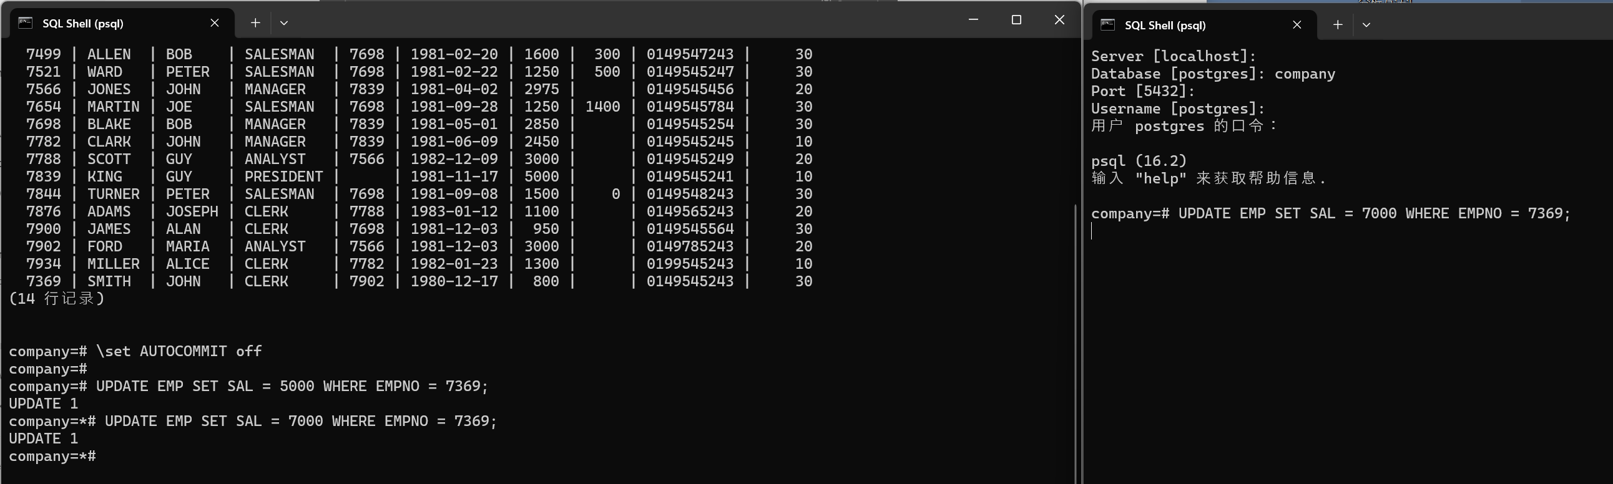

**Since the first client's transaction has not yet committed, this command may hang waiting because the first client's transaction has a lock on the record. To make the update**

**available for the second client, the first client should COMMIT.**

**6.-7.**

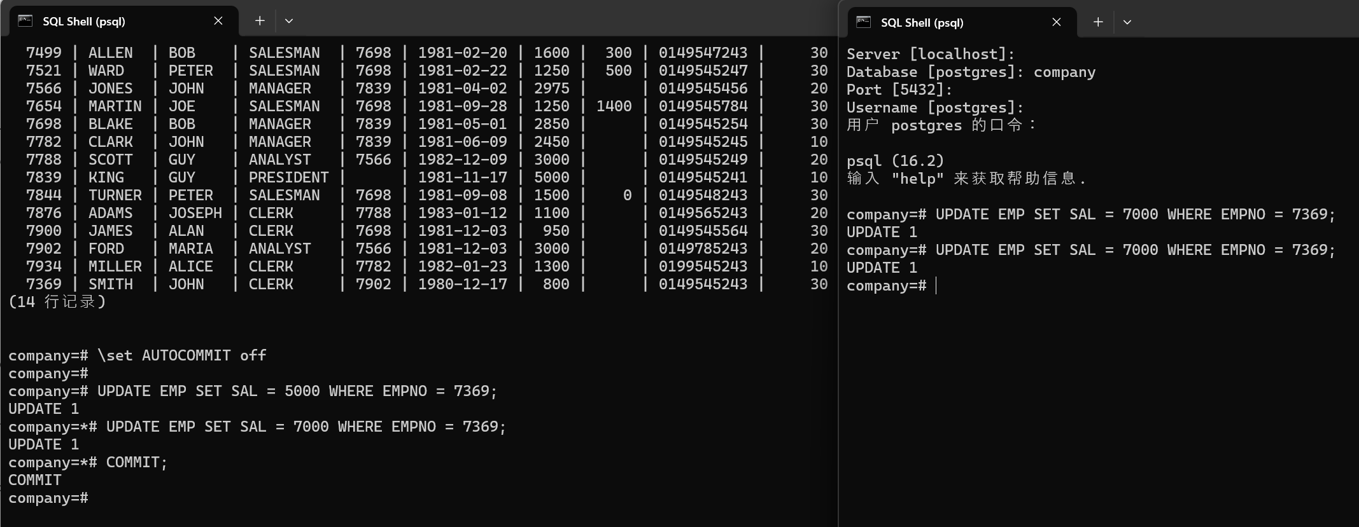

**The first client's transaction has been committed, and the second client's update operation has been successfully executed.**

# **Lab 2-Part 2 PL/SQL**

## **Exercice 1: Functions**

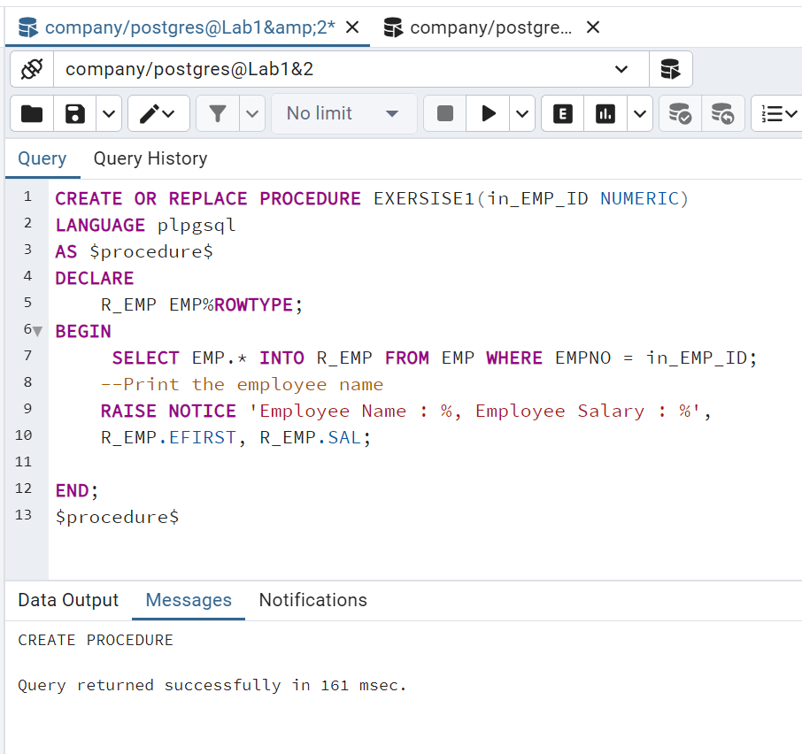

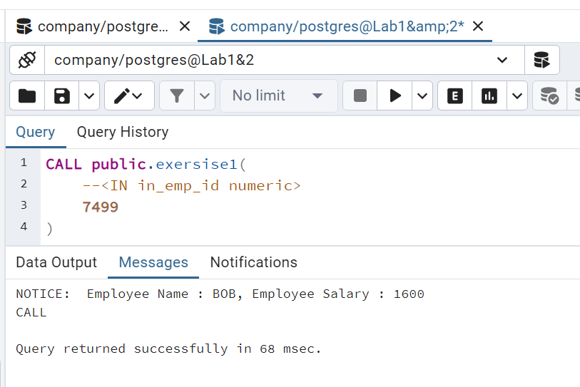

## **Exercice 2: Procedure & Display & Cursors**

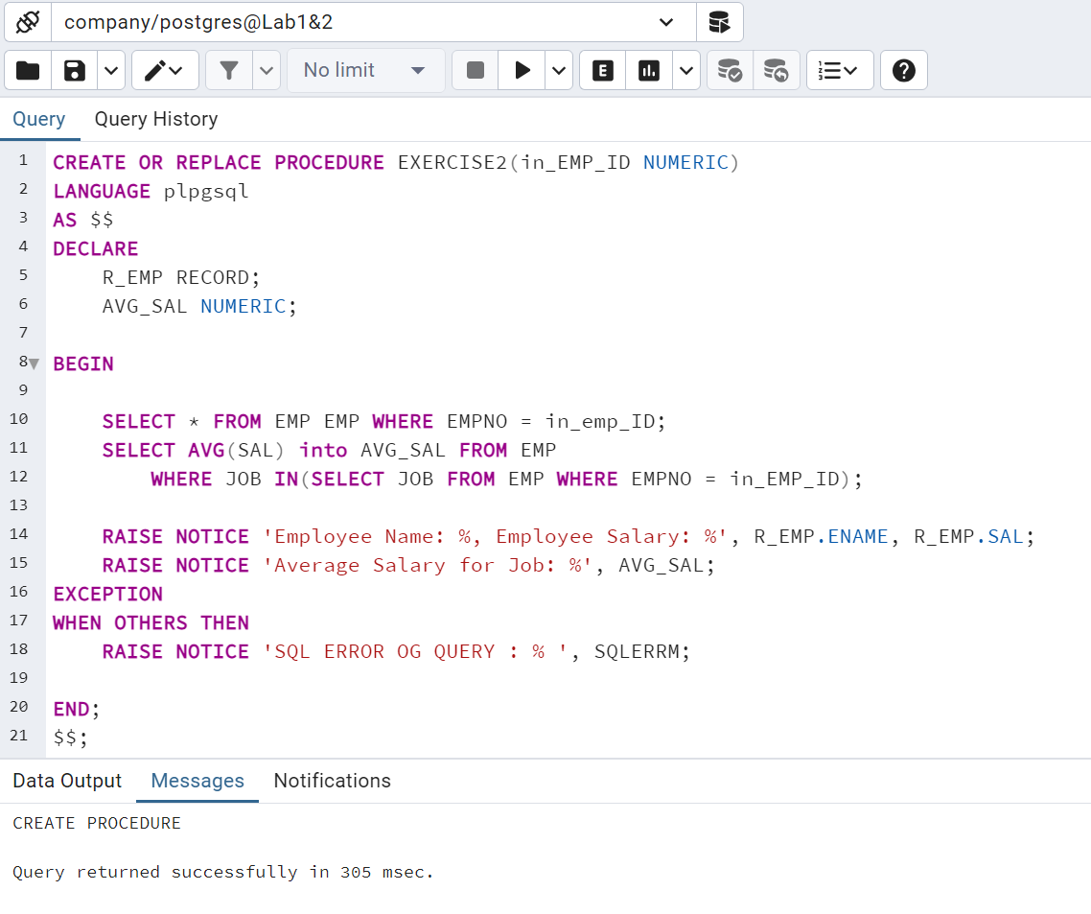

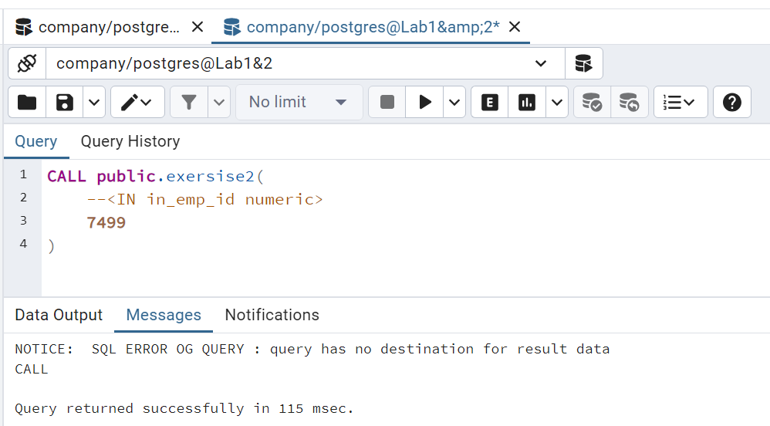

## **Exercice 3. Procedure & Update**

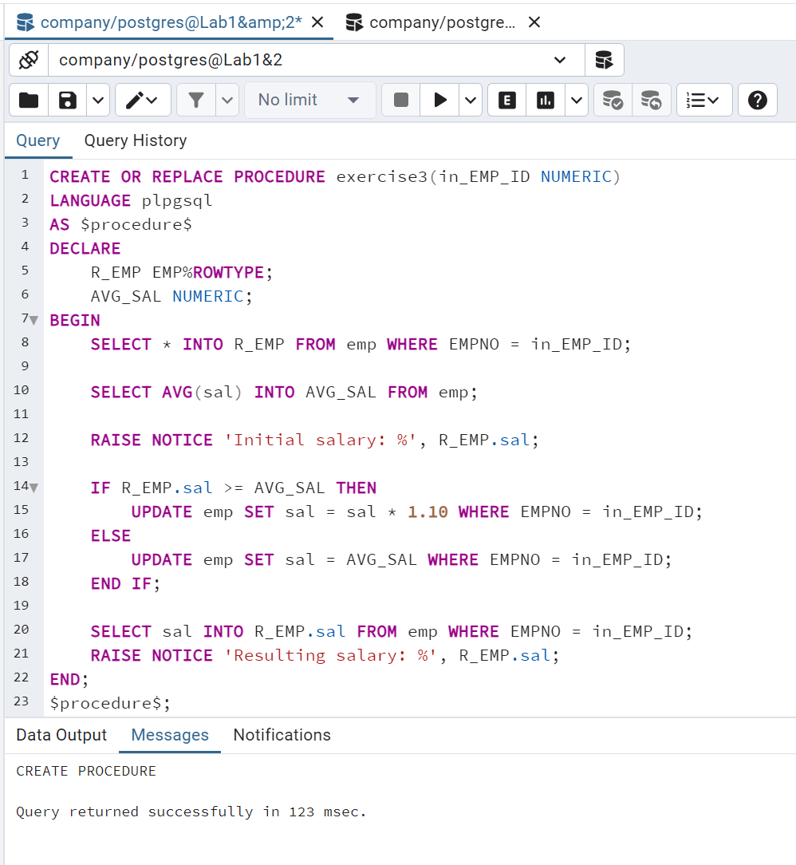

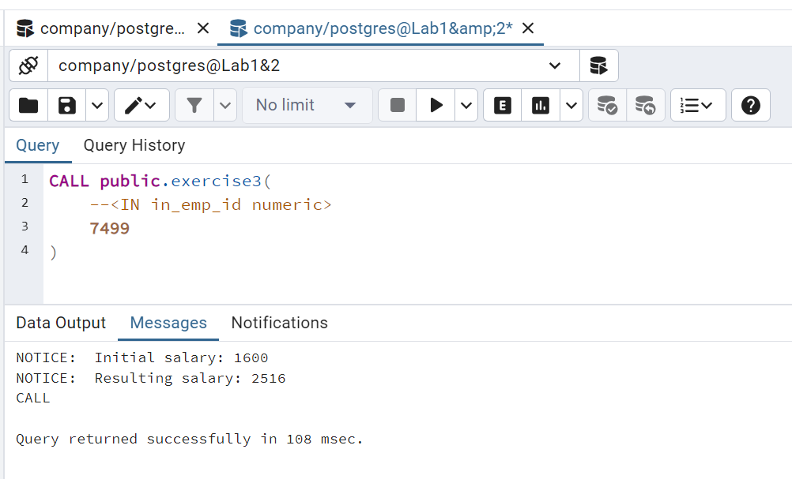

## **Exercice 4. Procedure**

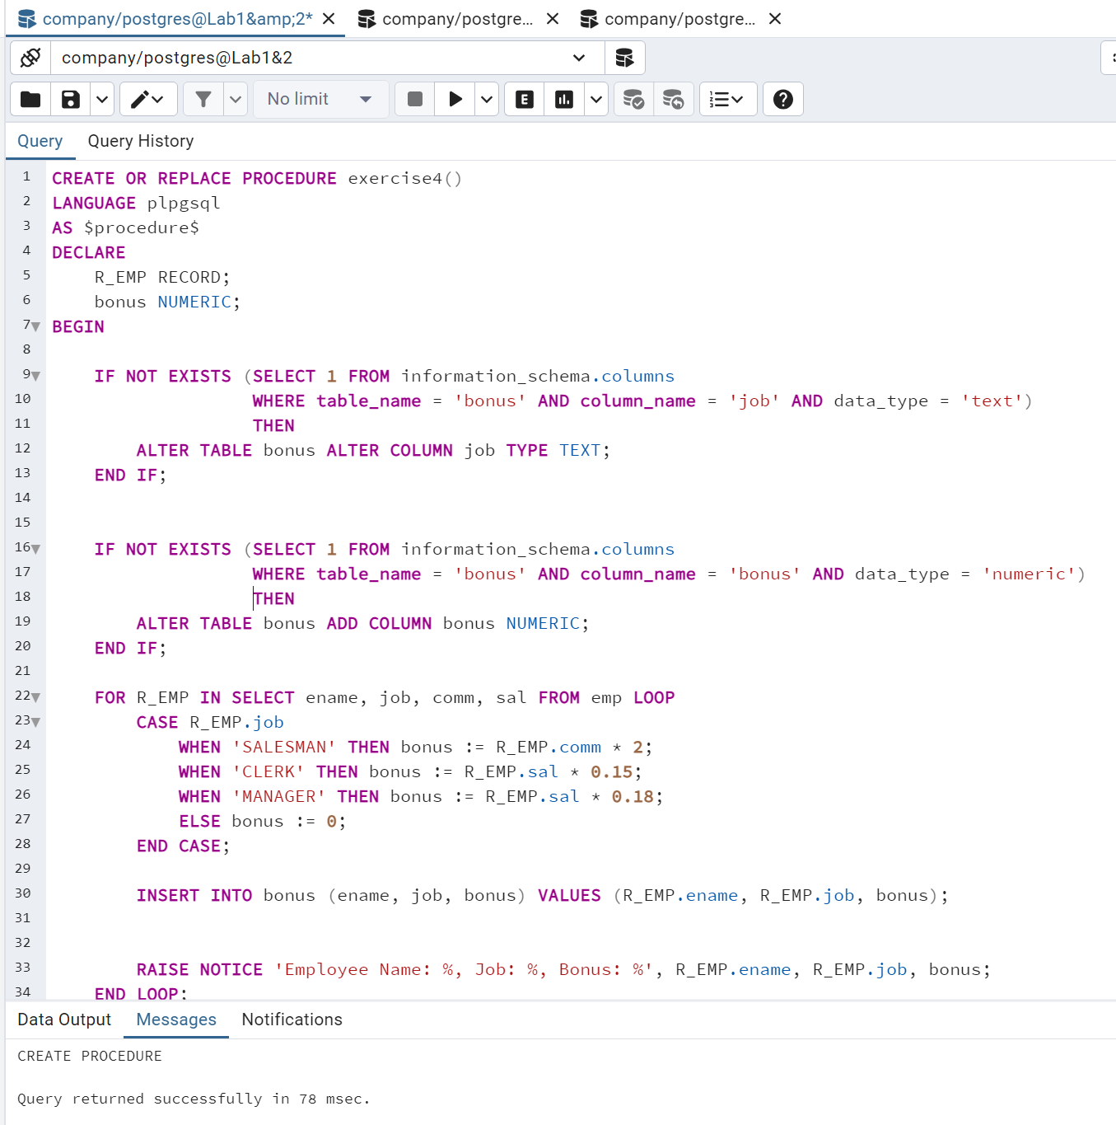

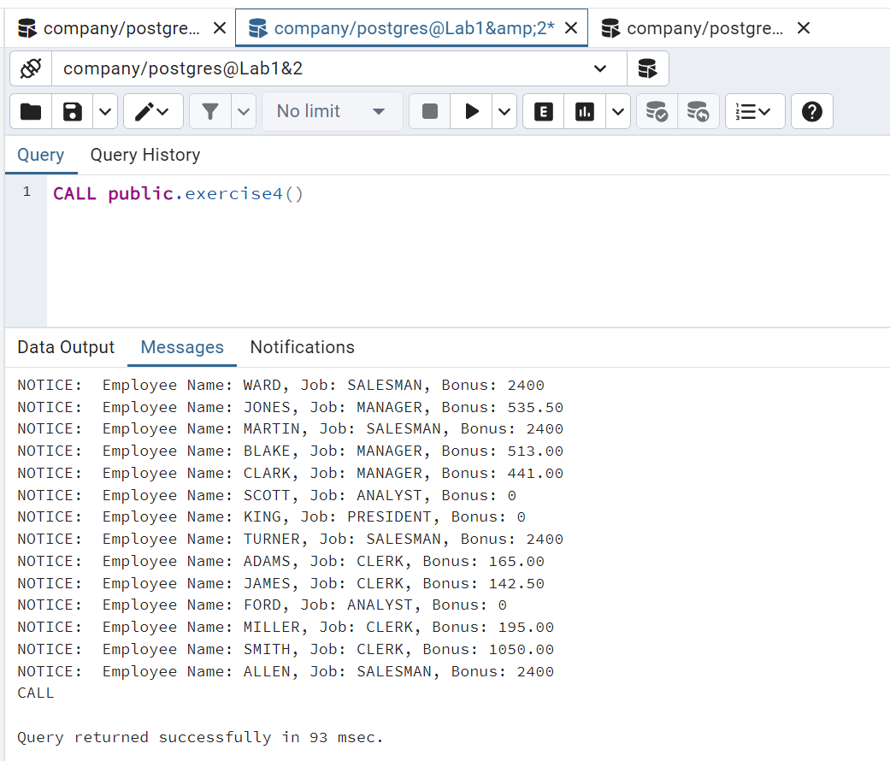

## **Exercice 5. SELECT for UPDATE**

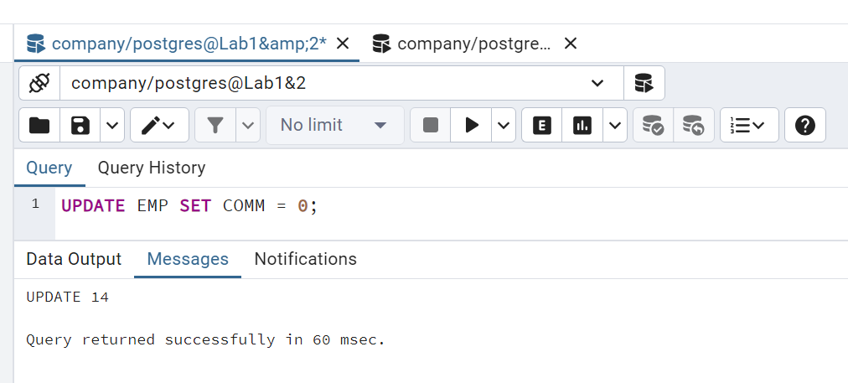

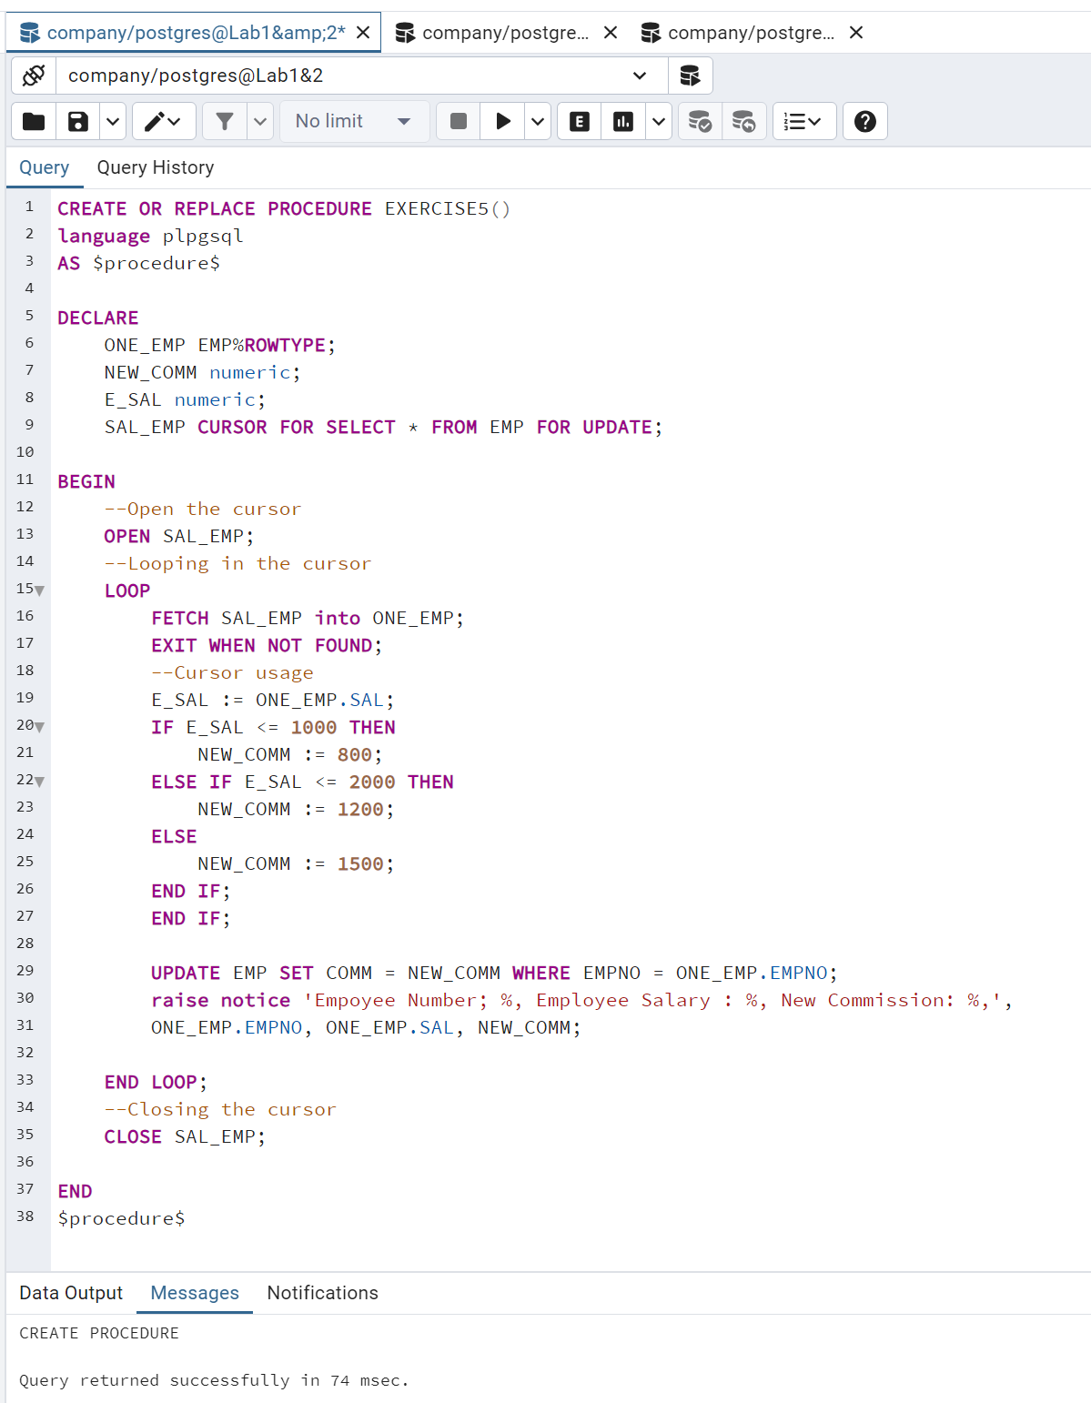

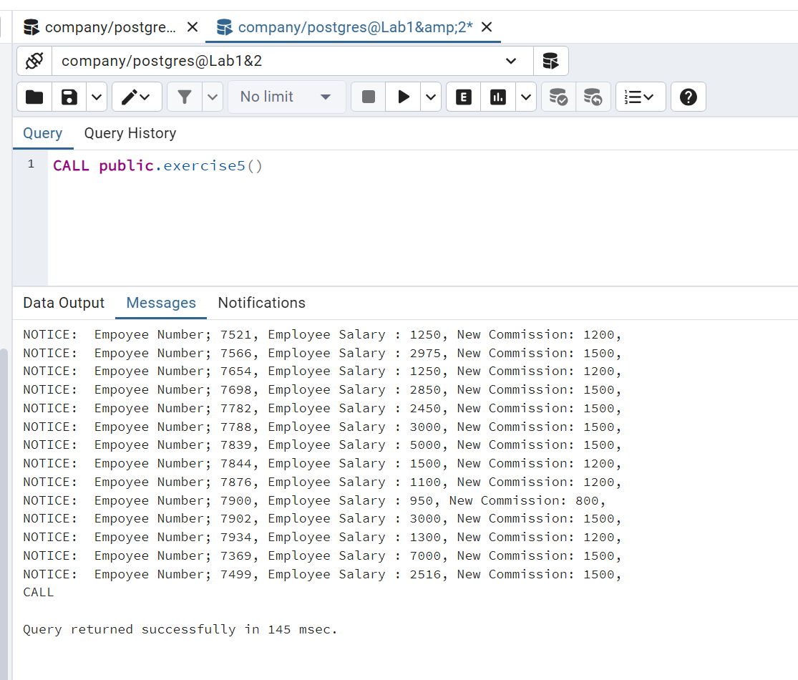

## **Exercice 6. Condition on EXIT loop**

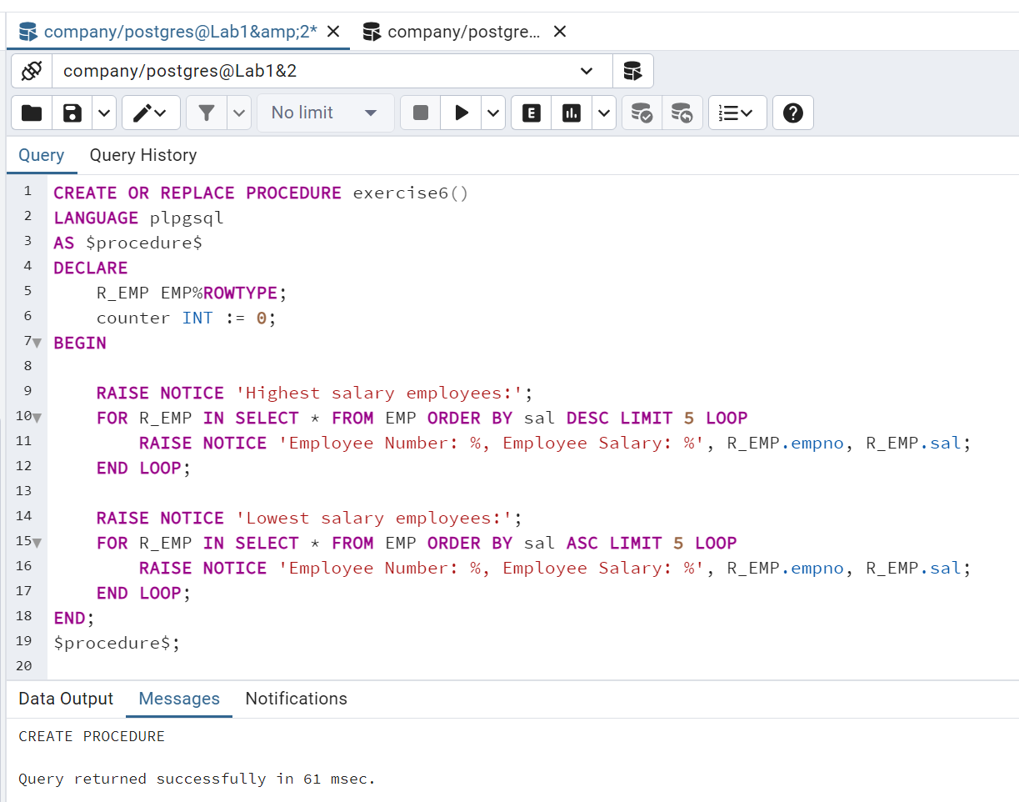

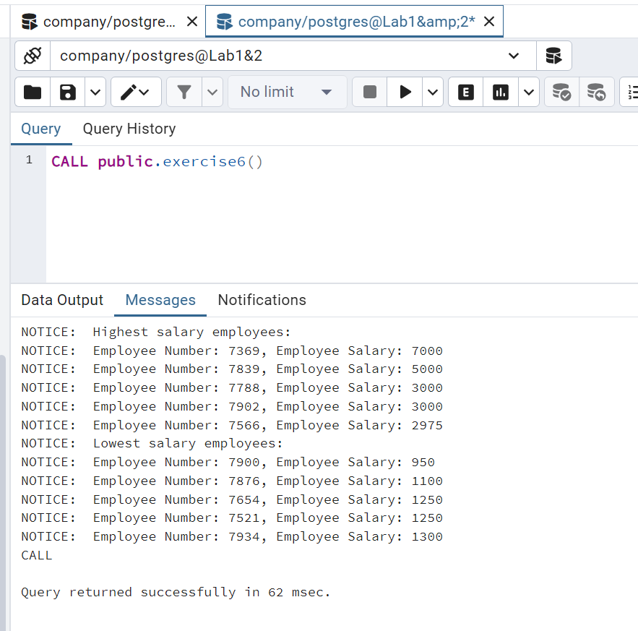

## **Exercice 7. Triggers**

## **1. Create the triggers & 2. Function to analyze results**

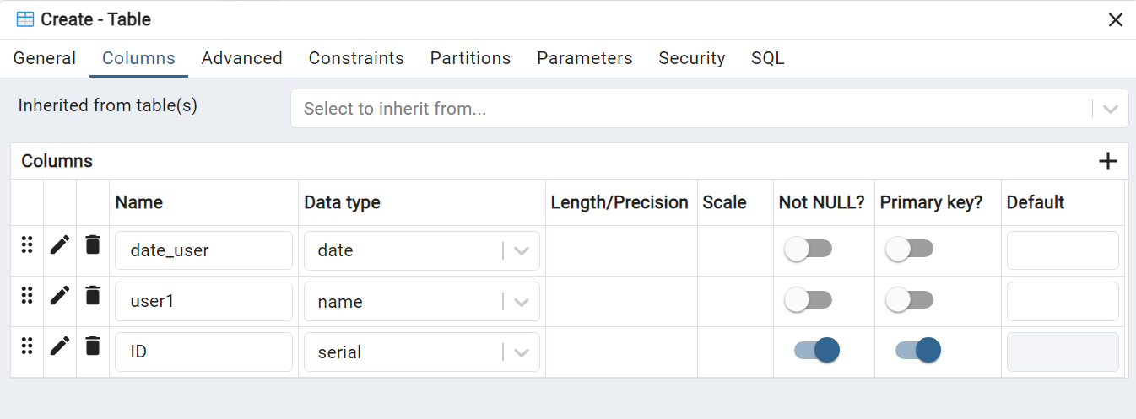

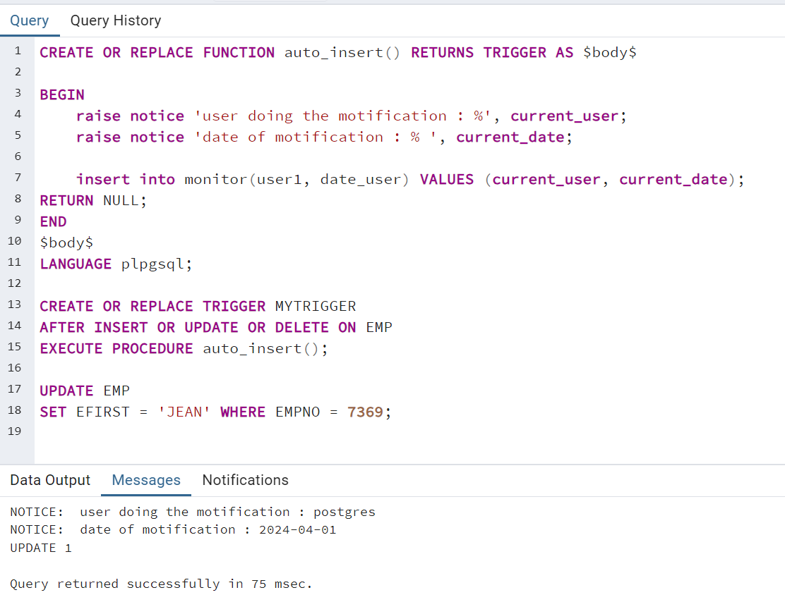

# **Lab 3**

## **Part I: A Graphic of Table: communication with database**

## Load Driver - 2. Connect to bdd - 3. Make a request.

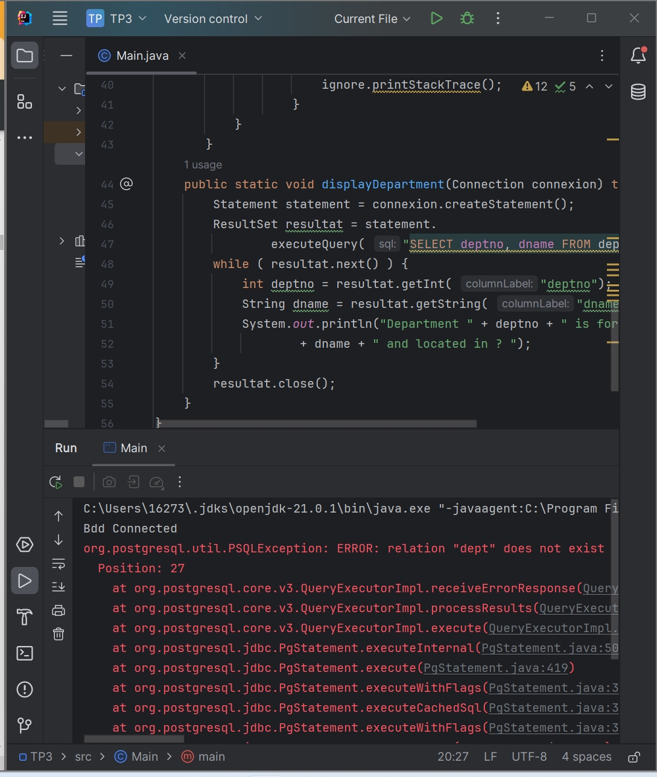

* **In order to solve: Create new Database -> "company".**

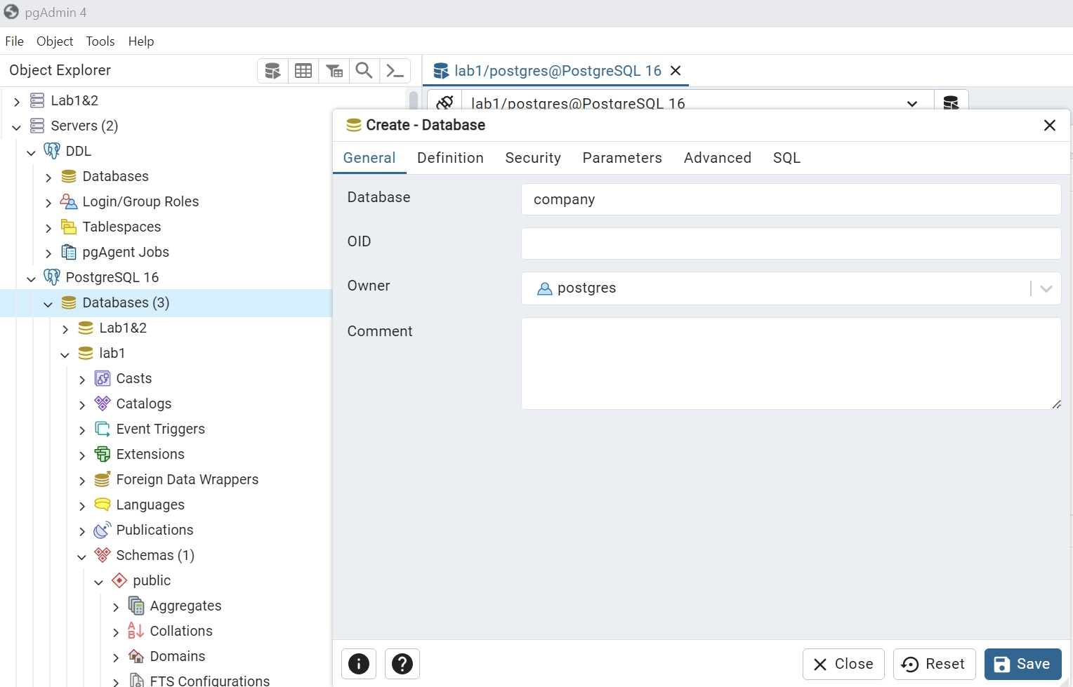

* **Close”NULL”**

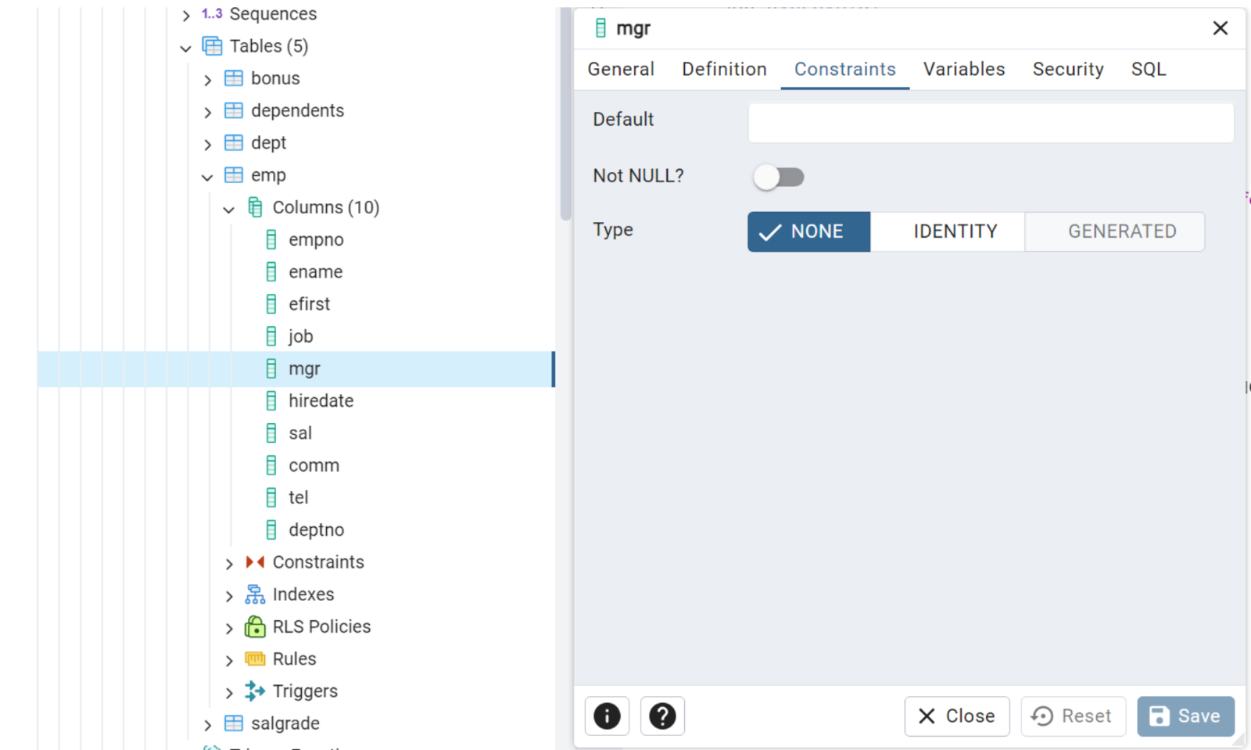

* **Add table**

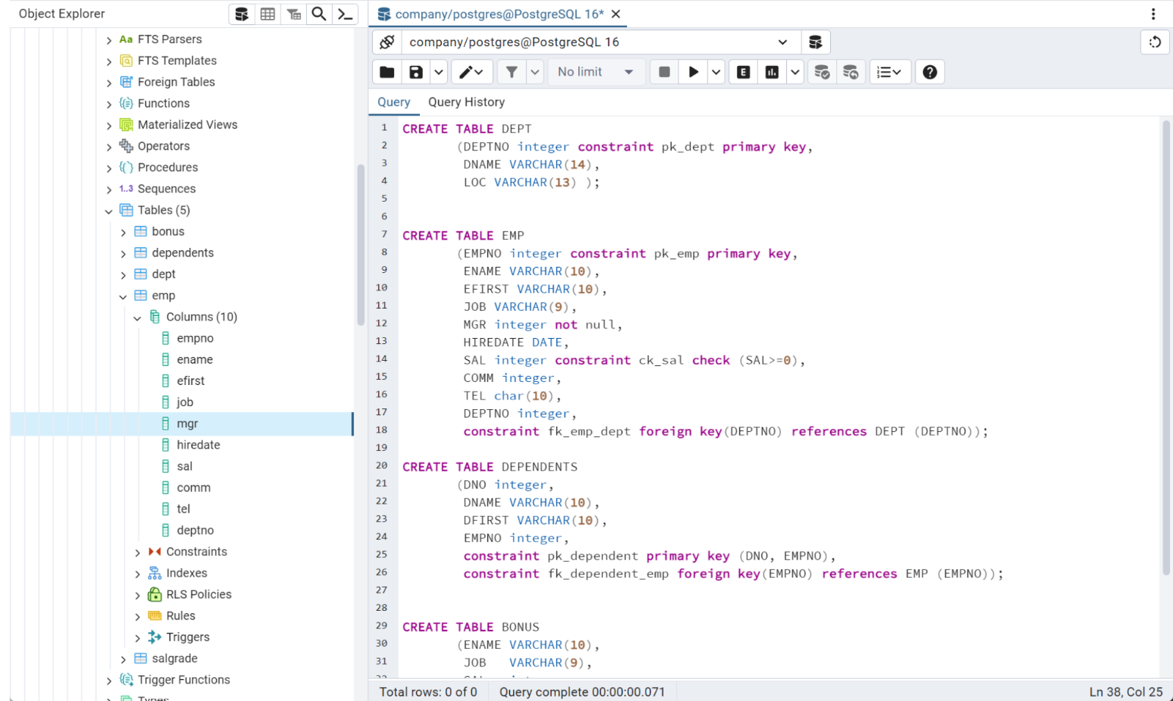

* **Add Info**

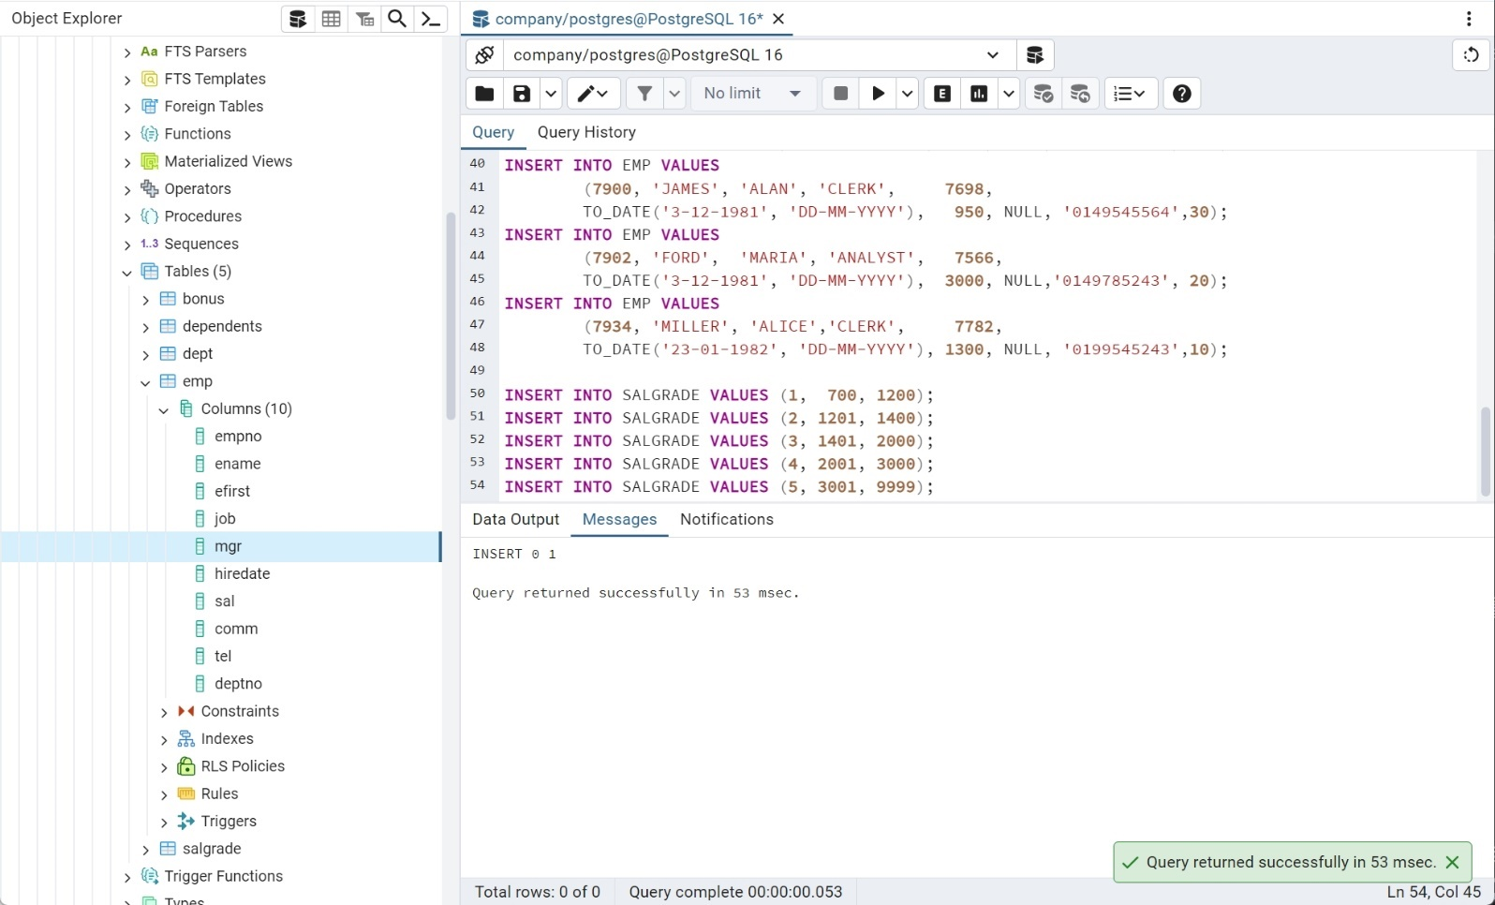

* **Modifier the JAVA code to link to “company”**

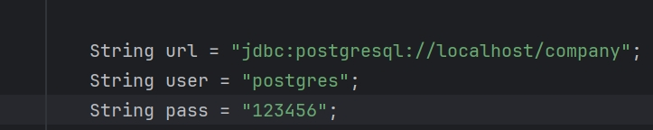

* **Re-run the code**

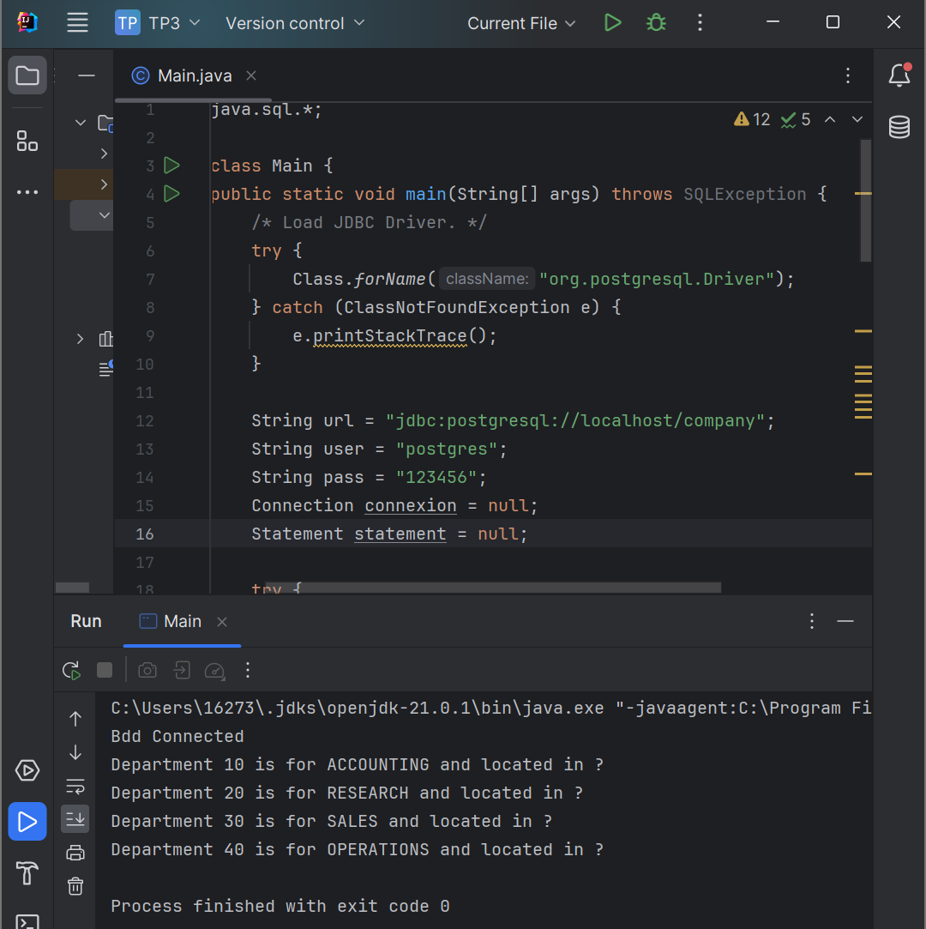

### Exercise 1: Modify the query above to add the location of the department.

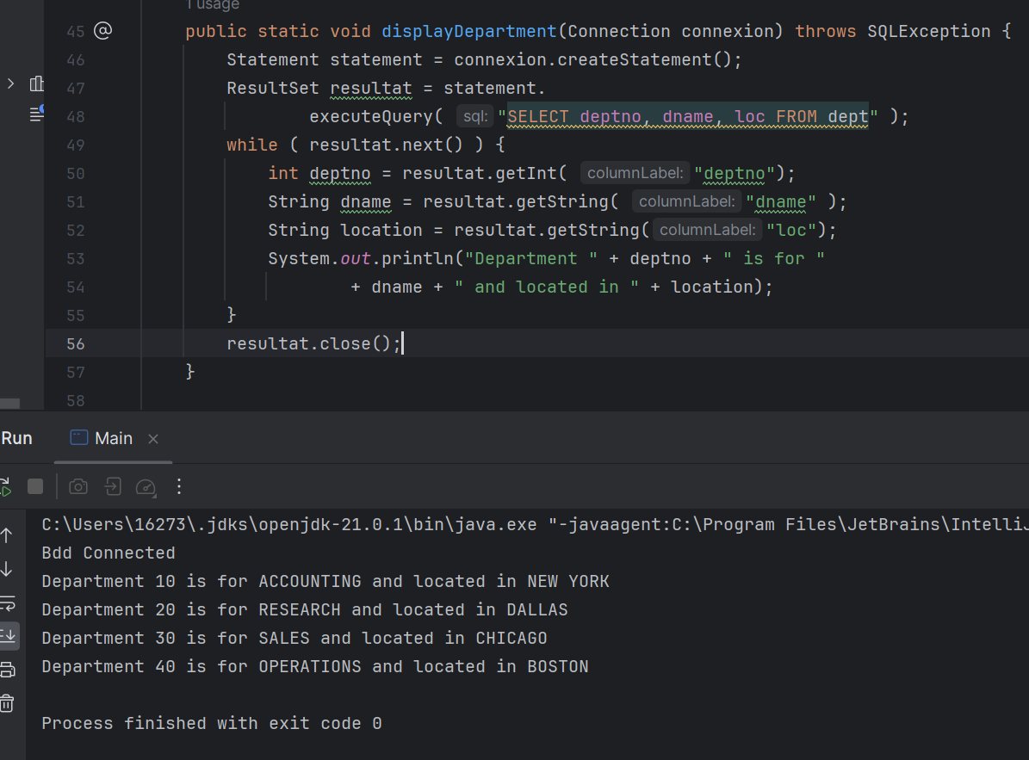

### Exercice 2: Move Department.

* **Add the move-function**

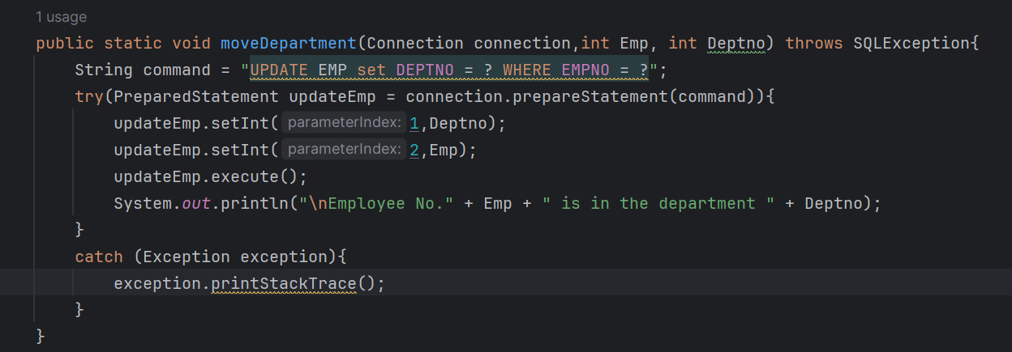

* **Call the function in the Main and run it**

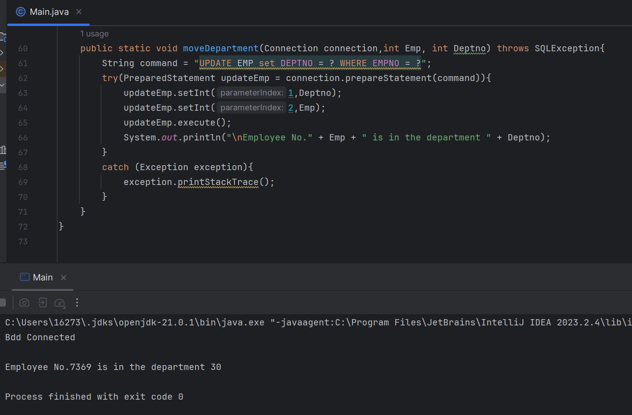

## **Exercice 3: Generic display of Tables:**

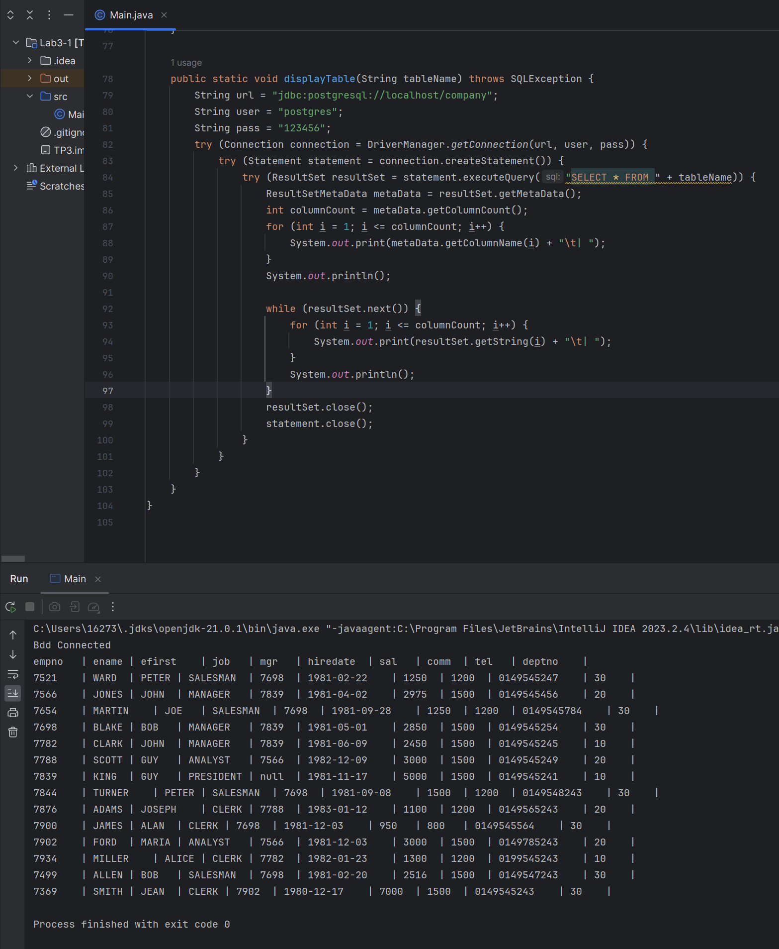

### Exercice 4: Security:

* **What is the Security flow to the method above?**

1. **`Statement` objects may lead to SQL injection. If user input is spliced directly into an SQL statement, can modify the behaviour of the SQL statement by constructing special input, for example, to retrieve, modify, or delete data,**

* **What are others Cons from this basic native method?**
  1. **SQL statements are usually hard coded in the code: making modification difficult, and the readability and maintainability of the code are poor.**

1. **Developers must ensure that all database-related resources are properly closed after use, otherwise problems such as memory leaks may occur.**
2. **SQL injection and potential others wrong arguments passed in the query.**

### Exercice 5:Modify moveDepartement() to use PrepareStatemen

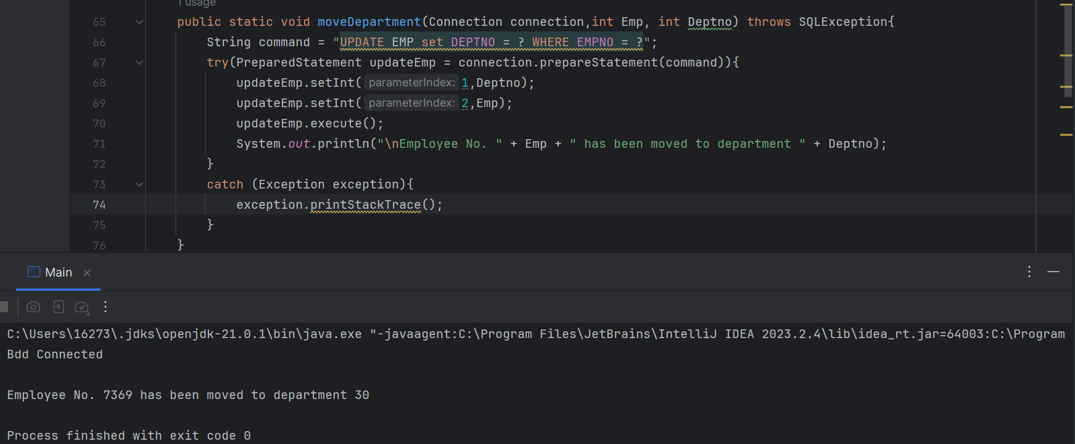

### Exercice 6: Try with displayTable

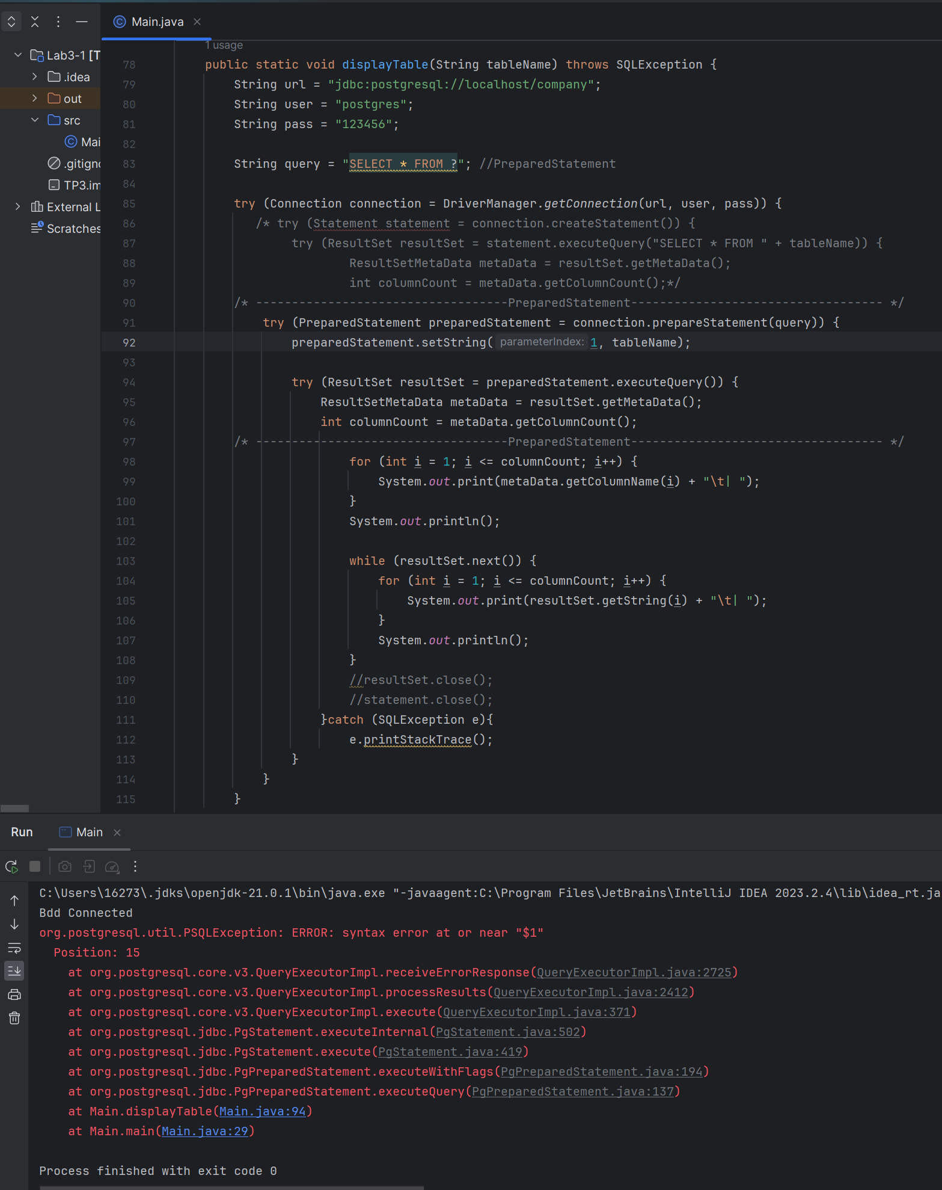

**JDBC does not allow table names or column names to be passed as parameters to PreparedStatement, preventing SQL injection and ensuring that only values can be dynamically inserted into SQL statements.**

### Exercice 7: With J2EE

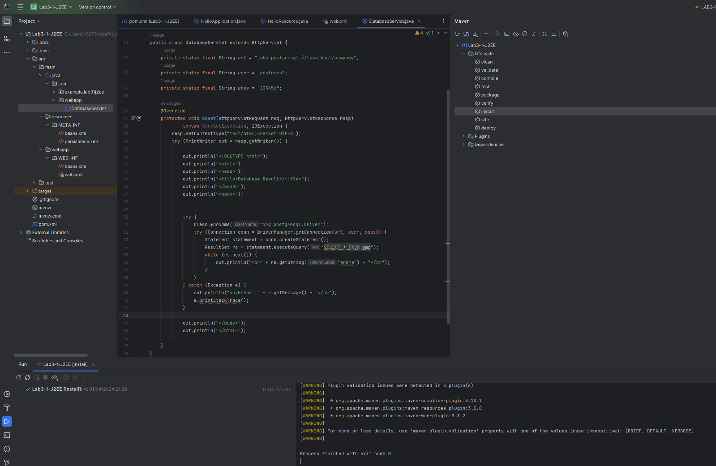

## **Part II : DAO.**

### Exercice 8: What are cons of JDBC as used above?

* **Boilerplate Code: JDBC requires verbose code for establishing connections, error handling, and resource cleanup.**
* **Error-Prone: Manually managing resources like connections, statements, and result sets increases the risk of resource leaks.**
* **Lack of Abstraction: JDBC operates at a low level, resulting in more effort for even simple queries and data manipulations.**
* **Maintenance Difficulty: Changes in the database schema often require updates in multiple parts of JDBC code, making maintenance challenging.**

### Exercice 9 : Write the Bean for Department

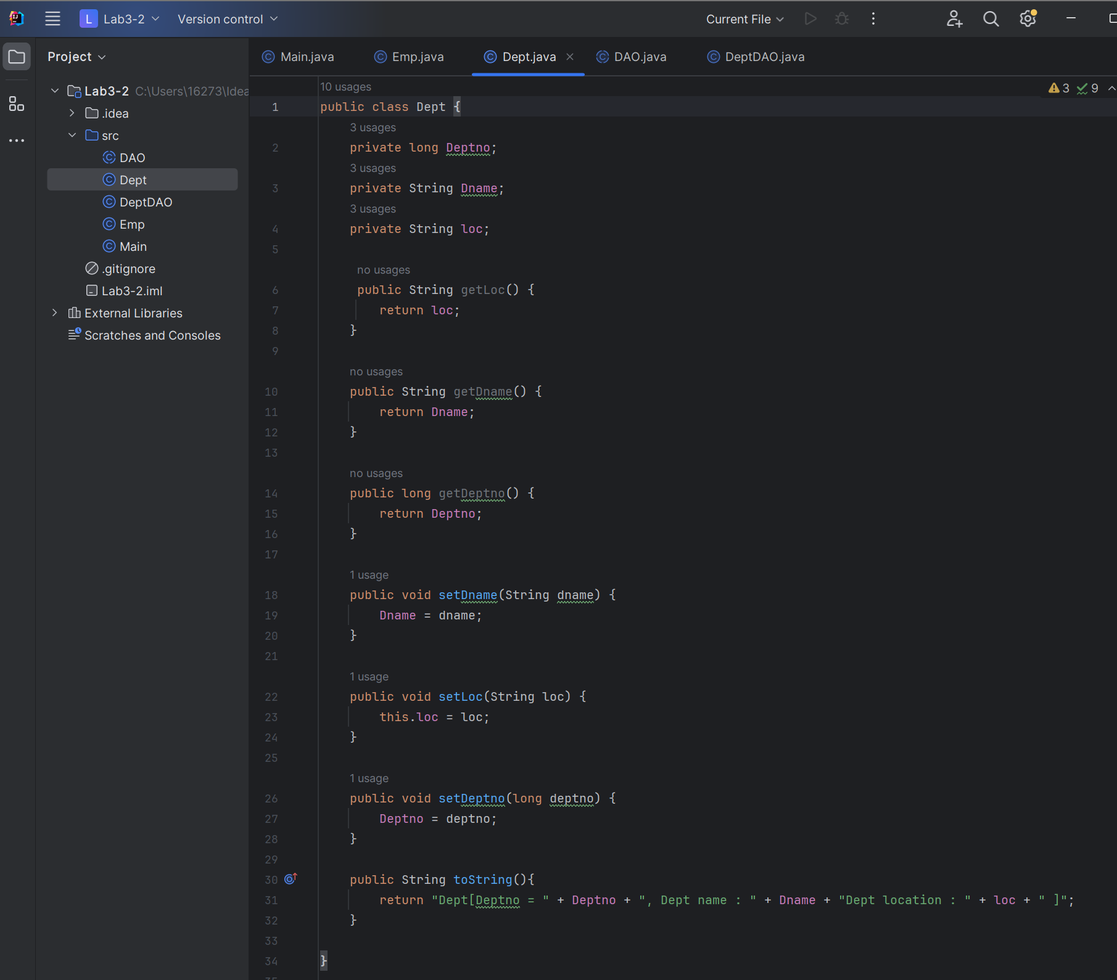

### Exercice 10 : Write Implementation for method find for departement DAO

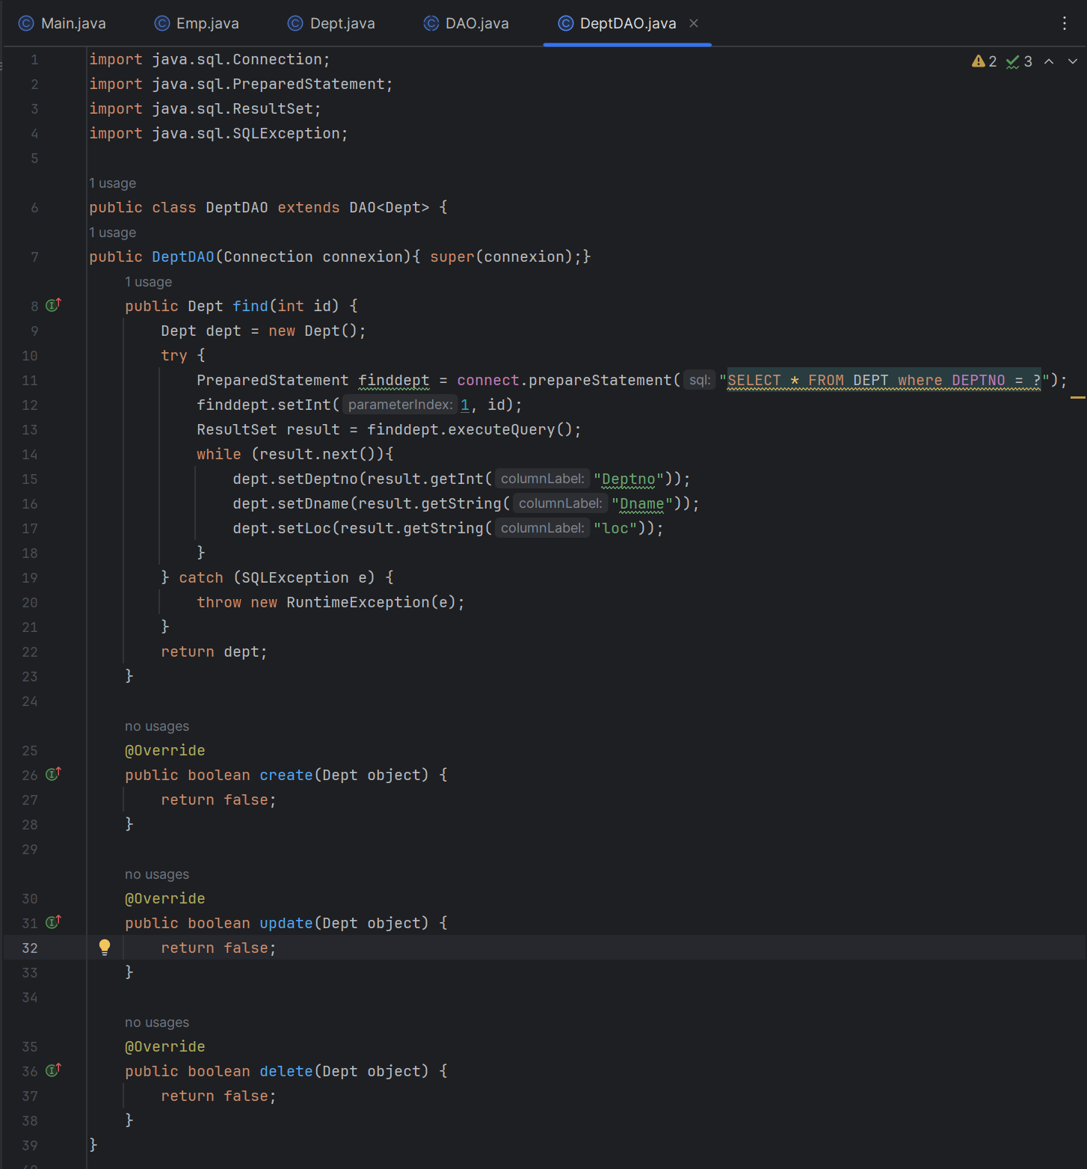

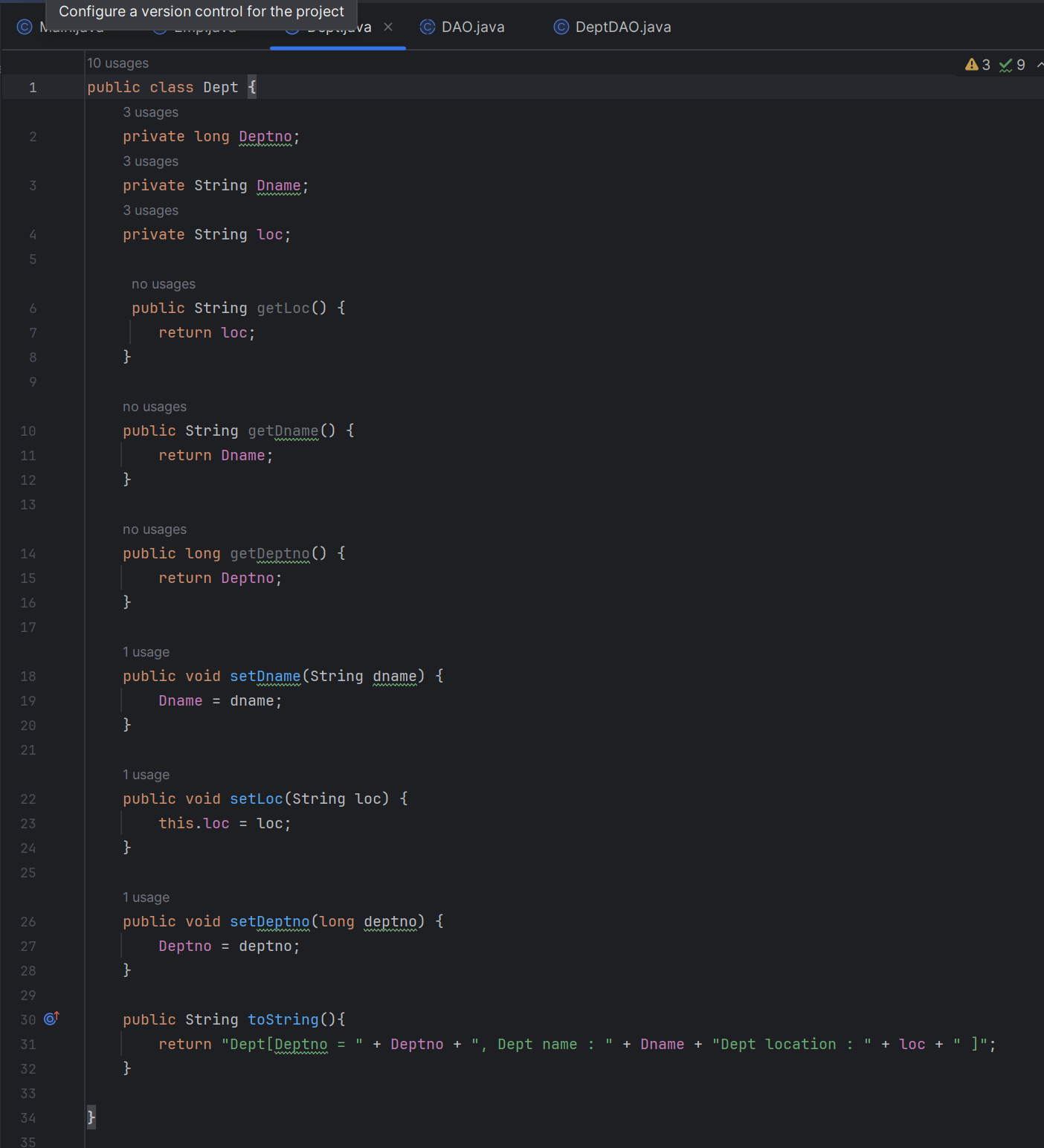

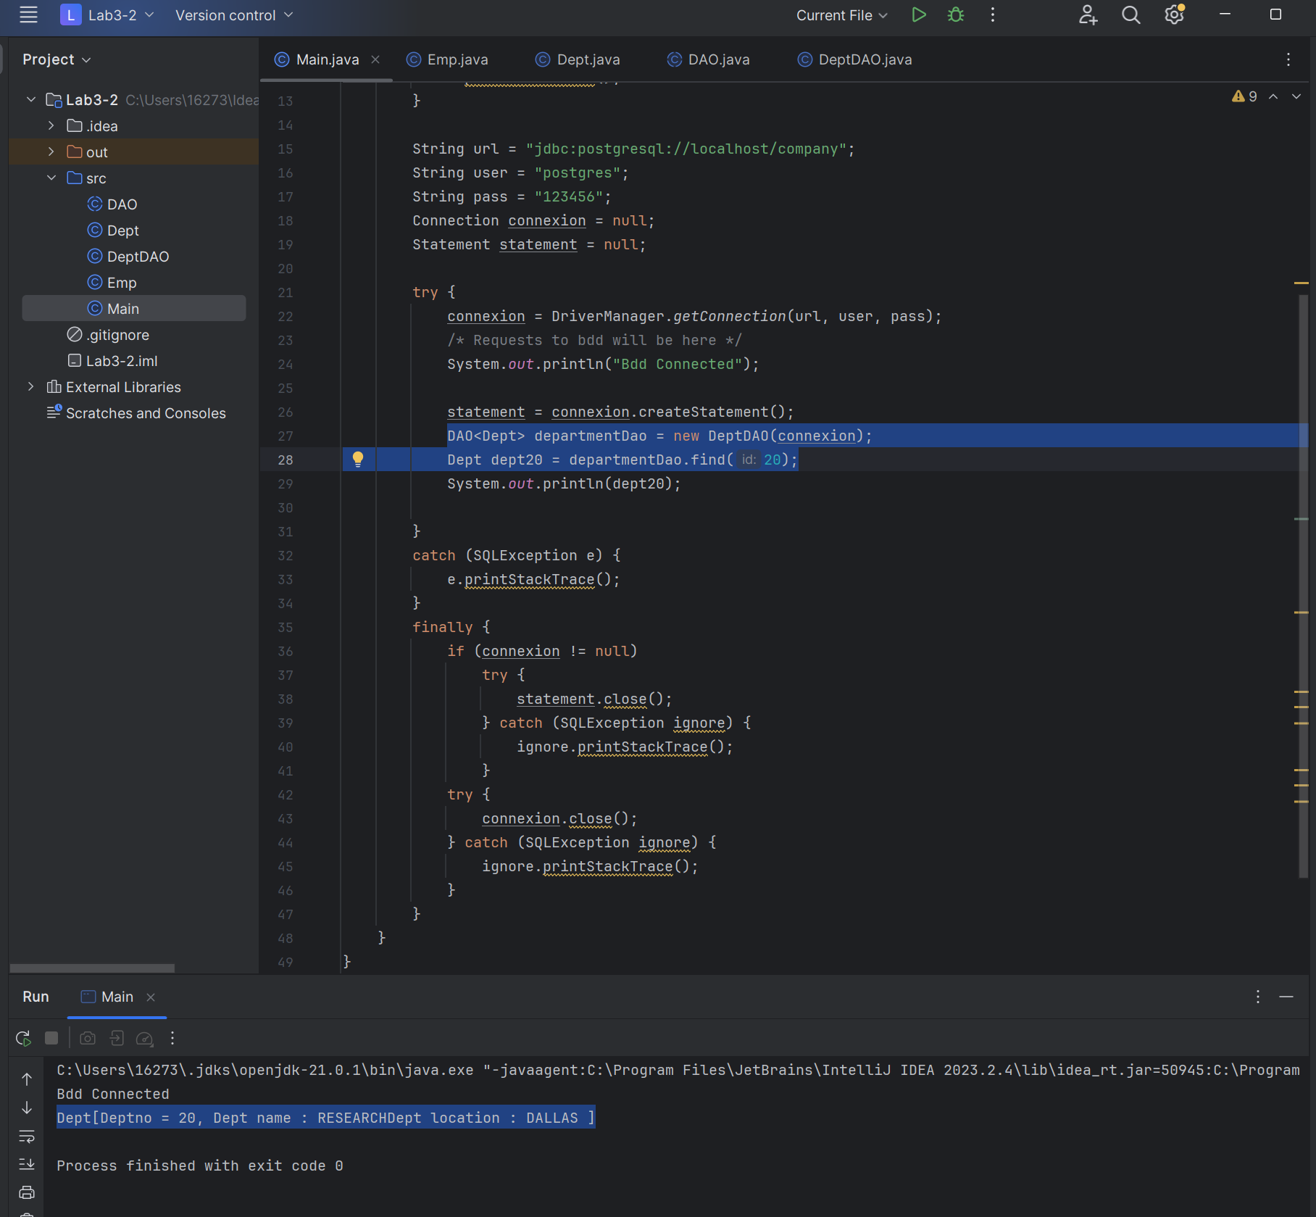

### Exercice 11: Write Implementation for method find for employee DAO.

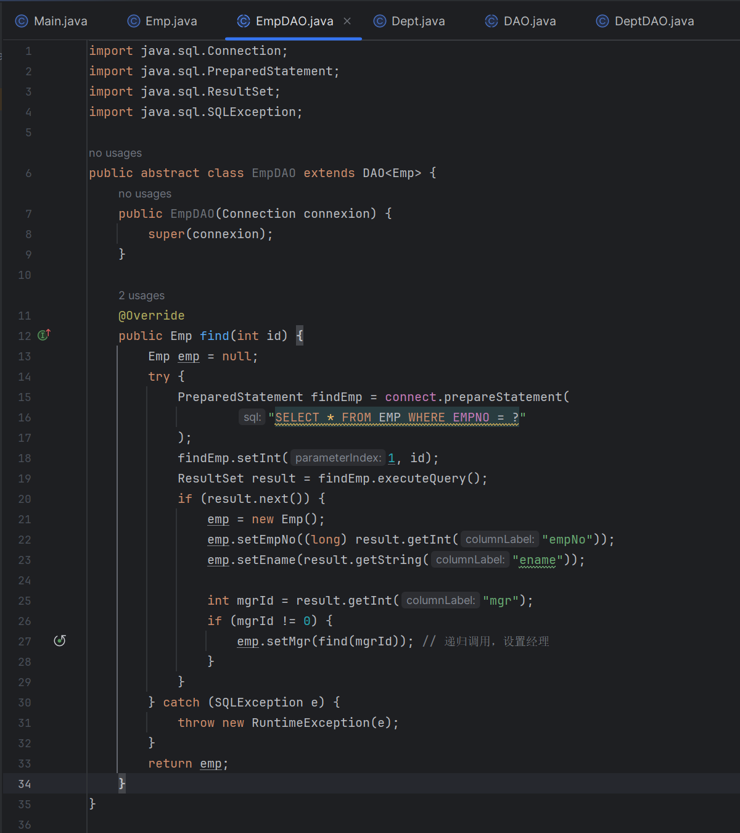

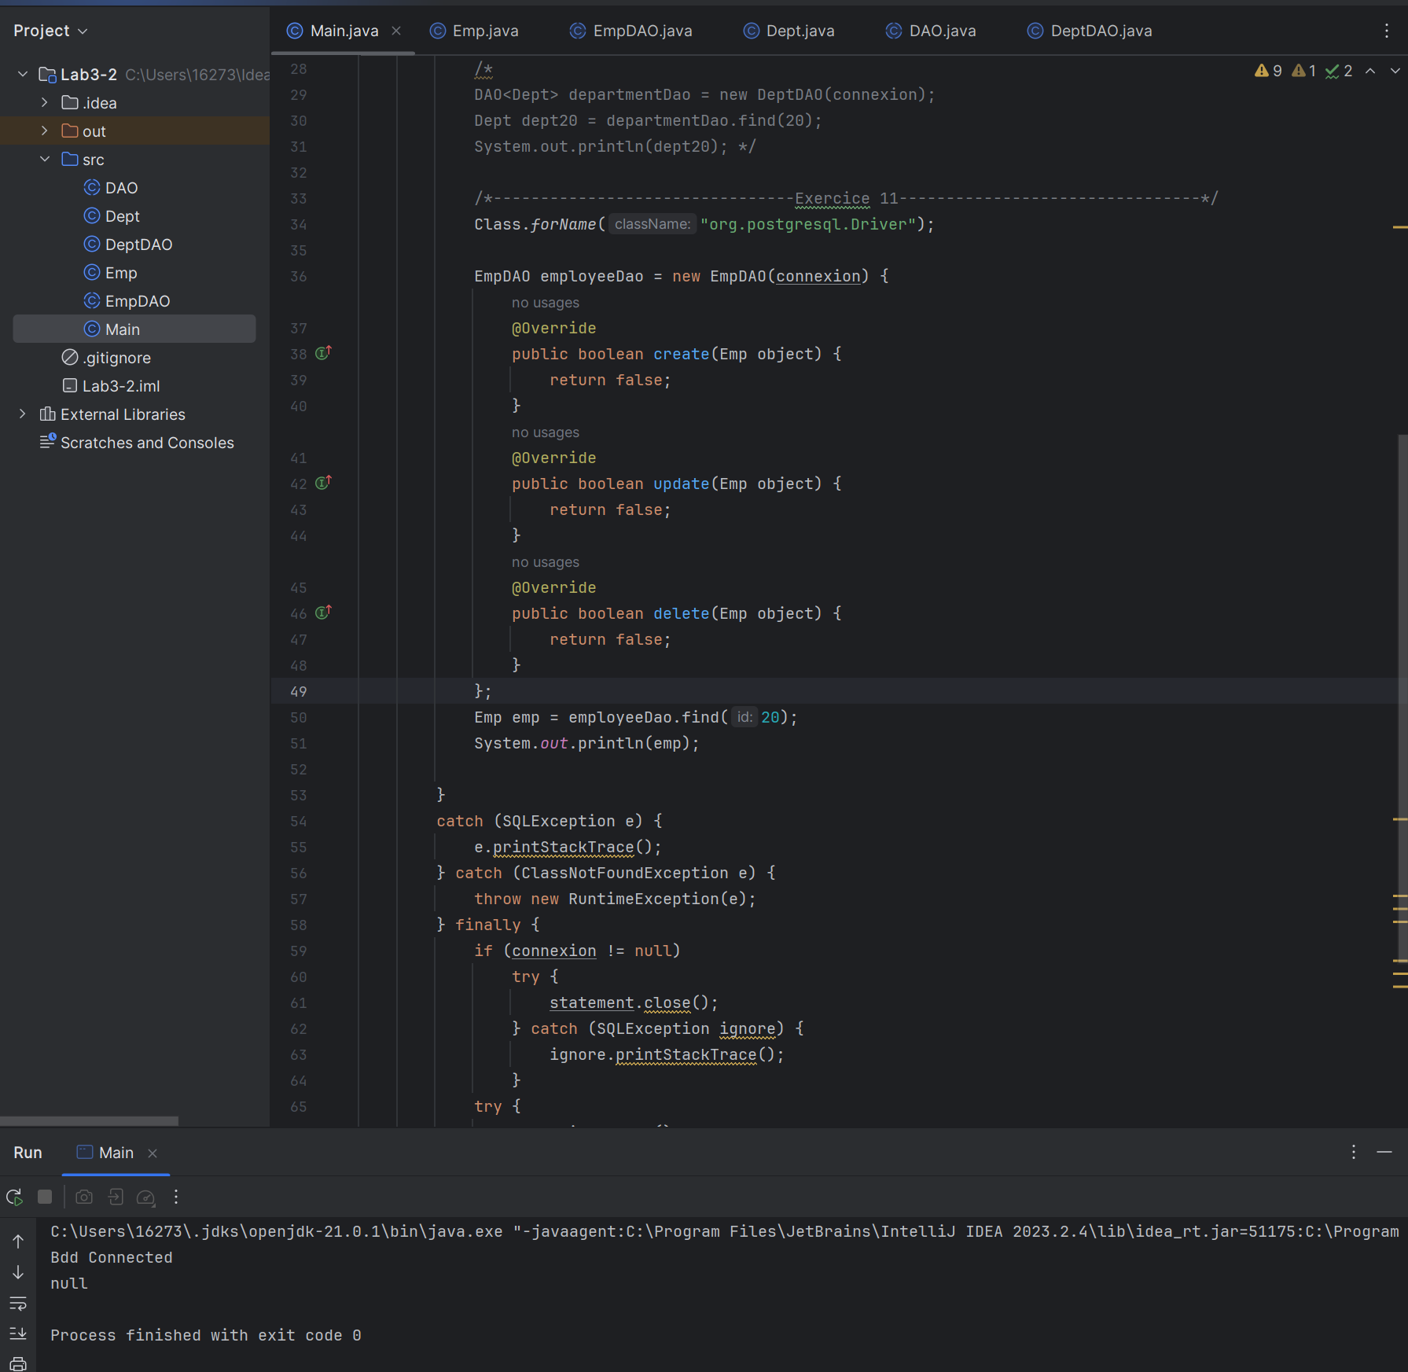

### Exercice 12 : Create DAOFactory and use it in previous example

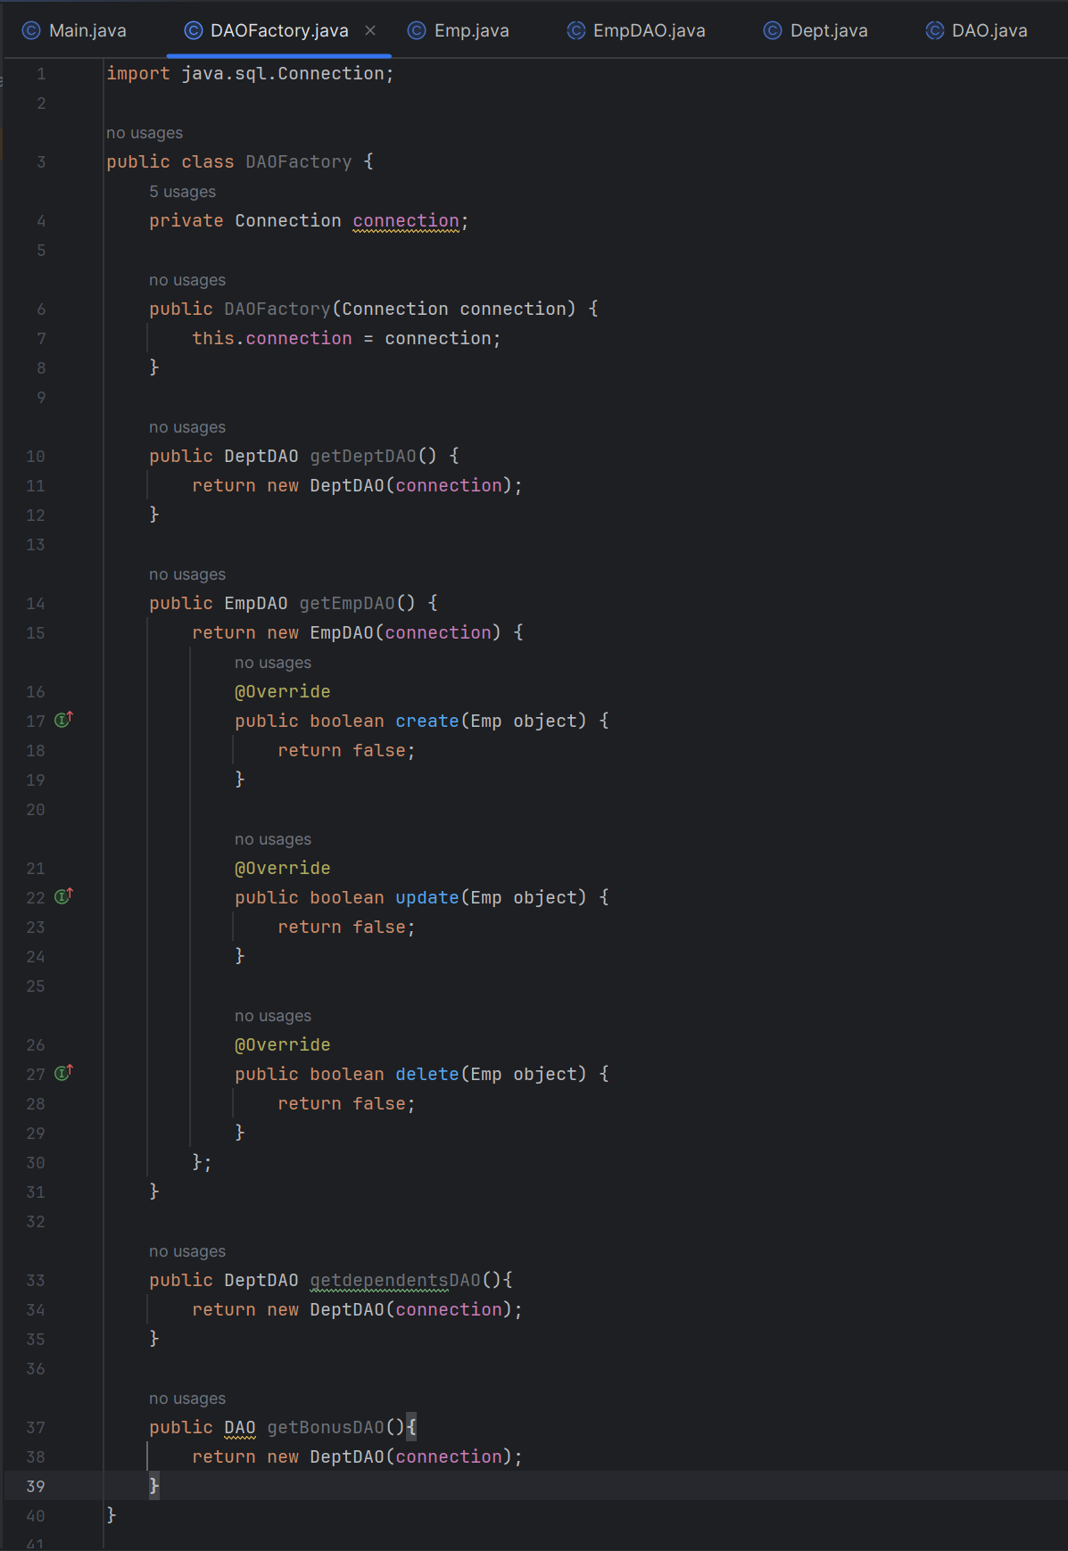

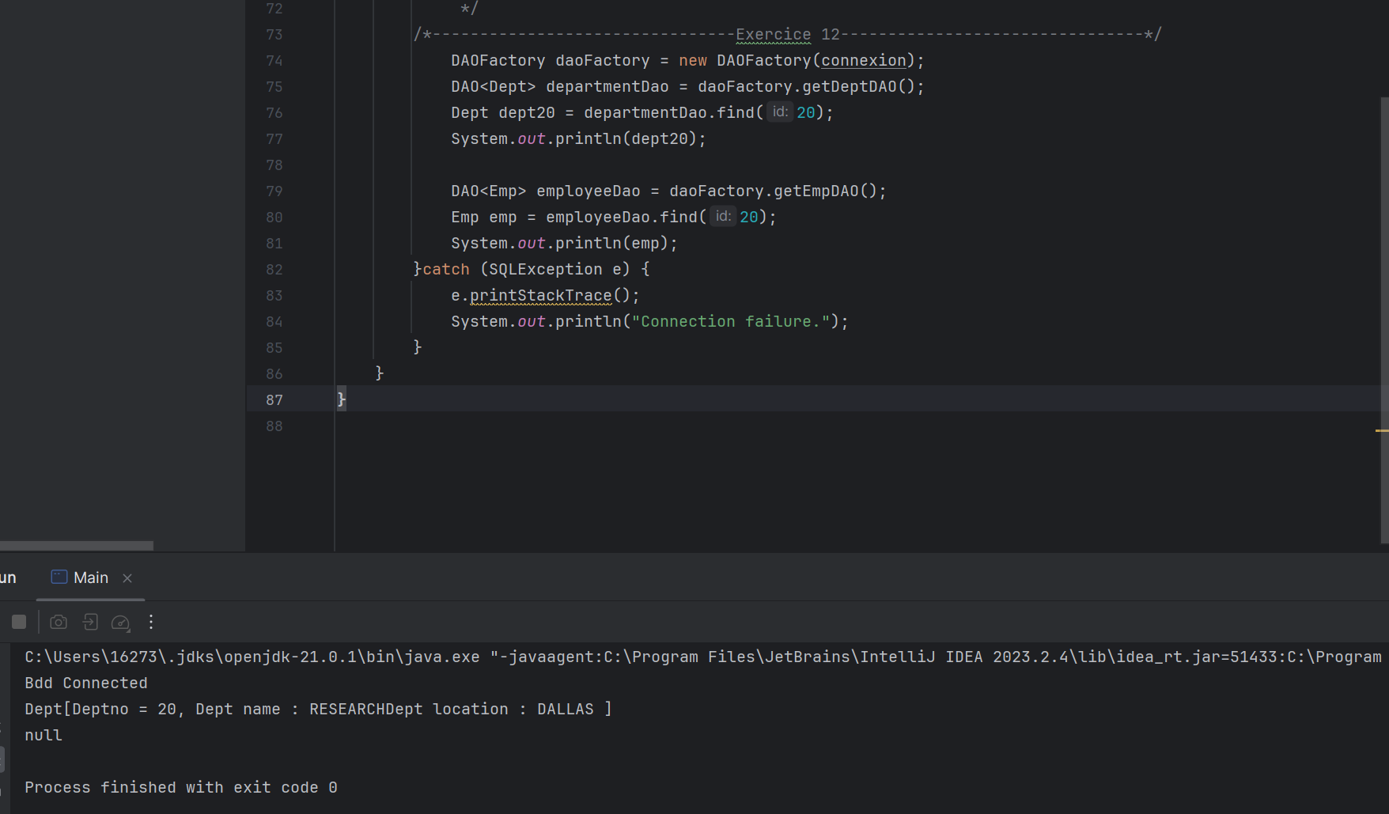

## **Part III : Spring Boot & JPA.**

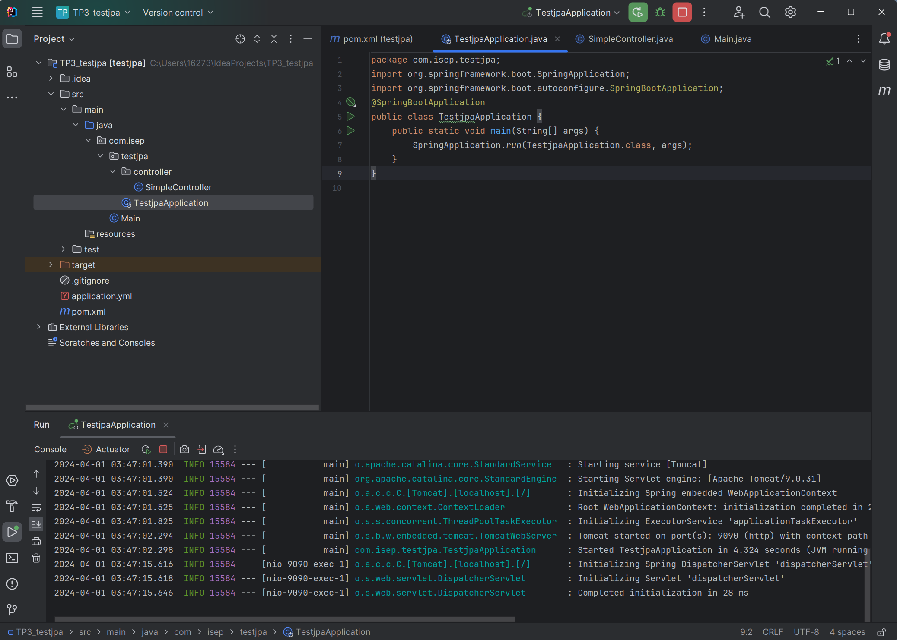

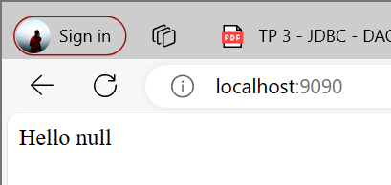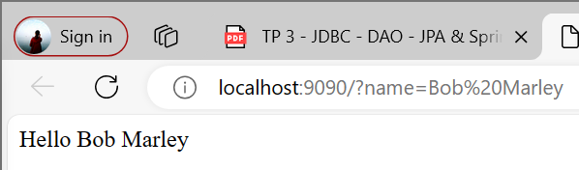

## **Exercice III.2 : Activate JPA and connect to your Database**

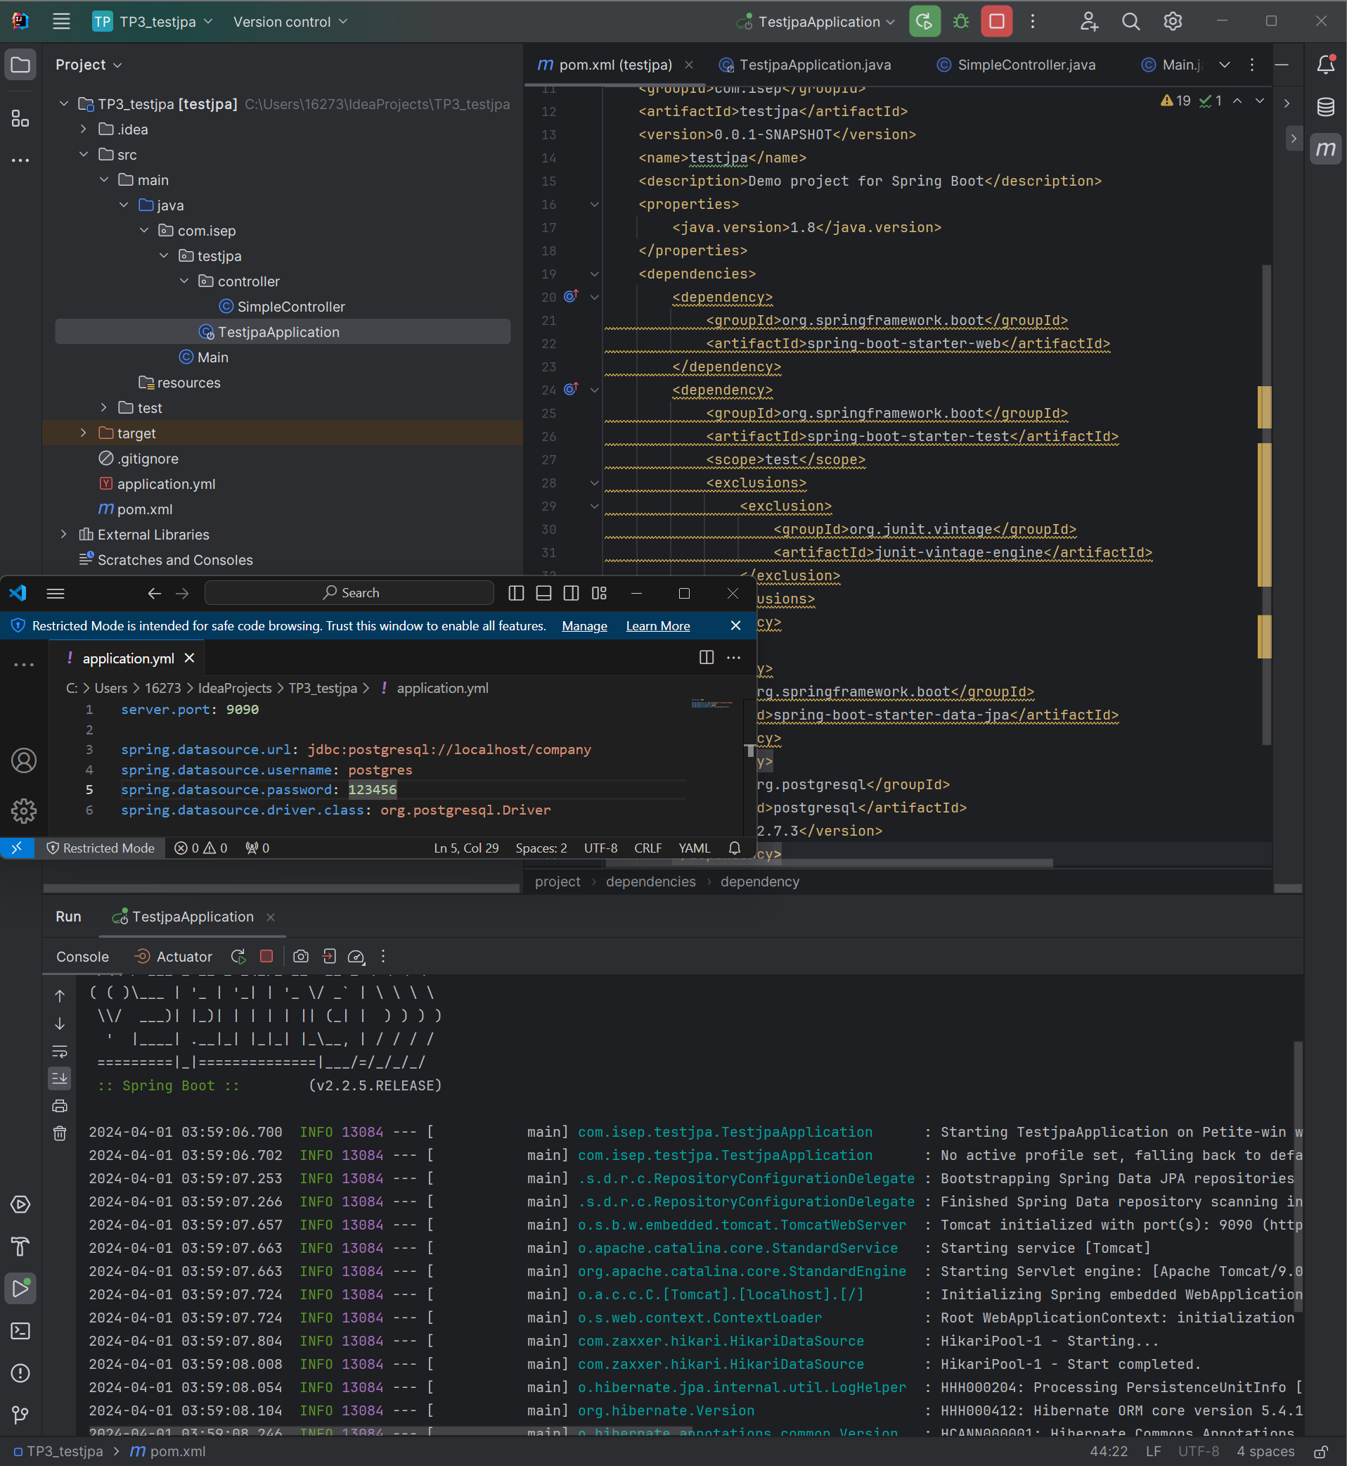

## **Exercise III.3 : Read Data in your Database**

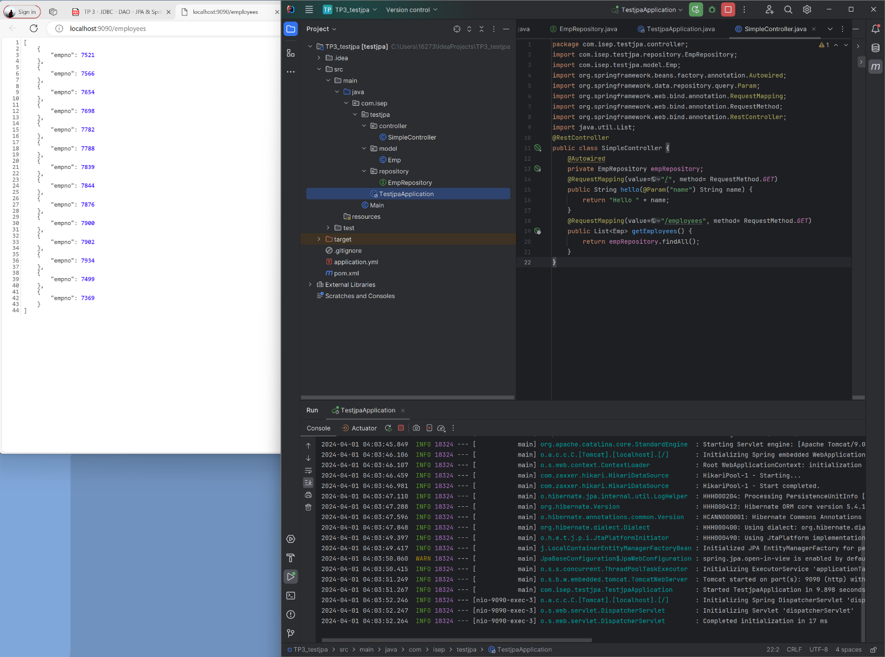

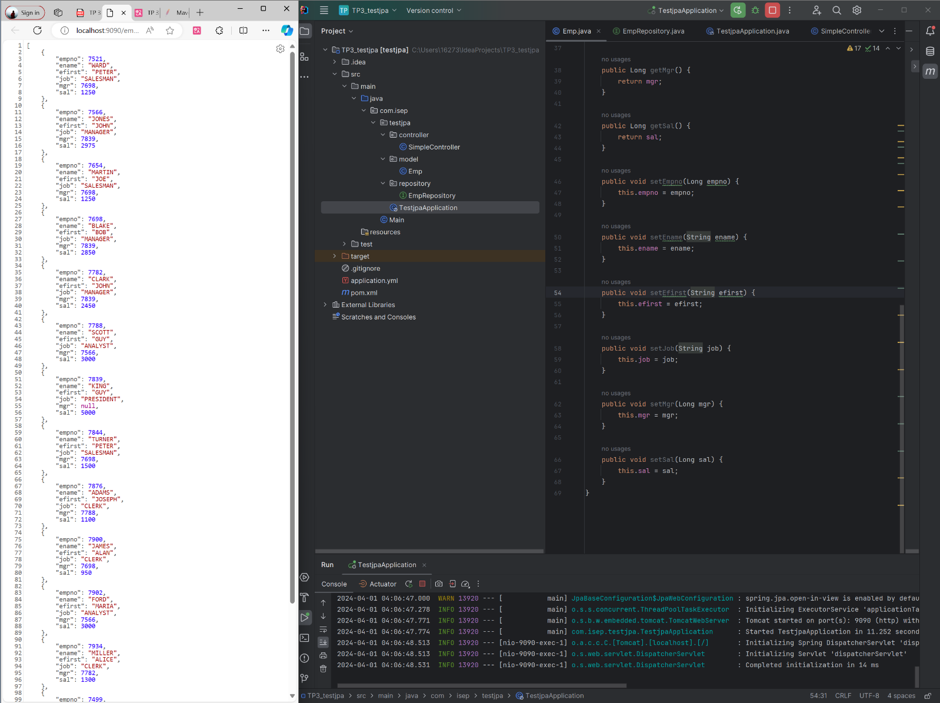

## **Exercise III.4 : Create an Object via JPA and expose it on a REST endpoint**

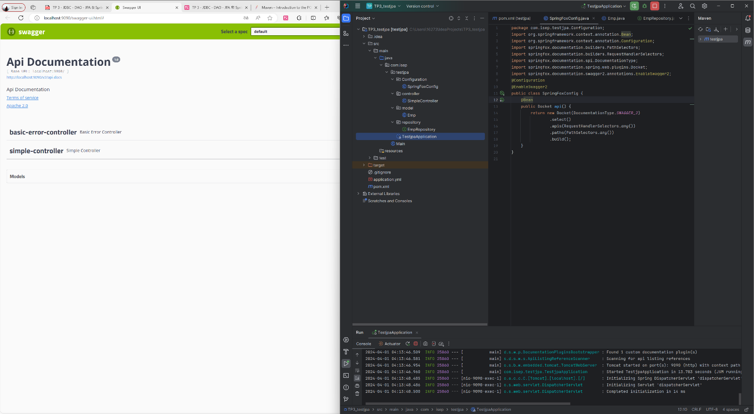

## **Exercise III.5 : GET by ID / Update by id / Delete by ID / Get All, via JPA / REST**

